Before the
Federal Communications Commission
Washington, D.C. 20554

In the Matter of  FCC Form 325 Data Collection  Modernization of Media Regulation Initiative | )  )  )  )  ) | MB Docket No. 17-290  MB Docket No. 17-105

NOTICE OF PROPOSED RULEMAKING

Adopted: November 16, 2017 Released: November 16, 2017

Comment Date: (60 days after date of publication in the Federal Register)
Reply Comment Date: (75 days after date of publication in the Federal Register)

By the Commission: Chairman Pai and Commissioners Clyburn, O’Rielly, and Carr issuing separate statements.

introduction
- This Notice of Proposed Rulemaking (NPRM) seeks comment on whether to eliminate Form 325, Annual Report of Cable Television Systems, or, in the alternative, on ways to modernize and streamline the form. Form 325 collects operational information from cable television systems nationwide, including their network structure, system-wide capacity, programming, and number of subscribers. There have been significant changes in the multichannel video programming distributor (MVPD) marketplace and in the way cable systems operate since the Commission last examined the requirement to file Form 325 almost two decades ago. Given these transformations in the industry, and the commercial availability of cable operator-related data, we think it is appropriate to take a fresh look at the form and to evaluate the continued need for the Form 325 information collection. We also note that, as part of the record in the Commission’s Modernization of Media Regulation Initiative proceeding, some industry commenters request that the Commission reevaluate the requirement for cable systems to file Form 325 and consider whether the form should be eliminated to reduce burdens on the cable industry. We seek comment on whether the costs of the Form 325 data collection now exceed the benefits of the information and on whether there may be less burdensome ways for the Commission to obtain this data or on whether the form should be modified to reflect technological and other pertinent industry changes.

background
- Form 325 collects operational information from cable television systems nationwide, including data about subscriber numbers, equipment, plant information, frequency and signal distribution information, and programming. The form must be filed annually by all cable systems with 20,000 or more subscribers, which accounts for the vast majority of cable subscribers, and a random sampling of small cable systems with fewer than 20,000 subscribers. Each year in December, the Commission sends a notification to each operator that must file Form 325 and instructs the operator to file the form electronically via the Cable Operations and Licensing System (COALS) within 60 days from the date of the letter. Form 325 filers report data from the last week in December of the preceding year. Cable systems have filed the current version of Form 325 since 2003, with minor updates made in 2008. Filers have been required to file the form electronically via COALS since 2005.
- The Commission first developed the form for use in 1966 and subsequently adopted it as an annual filing requirement in 1971. The Commission explained in 1971 that the form was “necessary to enable the Commission to keep abreast of [cable TV system] developments, fulfill its regulatory responsibilities in this field, and assist Congress in its consideration of related legislative proposals.” At that time, the Commission required that all cable systems file the form, declining to exclude small systems from this requirement because the Commission concluded that it needed comprehensive data to properly evaluate such systems.
- The Commission’s last significant modification of the Form 325 data collection was in 1999. At that time, the Commission revised and streamlined the form, and significantly reduced the number of cable systems required to file Form 325 annually by devising a sampling methodology to gather information from systems with fewer than 20,000 subscribers rather than requiring all such systems to file each year. The Commission sought “to strike a balance to reduce the burdens placed upon the industry and on Commission resources in the Form 325 information collection process while still retaining access to core information that is needed by the Commission in order to perform its regulatory functions.” It noted that the processing and compilation of Form 325 data was “a labor intensive process for the Commission.” The Commission concluded that the information collected based on the sampling of subscribers would “provide the Commission with an adequate profile of how cable systems operate today and how they impact the general population.” At that time, the Commission also considered whether to eliminate this data collection process entirely, assessing the utility of the form for purposes of the agency’s policymaking and enforcement activities. The Commission was not persuaded to eliminate the form, and it found that “there is sufficient value in the information collected . . . that the information collection process should not be altogether eliminated.”
- Today, industry commenters argue that Form 325 is burdensome for cable systems and has outlived its usefulness, given the availability of information about the cable industry from alternative sources and the changes in the MVPD marketplace. In the 2017 Modernization of Media Regulation Initiative proceeding, NCTA – The Internet and Television Association (NCTA), the American Cable Association (ACA), Verizon, and ITTA – The Voice of America’s Broadband Providers (ITTA) each assert that the Commission should eliminate the Form 325 requirement. NCTA argues that the routine collection of information does not make sense in today’s competitive video marketplace, particularly where there is no similar requirement applicable to non-cable MVPDs or online video distributors. NCTA argues further that the Form 325 filing “is not statutorily required and does not serve any clear or legitimate purpose.” ACA contends that Form 325 collects information that is publicly available or provided to the Commission in other required filings, such as signal distribution and frequency information, as well as information that has little utility today, such as set-top box and cable plant details. According to ACA, the form is no longer necessary and should be eliminated. Likewise, Verizon argues that the Commission should eliminate Form 325 and its associated data collection, opining that the information collected on the form does not fit competitive video services such as Verizon, is not reflective of today’s competitive video marketplace, and can be obtained from other sources. In reply comments, ITTA agrees with the arguments set forth by NCTA, ACA, and Verizon in favor of eliminating Form 325. No commenters argued in favor of retaining the form.

discussion

Utility of Form 325 Reporting Requirement
- We seek comment on the continued utility of collecting Form 325 data and whether the Commission should eliminate the form entirely. Given the substantial changes in the MVPD marketplace and in the operations of cable systems since the Commission last considered the utility and effectiveness of the Form 325 data collection almost two decades ago, including the transition to digital television and the development of new technologies and ways to deliver video programming to consumers, we believe it is appropriate to consider whether the form continues to be useful to the agency’s regulatory and adjudicatory functions with respect to the cable industry and whether the information collected therein is available from alternative sources. We also seek comment on the costs of this requirement for cable systems and on whether the benefits of the information outweigh the costs.
- We seek comment on whether changes in the MVPD marketplace or other factors since the Commission last considered the utility and effectiveness of the Form 325 data collection almost two decades ago should lead the Commission to a different conclusion regarding the need for the Commission to collect the data required by the form. To what extent do the changes in the industry and regulatory environment since 1999 obviate or reduce the need for this information? For example, in the 1999 Form 325 Order, the Commission noted the utility of the form in providing information about the number of leased access channels being used on cable systems. However, the Commission provides information on the average number of leased access channels in its annual report on cable industry prices. Is it still useful to collect this information on Form 325? We note that the Commission started collecting information from cable systems via Form 325 well before cable operators became significant players in the broadband market. The Commission currently collects information from broadband providers, including cable operators, on FCC Form 477, Local Telephone Competition and Broadband Reporting, and there is some overlap between the Form 325 and Form 477 data collections. Is there a continued need for the Commission to collect Form 325 data to support the Commission’s policy initiatives and decision making or to inform reports to Congress, such as the Commission’s annual video competition report? Would eliminating Form 325 hinder the Commission’s ability to evaluate the state of competition among cable systems? If so, what aspects of the form are essential to this evaluation?
- We also seek comment on the burden for cable operators to file Form 325 each year and, in particular, on the amount of time and resources it takes to complete the filing for each cable system. Do the benefits and uses of the information collected via Form 325 outweigh the burdens and costs on cable systems to file the form? To the extent the Commission might in the future need discrete information, would it be more cost effective for the Commission to undertake targeted information collections to obtain it?
- We also seek comment on whether and to what extent Form 325 merely duplicates information that the Commission can obtain from commercial sources. For example, the Commission routinely cites data from SNL Kagan, BIA/Kelsey, The Nielsen Company, and Warren Communications Television and Cable Factbook. What other sources of cable data are available? Does the information collected by other sources duplicate what is collected via Form 325? In recent years the Commission has cited Form 325 data in a few proceedings. To the extent this information continues to be useful, can the Commission obtain it from other sources? Is there unique value in having the Commission collect the information contained within Form 325, rather than relying on third-party sources?
- Are there other external uses of the Form 325 data collection of which the Commission should take account? We note that Warren Communications annually files a Freedom of Information Act (FOIA) request for Form 325 data from the Commission and that other entities and individuals have periodically sought Form 325 data through FOIA requests. The Commission does not provide this information in response to FOIA requests until three years after initial filing due to confidentiality requests that are routinely filed by cable operators. Is any information from alternative sources based on the FCC’s Form 325 data?

Ways to Improve and Modernize Form 325 Data Collection
- If the Commission decides to retain the Form 325 data collection, we seek comment on ways to improve and modernize the form. The cable television industry has experienced many changes since Form 325 was last updated, most notably the ongoing transition to digital technology and the introduction of video programming delivered via Internet protocol (IPTV). These changes may render some data collected by the form no longer necessary and raise new information needs not met by the current form. If the Commission decides to retain the Form 325 data collection, we seek to minimize the administrative burden on cable television systems and improve the quality and usefulness of Form 325 data to reflect technological and other pertinent industry changes. We also seek to ensure that the data we collect are closely aligned with the uses to which they will be put by the Commission.
- In addition, to the extent the form is retained, we propose to upgrade the current COALS filing system to minimize the filing burden for cable systems. An upgraded filing system would be able to pre-fill much of the data that does not change from year to year using other filings, such as community registrations, online public inspection files (OPIF), and previous Form 325 submissions. Cable operators will only have to verify the continued accuracy of any pre-filled information, and update those fields only if necessary.
- Currently, Form 325 is organized into five parts: (1) operator information; (2) general information; (3) frequency and signal distribution information; (4) channel line-up; and (5) certification. We seek comment below on each section of the form. We also seek comment on whether the Commission should consider any organizational changes to Form 325, such as changes to the categories of information collected. Commenters should specify any elements of the data collection that we should consider for elimination, whether because of redundancy, insufficient usefulness, or availability from other sources, as well as elements of the data collection that are particularly burdensome to filers. We also ask commenters to specify the data elements that should be retained or modified, as well as the rationale for any proposed change. Is there any information contained in Form 325 that would be helpful to consumers? Could some of the information be made publicly available earlier than three years from the date of filing?

Operator Information
- Identification and Contact Information. To the extent the form is retained, we tentatively conclude that cable system identification and contact information should remain a part of the Form 325 data collection. We seek comment on this tentative conclusion and on whether we should modify or streamline this section of the form. Currently, Form 325 requires filers to provide the cable operator’s legal name and complete mailing address, including zip code. Are there any ways in which the Commission can streamline this section of the form, such as by pre-filling information using a cable system’s Physical System Identifier (PSID), which is a six-digit number used by the Commission to identify each cable system?

General Information
- Subscriber Information. We seek comment on whether there is a continued need to collect cable subscriber information to the extent the form is retained, and, if not, whether we should eliminate this section of the form. We seek comment on the uses of this data and whether we can obtain it from other sources. We also seek comment on whether there are ways the Commission can update or streamline the reporting of information on cable subscribers, if it decides to retain this section of the form. Part II of Form 325 requires the reporting of subscriber information, including the number of subscribers; number of potential subscribers; whether the system is overbuilt by a competing cable system; number of homes passed that are also passed by a competing cable system; name of incumbent operator(s) where the system is overbuilt by a competing cable system; number of cable modem subscribers; and number of telephony subscribers. Subscriber data is a useful measure of the size and competitiveness of a cable system, and has been used by the Commission to prepare the annual video competition report and to inform our policymaking. For example, the Commission has used subscriber data as the basis for crafting rule exemptions and justifying differing regulatory treatment based on the number of subscribers served. Is subscriber data available from alternative sources, and, if so, is such data as accurate and current as data provided directly to the Commission by cable systems? We tentatively conclude that we should eliminate the collection of modem and telephony subscriber data via Form 325 because similar data is collected via FCC Form 477, Local Telephone Competition and Broadband Reporting, and we seek comment on this tentative conclusion. Should we collect data on the number of analog and digital subscribers so that the Commission can track the progress of each system’s transition to all-digital service? Or, is this information available from public sources? We also seek comment on whether we should retain the existing instruction for how bulk rate customers are calculated for the form, if the Commission continues to require reporting of subscriber numbers. Currently, when reporting the number of subscribers on Form 325, operators must include an estimate of the number of subscribers who pay a bulk rate for service through an intermediary, such as apartment management. On the existing form, the instructions explain that the number of bulk rate customers should be calculated as follows: “[b]ulk-rate customers = total annual bulk-rate charge divided by basic annual subscription rate for individual households.” Is there any reason to change this approach? Commenters advocating a different approach should explain their proposed methodology and why it would be an improvement over the one currently in place.
- Equipment Information. We seek comment on whether there is a continued need to collect equipment information via Form 325 to the extent the form is retained, and, if not, whether we should eliminate this section of the form. We seek comment on the uses of this data and whether we can obtain it from other sources. We also seek comment on whether there are ways the Commission can modernize this portion of Form 325 to better reflect devices used by consumers to view cable programming, if it decides to retain this section. Part II of Form 325 collects the following equipment information: the total number of leased cable modems deployed throughout the system and the total number of leased set-top boxes deployed in the system, including a breakdown of this total into the number of analog, hybrid, and digital set-top boxes leased. Is this information relevant to the Commission’s duties under Section 629 of the Communications Act of 1934, as amended? Should we modify the equipment section of Form 325 to better achieve our duties under Section 629, and, if so, how? Or, is this information available from public sources? What information will best allow the Commission to determine whether the market for equipment used to access multichannel video programming is fully competitive, pursuant to Section 629? How can we best measure the level of competition as contemplated by Section 629?
- Plant Information. We seek comment on whether there is a continued need to collect plant information via Form 325 to the extent the form is retained, and, if not, whether we should eliminate this section of the form. We seek comment on the uses of this data and whether we can obtain it from other sources. We also seek comment on how the Commission can modernize this portion of Form 325 to better reflect system capacity, if it decides to retain this section. Part II of Form 325 collects information on the cable plant, including the type of delivery system used (e.g., xDSL, fiber to the home, Hybrid Fiber-Coaxial (HFC) network, or other); the length of optical fiber used in the plant; the number of fiber optic nodes, including the average number of subscribers served from these nodes; whether the cable system is part of a cluster, and, if so, the number of systems included in the cluster and total number of subscribers served by the cluster; and whether the facility uses Cable Television Relay Service (CARS) links, as well as a list of all call signs used by the system. Is this information still relevant to the Commission’s regulation of cable television? Collecting information about system technology and capacity may enable us to better understand the ability of a system to comply with various regulations, based on their sophistication, capacity, and other technological limitations. Given that, in a digital world, the technical specifications of the cable plant no longer directly correlate to the systems’ capacity for delivering programming, these questions may not provide meaningful information about an ever-growing percentage of systems. As cable systems have converted to digital technology, data on the number of programming streams, as well as on the compression and modulation used, may be more valuable than previous metrics used for measuring capacity of analog systems. We seek comment on this analysis. Is such data available from other sources? In conjunction with Section III.B.3 below (frequency and signal distribution information), we seek comment on how the Commission can update its questions on system technology and capacity should it retain the form.

Frequency and Signal Distribution Information
- We seek comment on whether there is a continued need to collect information on frequency and signal distribution to the extent the form is retained, and, if not, whether we should eliminate this section of the form. We seek comment on the uses of this data and whether we can obtain it from other sources. We also seek comment on how the Commission can modernize the questions about a cable system’s technical capabilities, capacity, and potential for growth, including its ability to offer sophisticated services, if it decides to retain this section of the form. Part III of Form 325 requires cable systems to report frequency and signal distribution information, including available upstream spectrum and maximum activated upstream spectrum; available downstream spectrum and maximum activated downstream spectrum; number of channels allocated to analog video programming and the number of channels actually used for analog video programming; number of channels allocated to digital video programming and the number of channels actually used for digital video programming; number of digital streams carried per 6 MHz of bandwidth; and modulation method used. To what extent does this type of data enable the Commission to measure a system’s competitiveness and aid our policymaking with respect to the cable industry? Does the ongoing cable transition to digital transmission and other advancements in cable technology, such as IPTV, render many of the current questions on this part of the form ineffective or unnecessary, or does it raise new information needs not met by the current form? Is there a need for the Commission to understand the current capacity of a system, its potential for increases in capacity, and the rate at which new capacity is being delivered into the marketplace over time? If so, how can we gather information on system technology and capacity in a way that will prove flexible and informative as technology continues to evolve? Is such data available from other sources?

Channel Line-Up
- We tentatively conclude that we should eliminate the collection of channel line-up information to the extent the form is retained. We note that information about a cable system’s programming is available from online sources, including on cable operator websites and from third-party guide services. Given the availability of this information from other public sources, we tentatively conclude that it is not necessary to continue to collect it from the cable operators via Form 325. We seek comment on this tentative conclusion. If, on the other hand, the Commission ultimately decides that this information collection is necessary and useful, are there ways for the Commission to streamline this section of Form 325 to reduce the burden on cable systems to input their entire channel lineup? For example, should we reduce the types of program channels that must be reported? Currently, Part IV of Form 325 requires cable systems to list the program name, type (e.g., broadcast must carry, broadcast retransmission consent, leased access, public access, government access, education access, local origination, cable network, or other), format (e.g., analog, digital, or digital high definition), and tier (e.g., basic, cable programming services tier/expanded basic tier, premium, pay per view, or other) for each program carried on the system. We seek general comment on the burdens associated with the collection of programming information and any associated benefits.

Procedural Changes for Filing Form 325
- Applicability of Requirement to Small Cable Systems. We seek comment on whether the annual Form 325 filing requirement should continue to apply to a random sampling of cable systems that serve fewer than 20,000 subscribers, if the Commission decides to retain the form. Specifically, the Commission samples approximately 50 percent of the systems serving between 5,000 and 20,000 subscribers, but only approximately 4 percent of systems serving fewer than 5,000 subscribers.
- We seek specific comment on the burden imposed by the Form 325 filing requirement on smaller cable systems. In its media modernization proceeding comments, ACA contends that, should the Commission decide to retain Form 325, it should no longer require cable systems with fewer than 20,000 subscribers to complete the form. According to ACA, “[r]andomly sampling smaller cable systems increases the burden on those smaller providers selected, as the operators often have no experience filling [out] the form and must often engage outside resources for assistance completing it.” Which data, if any, is particularly burdensome on smaller systems to provide? Commenters should explain and quantify such burden. If the Commission decides to retain the form, will the burden on small systems to file Form 325 be significantly reduced if the Commission streamlines and modernizes the form as discussed herein? How is the data from smaller cable systems useful to the Commission, and does its usefulness outweigh the burden on such systems?
- We tentatively conclude that, at a minimum, the Commission should exempt systems that serve fewer than 5,000 subscribers and are not affiliated with a larger operator from filing Form 325, if the form is retained. We seek comment on this tentative conclusion. Given the relative burdens and benefits, should we also exempt other smaller systems from having to complete the form? In addition, for those small cable systems that may still be required to file, should the Commission maintain the current approach of requiring only a sample of these systems to file Form 325 each year? Instead of randomly sampling smaller systems annually, should we require smaller systems to file the report every two, three, or five years, or some other time period? How should we define small systems for such purposes? For example, we could require systems that serve between 5,000 and 20,000 subscribers and are not affiliated with a larger operator (serving more than 2 percent of all MVPD subscribers) to file every three years. We seek comment on these or any other alternative approaches.
- Fixed Date for Form 325 Annual Filing. We seek comment on whether we should set a fixed date on which cable systems must annually file Form 325, if the Commission decides to retain the form. Currently, all systems, even those with 20,000 or more subscribers, wait for the Commission to notify them of their obligation to file Form 325. This notification, in addition to establishing the obligation to file, begins a 60-day clock determining when the operator must file. As a result, operators remain uncertain, from year to year, when they must file. Should we instead set a fixed date on which filing must occur? We believe this approach could simplify the annual reporting process and add certainty and efficiency to the operator’s workflow and that of the Commission, and we seek comment on this analysis. If the Commission were to adopt a fixed due date, which date would be appropriate? Currently, we request that systems report their information as of the last full week in December, and believe retaining that “as of” date makes sense for year-to-year consistency. The date should ensure that cable systems have sufficient time to compile and file their information. Given that the Commission previously required Form 325 to be filed on March 1 of each year, would that be an appropriate date?
- Confidential Treatment of Form 325. We seek comment on whether we should adopt any standardized confidentiality procedures for Form 325, if the Commission decides to retain the form, and, if so, what those standards should be. Form 325 filings and the information contained therein generally are not made available to the public until three years after filing due to confidentiality requests that are routinely filed by cable operators, but are made public via COALS thereafter. Before the three-year period, the data is used by the Commission on an anonymized basis. Should the Commission automatically designate certain sections of Form 325 as confidential for all filers, and, if so, which sections? Is there a need to adopt more formal Form 325 confidentiality procedures or are the Commission’s current practices sufficient? Should the Commission provide a mechanism for filers to request confidentiality within the Form 325 as it does with regard to Form 477 filers?

procedural matters

Initial Regulatory Flexibility Analysis
- As required by the Regulatory Flexibility Act of 1980, as amended (RFA), the Commission has prepared an Initial Regulatory Flexibility Analysis (IRFA) relating to this NPRM. The IRFA is set forth in Appendix A.

Initial Paperwork Reduction Act Analysis
- The NPRM may result in revised information collection requirements. If the Commission adopts any revised information collection requirement, the Commission will publish a notice in the Federal Register inviting the public to comment on the requirement, as required by the Paperwork Reduction Act of 1995, Public Law 104-13 (44 U.S.C. §§ 3501-3520). In addition, pursuant to the Small Business Paperwork Relief Act of 2002, Public Law 107-198, see 44 U.S.C. § 3506(c)(4), the Commission seeks specific comment on how it might “further reduce the information collection burden for small business concerns with fewer than 25 employees.”

Ex Parte Rules
- Permit-But-Disclose. This proceeding shall be treated as a “permit-but-disclose” proceeding in accordance with the Commission’s ex parte rules. Persons making ex parte presentations must file a copy of any written presentation or a memorandum summarizing any oral presentation within two business days after the presentation (unless a different deadline applicable to the Sunshine period applies). Persons making oral ex parte presentations are reminded that memoranda summarizing the presentation must (1) list all persons attending or otherwise participating in the meeting at which the ex parte presentation was made, and (2) summarize all data presented and arguments made during the presentation. If the presentation consisted in whole or in part of the presentation of data or arguments already reflected in the presenter’s written comments, memoranda, or other filings in the proceeding, the presenter may provide citations to such data or arguments in his or her prior comments, memoranda, or other filings (specifying the relevant page and/or paragraph numbers where such data or arguments can be found) in lieu of summarizing them in the memorandum. Documents shown or given to Commission staff during ex parte meetings are deemed to be written ex parte presentations and must be filed consistent with rule 1.1206(b). In proceedings governed by rule 1.49(f) or for which the Commission has made available a method of electronic filing, written ex parte presentations and memoranda summarizing oral ex parte presentations, and all attachments thereto, must be filed through the electronic comment filing system available for that proceeding, and must be filed in their native format (e.g., .doc, .xml, .ppt, searchable .pdf). Participants in this proceeding should familiarize themselves with the Commission’s ex parte rules.

Filing Requirements
- Comments and Replies. Pursuant to sections 1.415 and 1.419 of the Commission’s rules, 47 CFR §§ 1.415, 1.419, interested parties may file comments and reply comments on or before the dates indicated on the first page of this document. Comments may be filed using the Commission’s Electronic Comment Filing System (ECFS). See Electronic Filing of Documents in Rulemaking Proceedings, 63 FR 24121 (1998).
- Electronic Filers: Comments may be filed electronically using the Internet by accessing the ECFS: http://fjallfoss.fcc.gov/ecfs2/.
- Paper Filers: Parties who choose to file by paper must file an original and one copy of each filing. If more than one docket or rulemaking number appears in the caption of this proceeding, filers must submit two additional copies for each additional docket or rulemaking number.
Filings can be sent by hand or messenger delivery, by commercial overnight courier, or by first-class or overnight U.S. Postal Service mail. All filings must be addressed to the Commission’s Secretary, Office of the Secretary, Federal Communications Commission.
- All hand-delivered or messenger-delivered paper filings for the Commission’s Secretary must be delivered to FCC Headquarters at 445 12th Street, SW, TW-A325, Washington, DC 20554. The filing hours are 8:00 a.m. to 7:00 p.m. All hand deliveries must be held together with rubber bands or fasteners. Any envelopes and boxes must be disposed of before entering the building.
- Commercial overnight mail (other than U.S. Postal Service Express Mail and Priority Mail) must be sent to 9050 Junction Drive, Annapolis Junction, MD 20701.
- U.S. Postal Service first-class, Express, and Priority mail must be addressed to 445 12th Street, SW, Washington, DC 20554.
- Availability of Documents. Comments, reply comments, and ex parte submissions will be available for public inspection during regular business hours in the FCC Reference Center, Federal Communications Commission, 445 12th Street, SW, CY-A257, Washington, DC 20554. These documents will also be available via ECFS. Documents will be available electronically in ASCII, Microsoft Word, and/or Adobe Acrobat.
- People with Disabilities. To request materials in accessible formats for people with disabilities (Braille, large print, electronic files, audio format), send an e-mail to fcc504@fcc.gov or call the FCC’s Consumer and Governmental Affairs Bureau at (202) 418-0530 (voice), (202) 418-0432 (TTY).

Additional Information
- For additional information on this proceeding, contact Maria Mullarkey, Maria.Mullarkey@fcc.gov, of the Policy Division, Media Bureau, (202) 418-2120.

Ordering Clauses
- Accordingly, IT IS ORDERED that, pursuant to the authority found in sections 4(i), 4(j), 303, and 628 of the Communications Act of 1934, as amended, 47 U.S.C. §§ 154(i), 154(j), 303, and 548, this Notice of Proposed Rulemaking IS ADOPTED.
- IT IS FURTHER ORDERED that the Commission’s Consumer and Governmental Affairs Bureau, Reference Information Center, SHALL SEND a copy of this Notice of Proposed Rulemaking, including the Initial Regulatory Flexibility Analysis, to the Chief Counsel for Advocacy of the Small Business Administration.
FEDERAL COMMUNICATIONS COMMISSION

Marlene H. Dortch
Secretary
APPENDIX A

Initial Regulatory Flexibility Analysis

- As required by the Regulatory Flexibility Act of 1980, as amended (RFA), the Commission has prepared this present Initial Regulatory Flexibility Analysis (IRFA) concerning the possible significant economic impact on small entities by the policies and rules proposed in the Notice of Proposed Rulemaking (NPRM). Written public comments are requested on this IRFA. Comments must be identified as responses to the IRFA and must be filed by the deadlines for comments provided on the first page of the NPRM. The Commission will send a copy of the NPRM, including this IRFA, to the Chief Counsel for Advocacy of the Small Business Administration (SBA). In addition, the NPRM and IRFA (or summaries thereof) will be published in the Federal Register.

Need for, and Objectives of, the Proposed Rules
- Form 325 collects operational information from cable television systems nationwide, including their network structure, system-wide capacity, programming, and number of subscribers, which is used to inform the Commission’s policymaking and enforcement activities on matters related to the cable industry. The NPRM seeks comment on the utility of collecting Form 325 data and whether the Commission should continue to require this annual filing by cable television systems. The NPRM also seeks comment on ways to modernize and streamline Form 325 to minimize the administrative burden on cable systems while ensuring that the most pertinent information about cable television systems is collected, if the Commission decides to retain the Form 325 data collection. Further, the NPRM seeks comment on the impact of the Form 325 filing requirement on smaller cable systems and on whether the annual Form 325 filing requirement should continue to apply to a random sampling of cable systems that serve fewer than 20,000 subscribers.

Legal Basis
- The proposed action is authorized pursuant to sections 4(i), 4(j), 303, and 628 of the Communications Act of 1934, as amended, 47 U.S.C. §§ 154(i), 154(j), 303, and 548.

Description and Estimate of the Number of Small Entities To Which the Proposed Rules Will Apply
- The RFA directs agencies to provide a description of, and where feasible, an estimate of the number of small entities that may be affected by the proposed rules, if adopted. The RFA generally defines the term “small entity” as having the same meaning as the terms “small business,” “small organization,” and “small governmental jurisdiction.” In addition, the term “small business” has the same meaning as the term “small business concern” under the Small Business Act. A small business concern is one which: (1) is independently owned and operated; (2) is not dominant in its field of operation; and (3) satisfies any additional criteria established by the SBA. Below, we provide a description of such small entities, as well as an estimate of the number of such small entities, where feasible.
- Cable Companies and Systems (Rate Regulation Standard). The Commission has also developed its own small business size standards, for the purpose of cable rate regulation. Under the Commission’s rules, a “small cable company” is one serving 400,000 or fewer subscribers, nationwide. Industry data indicate that, of 1,076 cable operators nationwide, all but 11 are small under this size standard. In addition, under the Commission’s rules, a “small system” is a cable system serving 15,000 or fewer subscribers. Industry data indicate that, of 6,635 systems nationwide, 5,802 systems have under 10,000 subscribers, and an additional 302 systems have 10,000-19,999 subscribers. Thus, under this second size standard, the Commission believes that most cable systems are small.
- Cable System Operators. The Act also contains a size standard for small cable system operators, which is “a cable operator that, directly or through an affiliate, serves in the aggregate fewer than 1 percent of all subscribers in the United States and is not affiliated with any entity or entities whose gross annual revenues in the aggregate exceed $250,000,000.” The Commission has determined that an operator serving fewer than 677,000 subscribers shall be deemed a small operator, if its annual revenues, when combined with the total annual revenues of all its affiliates, do not exceed $250 million in the aggregate. Industry data indicate that, of 1,076 cable operators nationwide, all but 10 are small under this size standard. We note that the Commission neither requests nor collects information on whether cable system operators are affiliated with entities whose gross annual revenues exceed $250 million, and therefore we are unable to estimate more accurately the number of cable system operators that would qualify as small under this size standard.
- Open Video Services. Open Video Service (OVS) systems provide subscription services. The open video system framework was established in 1996, and is one of four statutorily recognized options for the provision of video programming services by local exchange carriers. The OVS framework provides opportunities for the distribution of video programming other than through cable systems. Because OVS operators provide subscription services, OVS falls within the SBA small business size standard covering cable services, which is “Wired Telecommunications Carriers.” The SBA has developed a small business size standard for this category, which is: all such firms having 1,500 or fewer employees. To gauge small business prevalence for the OVS service, the Commission relies on data currently available from the U.S. Census for the year 2012. According to that source, there were 3,117 firms that in 2012 were Wired Telecommunications Carriers. Of these, 3,059 operated with less than 1,000 employees. Based on this data, the majority of these firms can be considered small. In addition, we note that the Commission has certified some OVS operators, with some now providing service. Broadband service providers (“BSPs”) are currently the only significant holders of OVS certifications or local OVS franchises. The Commission does not have financial or employment information regarding the entities authorized to provide OVS, some of which may not yet be operational. Thus, at least some of the OVS operators may qualify as small entities. The Commission further notes that it has certified approximately 45 OVS operators to serve 116 areas, and some of these are currently providing service. Affiliates of Residential Communications Network, Inc. (RCN) received approval to operate OVS systems in New York City, Boston, Washington, D.C., and other areas. RCN has sufficient revenues to assure that they do not qualify as a small business entity. Little financial information is available for the other entities that are authorized to provide OVS and are not yet operational. Given that some entities authorized to provide OVS service have not yet begun to generate revenues, the Commission concludes that up to 44 OVS operators (those remaining) might qualify as small businesses that may be affected by the rules and policies adopted herein.
- Satellite Master Antenna Television (SMATV) Systems, also known as Private Cable Operators (PCOs). SMATV systems or PCOs are video distribution facilities that use closed transmission paths without using any public right-of-way. They acquire video programming and distribute it via terrestrial wiring in urban and suburban multiple dwelling units such as apartments and condominiums, and commercial multiple tenant units such as hotels and office buildings. SMATV systems or PCOs are now included in the SBA’s broad economic census category, “Wired Telecommunications Carriers,” which was developed for small wireline firms. Under this category, the SBA deems a wireline business to be small if it has 1,500 or fewer employees. Census data for 2012 indicate that in that year there were 3,117 firms operating businesses as wired telecommunications carriers. Of that 3,117, 3,059 operated with 999 or fewer employees. Based on this data, we estimate that a majority of operators of SMATV/PCO companies were small under the applicable SBA size standard.

Description of Projected Reporting, Recordkeeping, and Other Compliance Requirements
- As indicated above, the NPRM seeks comment on the utility of collecting Form 325 data and on whether the Commission should eliminate the Form 325 data collection entirely. The NPRM also seeks comment on ways to improve and modernize the form, if the Commission decides to retain the Form 325 data collection. With respect to each section of Form 325, the NPRM seeks comment on whether there is a continued need to collect the information solicited therein to the extent the form is retained, and, if not, whether the Commission should eliminate that particular section of the form; on the uses of the data and whether such data can be obtained from other sources; and on how the Commission can update or modernize the questions, if it decides to retain that particular section of the form. In order to evaluate any new or modified reporting, recordkeeping, or other compliance requirements that may result from the actions proposed in this NPRM, the Commission has sought input from the parties on various matters. For example, the NPRM seeks comment on the burden imposed by the Form 325 filing requirement on smaller cable systems; which data, if any, is particularly burdensome on smaller systems to provide; and whether the burden on smaller systems to file Form 325 will be significantly reduced if the form is streamlined and modernized as proposed in the NPRM. The NPRM tentatively concludes that, at a minimum, the Commission should exempt systems that serve fewer than 5,000 subscribers and are not affiliated with a larger operator from filing Form 325, if the form is retained. The NPRM also seeks comment on whether to exempt other smaller systems from having to complete the form or whether to maintain the current approach of requiring a sample of smaller cable systems to file the Form 325 each year. Through this NPRM, the Commission seeks to minimize the administrative burden on cable television systems, including smaller cable systems, improve the quality and usefulness of Form 325 data to reflect technological and other pertinent industry changes, and to ensure that the data collected are closely aligned with the uses to which they will be put by the Commission, if the Commission retains the form. We anticipate that the removal or modification of Form 325 reporting requirements will lead to a long-term reduction in reporting, recordkeeping, or other compliance requirements on all cable systems, including small entities.

Steps Taken to Minimize Significant Economic Impact on Small Entities and Significant Alternatives Considered
- The RFA requires an agency to describe any significant alternatives that it has considered in reaching its proposed approach, which may include the following four alternatives (among others): “(1) the establishment of differing compliance or reporting requirements or timetables that take into account the resources available to small entities; (2) the clarification, consolidation, or simplification of compliance and reporting requirements under the rule for such small entities; (3) the use of performance, rather than design standards; and (4) an exemption from coverage of the rule, or any part thereof, for small entities.”
- The Commission expects to more fully consider the economic impact on small entities following its review of comments filed in response to the NPRM and this IRFA. Generally, the NPRM seeks comment on the burden for cable operators to file Form 325 each year and on the amount of time and resources it takes to complete the filing for each cable system. The NPRM also asks whether the benefits and uses of the information collected via Form 325 outweigh the burdens and costs on cable systems to file the form. The NPRM also seeks specific comment on the burden imposed by the Form 325 filing requirement on smaller cable systems. The NPRM inquires as to which data is particularly burdensome on smaller systems to provide and on whether the burden on small systems to file Form 325 would be significantly reduced if the Commission streamlines and modernizes the form as discussed in the NPRM, if it decides to retain the form. The NPRM tentatively concludes that, at a minimum, the Commission should exempt systems that serve fewer than 5,000 subscribers and are not affiliated with a larger operator from filing Form 325, if the form is retained. The NPRM asks whether the Commission should exempt other smaller cable systems from having to complete the form or on any alternative approaches to alleviate the filing burden on smaller systems, such as requiring smaller systems to file the report every few years instead of randomly sampling smaller systems annually. If the Commission decides to retain Form 325, it seeks comment on ways in which it can streamline the current requirements and thereby reduce the burdens on small cable system filers. The Commission’s evaluation of the comments filed on these topics as well as on other questions in the NPRM that seek to reduce the burdens placed on small cable systems will shape the final conclusions it reaches, the final significant alternatives it considers, and the actions it ultimately takes in this proceeding to minimize any significant economic impact that may occur on small entities.

Federal Rules that May Duplicate, Overlap, or Conflict With the Proposed Rule
- None
APPENDIX B
Form 325
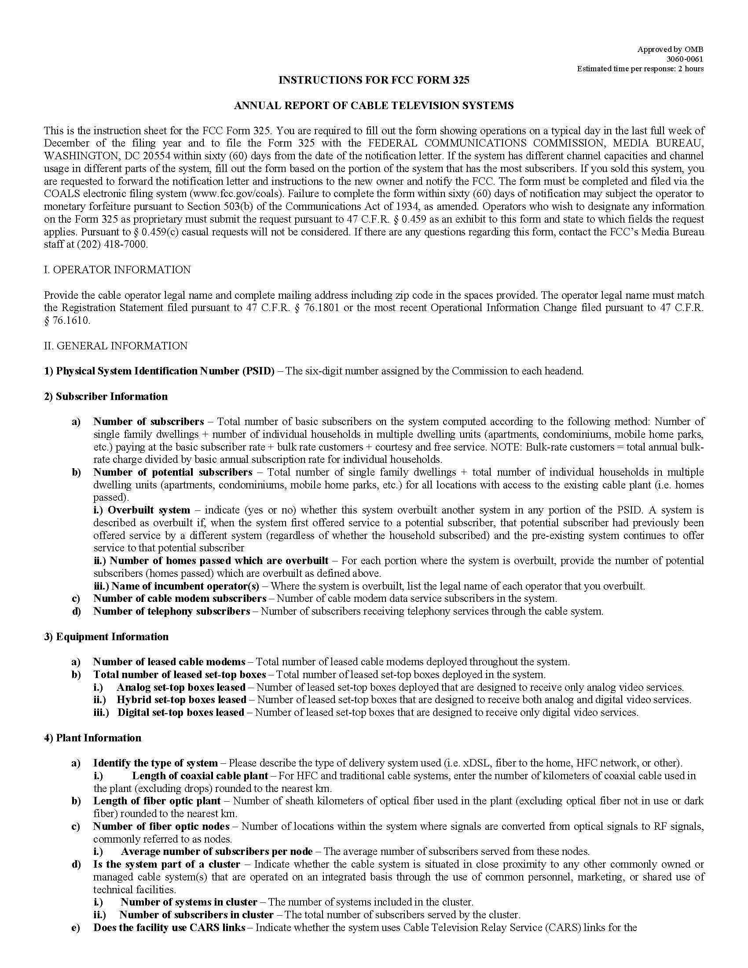
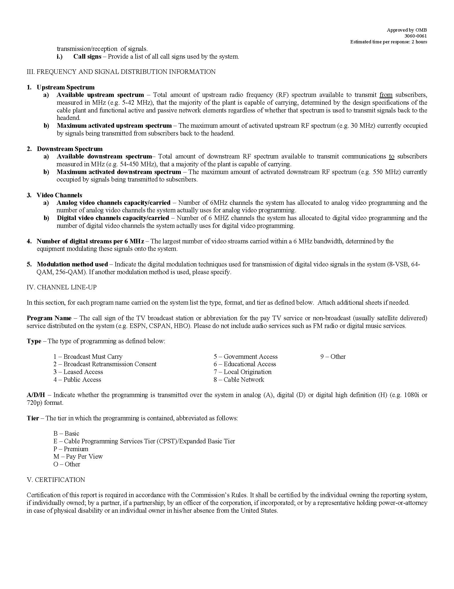

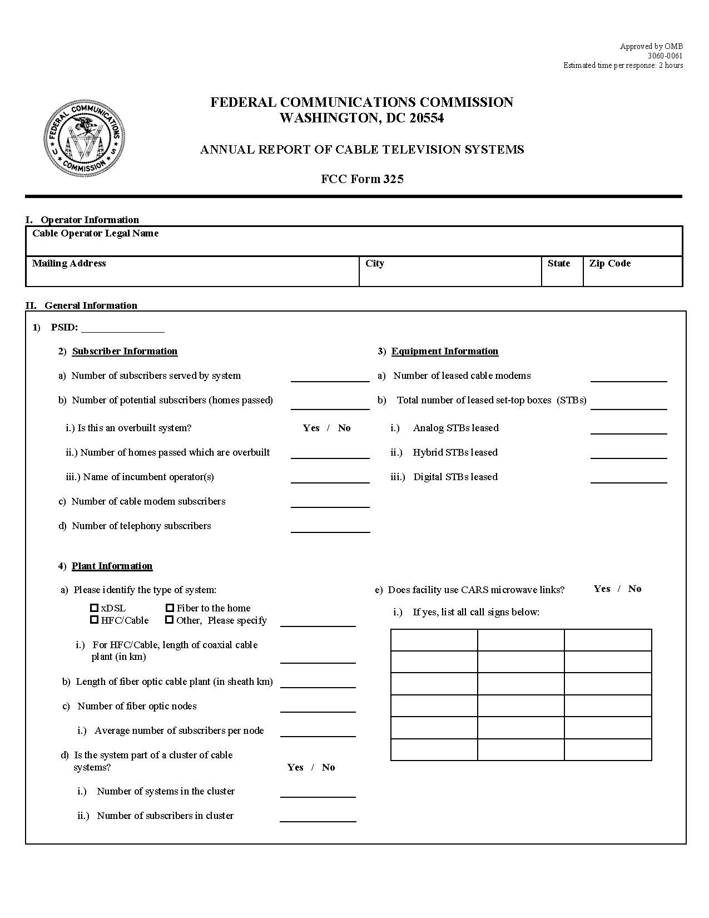

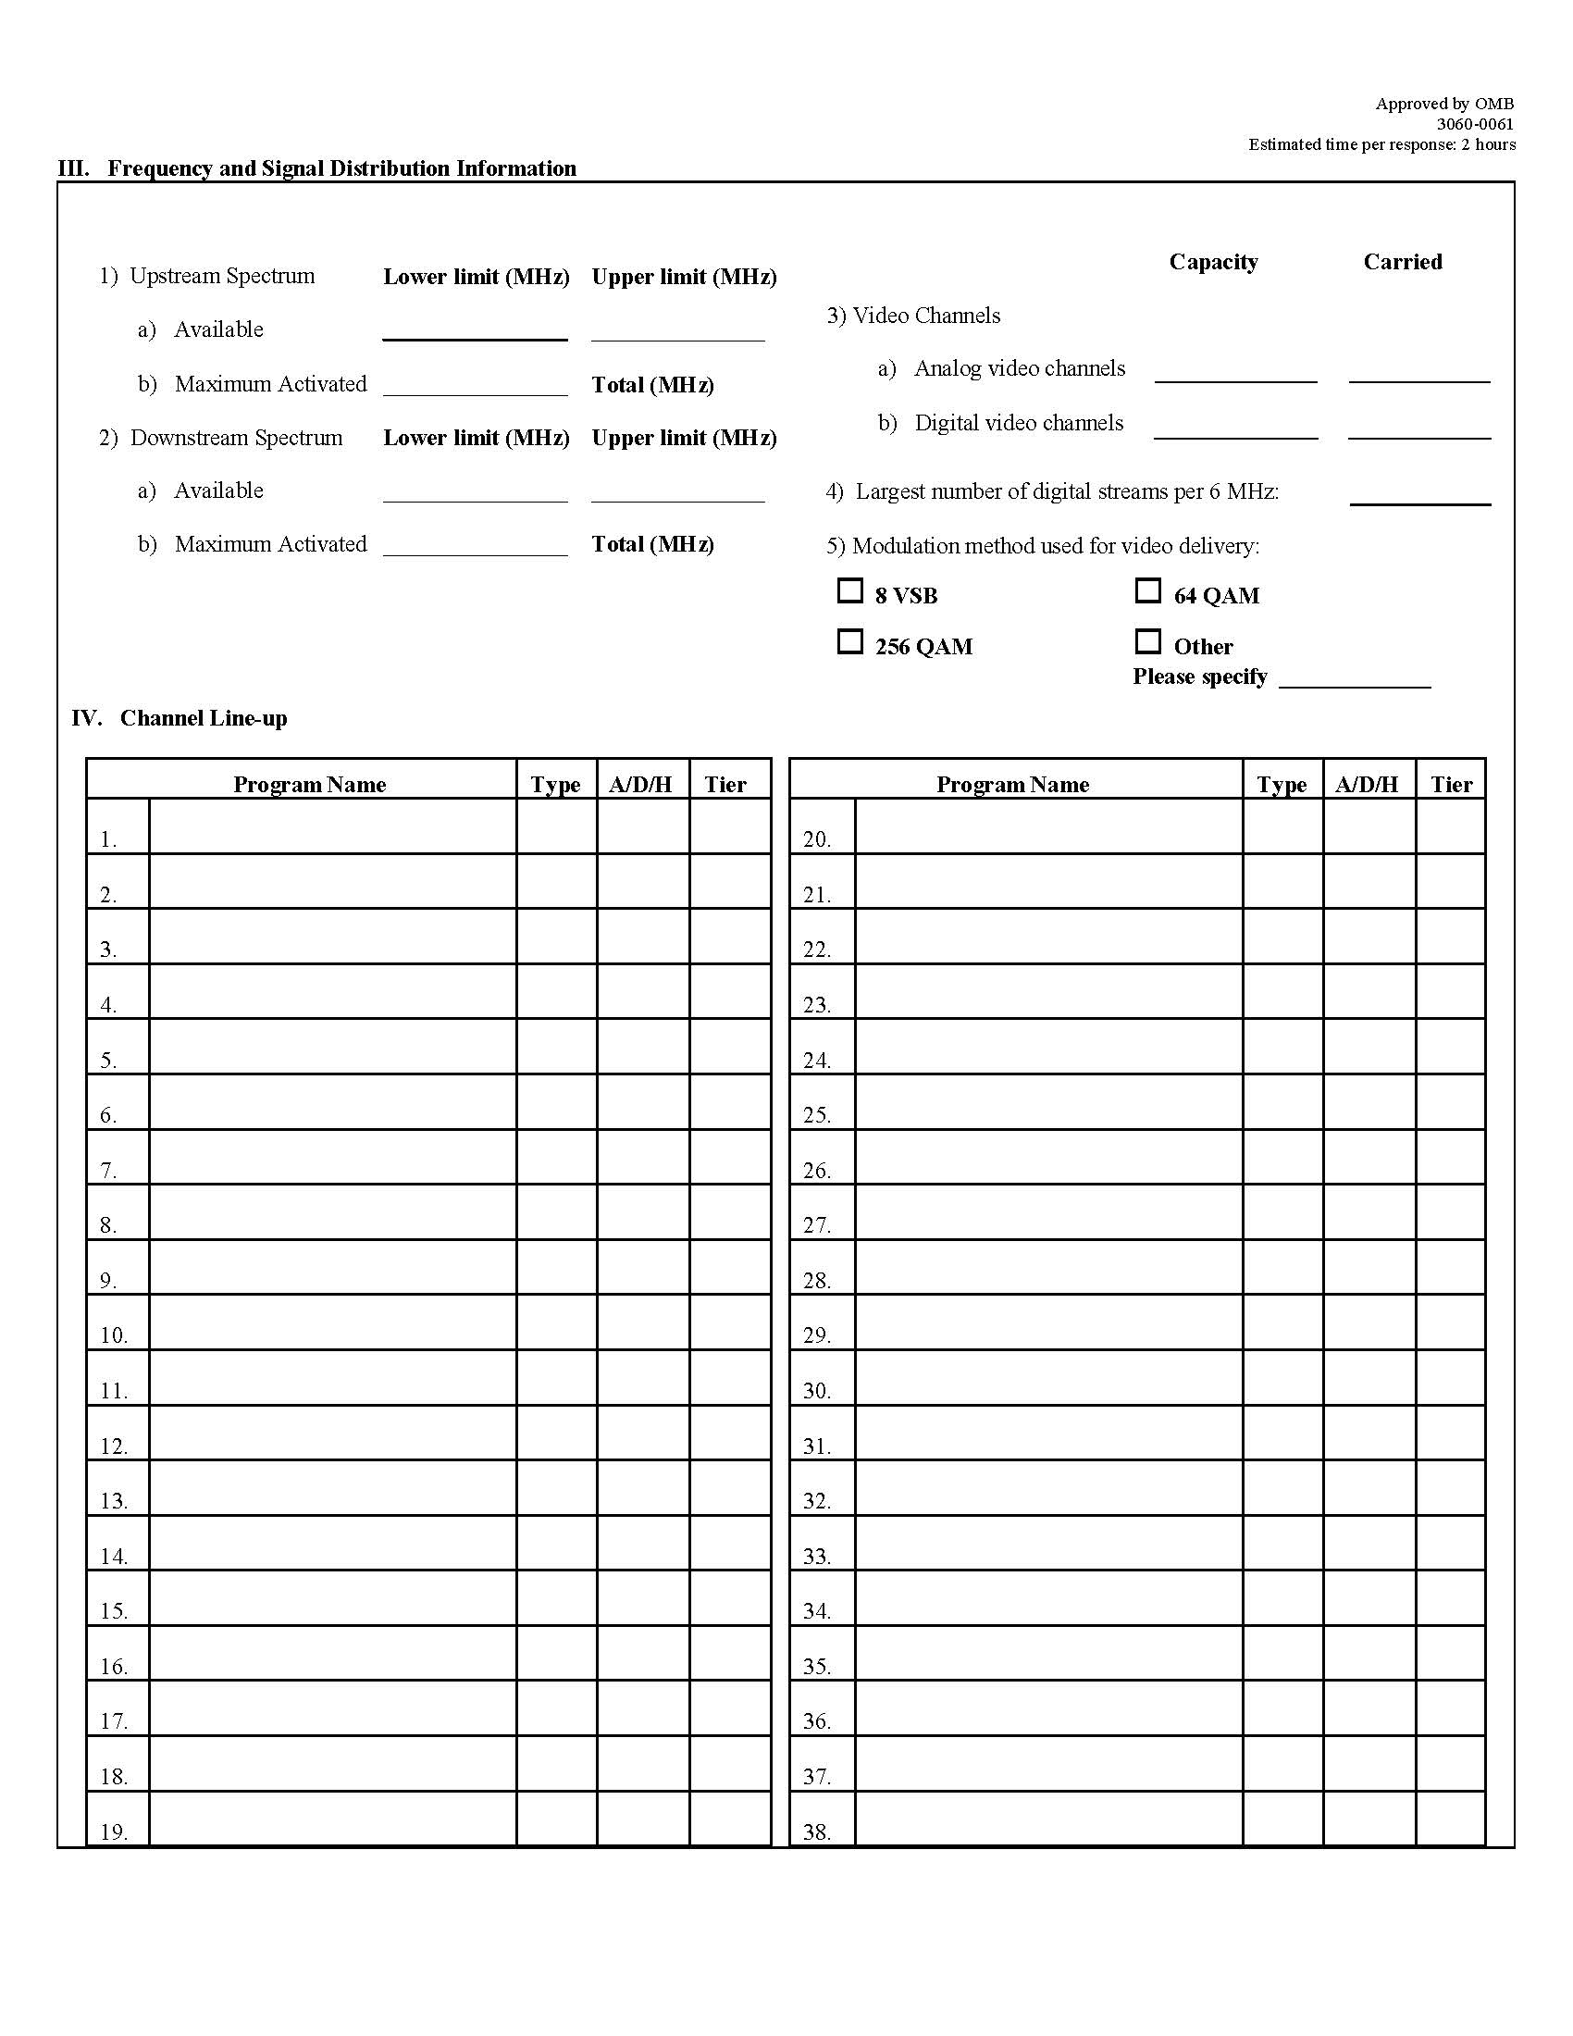

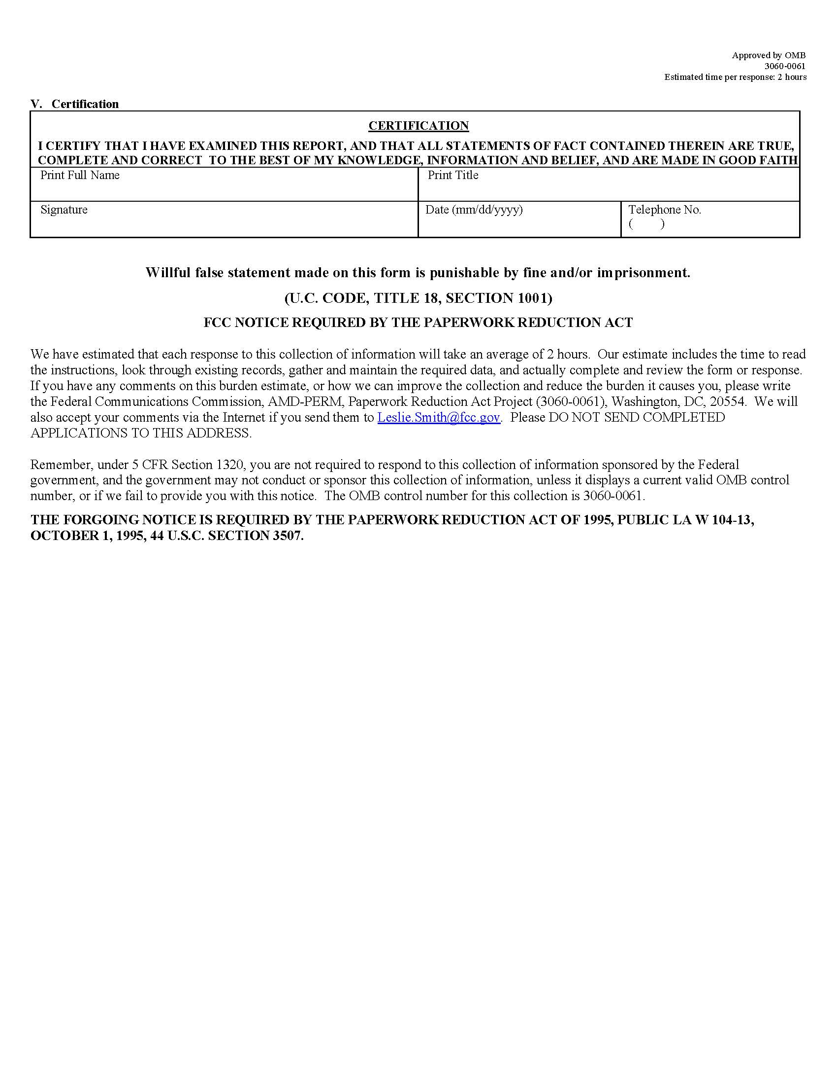

STATEMENT OF
CHAIRMAN AJIT PAI
Re: FCC Form 325 Data Collection, MB Docket No. 17-290; Modernization of Media Regulation Initiative, MB Docket No. 17-105.
The last time the Commission updated its Form 325 reporting requirements for cable television systems, The Sopranos had barely inched into its first season. And while today the show is still rated by critics as one of the best TV dramas of all time, the FCC’s Form 325 has not aged as well.
Over the past 18 years, the cable industry has changed significantly with the evolution of technology and changes in service offerings. Moreover, data about cable operators has become increasingly available from various commercial sources. Many have called for the Commission to acknowledge these changes by eliminating burdensome Form 325 annual MVPD reporting requirements. This Notice responds to those calls, and invites public input on streamlining or eliminating the data collection. This is the third Notice stemming from our Modernization of Media Regulation Initiative, and it sends an important message: Don’t stop believin’ in our commitment to update our rules.
Thank you to Steven Broeckaert, Michelle Carey, Martha Heller, Maria Mullarkey, and Mary Beth Murphy of the Media Bureau, and Susan Aaron and Dave Konczal from the Office of General Counsel for your efforts on this Notice.
STATEMENT OF
COMMISSIONER MIGNON L. CLYBURN
Re: FCC Form 325 Data Collection, MB Docket No. 17-290; Modernization of Media Regulation Initiative, MB Docket No. 17-105.
A data-driven agency uses and collects that data, to help inform decision-making as it serves the public interest. So, taking a look under the hood to determine whether we are asking the right questions and collecting the information needed to support the Commission’s work, is a concept I fully endorse.

As a general matter, I believe more data is better than less, so I will always look twice when an annually required form is proposed to be eliminated. For example, data on the number of leased set-top boxes deployed in a given cable television system can help us determine whether the goals of Section 629 are being achieved. Questions about whether a system is overbuilt by a competing cable system can provide insight into the state of competition in the video marketplace.

But to ensure that we build a thorough record, I asked my colleagues to include several additional questions in this NPRM. Included is whether eliminating Form 325 would hinder the Commission’s ability to evaluate the state of competition among cable systems? Whether any information contained in Form 325 is specifically helpful to consumers and if it is possible to make this data publicly available sooner than the current three-year timeframe?

I thank the Chairman for agreeing to my edits and the Media Bureau staff for teeing up this item.
STATEMENT OF
COMMISSIONER MICHAEL O’RIELLY

Re: FCC Form 325 Data Collection, MB Docket No. 17-290; Modernization of Media Regulation Initiative, MB Docket No. 17-105.
I am pleased to see the Commission take another step forward in modernizing our media regulations. Up this month, we have an annual reporting form that cable providers with over 20,000 subscribers, as well as a random sampling of the smallest cable providers, must file. All of this information is publicly available from a host of alternative sources, including SNL Kagan, Nielson, and Warren Communications, does not reflect today’s competitive video marketplace, does not apply to cable competitors, and does not serve an actual purpose. In fact, it is unclear whether the FCC actually uses the data provided. For these reasons, no commenters argued in favor of maintaining the form.

Based on the above, it is curious to me why we did not at least tentatively conclude to eliminate this form altogether. Instead, the Commission meticulously analyzes each section of the form. Because I believe the end result will be the same—that the record will support full elimination—I support the item. Moreover, I thank the Chairman for adding a few tentative conclusions that key parts of this form should be eliminated.

From a larger perspective, I am pleased to see the Commission tackle an outdated cable regulation this month. I hope we will see more of these in the future. In fact, we should package a host of ideas provided in the record into our next item. For example, the Commission should eliminate the EEO Public Inspection File website posting requirement on cable operators. The Commission already requires cable operators to maintain certain EEO reports in their public files, which are housed in a Commission-hosted online database. It is duplicative to also require this information on the company’s website.

I also support, whenever possible, clarifying in our rules that “written” notice can be electronic notice. This includes notices cable distributors are required to provide to broadcasters under the retransmission consent process or in response to consumer complaints, particularly when the consumer provides an e-mail address on the complaint and does not request a response in a different format. Updating our requirements from paper notices to electronic notices is the essence of modernization.

I personally think all of these items could be teed up in one Notice of Proposed Rulemaking in order to quickly advance these smaller procedural items. That way, we can get to some of the bigger ideas proposed in the record. I remind my colleagues that unnecessary costs imposed on businesses that we regulate are passed on to the consumer in one form or another, many on a monthly basis. Therefore, it is certainly in the public interest to tackle these issues, and to do so quickly.
STATEMENT OF
COMMISSIONER BRENDAN CARR
Re: FCC Form 325 Data Collection, MB Docket No. 17-290; Modernization of Media Regulation Initiative, MB Docket No. 17-105.
With this item, we take another step toward reducing unnecessary paperwork burdens. According to the Office of Management and Budget, the costs associated with the Commission’s current information collections exceed $790 million annually. It’s far from clear that this hefty price tag is worth it. That’s why I’m pleased that this Commission has been reevaluating the necessity and utility of a number of our reporting requirements. Today is no different. Specifically, we seek comment on whether to streamline or eliminate FCC Form 325, which the agency has used to collect operational data about cable systems.
Cable providers have advocated for the elimination of this Form in the media modernization proceeding. They contend that routine collection of this data is unnecessary today, especially when their satellite and online video competitors are not saddled with a similar obligation. They also express concern about the burden and uncertainty imposed on smaller cable operators who are randomly selected (lucky them) each year to complete the Form. We should allow these service providers to focus their time and resources on competing for customers in today’s dynamic video marketplace, not filling out FCC forms. So I’m glad that we’re initiating this rulemaking to reduce or eliminate this reporting burden and this item has my support. I hope that we will act swiftly based on the record we receive.

Earlier this year, the Commission launched a proceeding to review its rules applicable to media entities and eliminate or modify regulations that are outdated, unnecessary, or unduly burdensome. See FCC, Public Notice, Commission Launches Modernization of Media Regulation Initiative, 32 FCC Rcd 4406 (2017). This proceeding also follows the direction of the staff’s 2014 report on process reform, which states that “the Commission should initiate a rulemaking to update FCC Form 325, capturing data more reflective of the current MVPD marketplace and technologies.” See Federal Communications Commission, Report on FCC Process Reform, at 74 (Feb. 14, 2014), available at https://www.fcc.gov/article/da-14-199a2. This proceeding furthers several of the goals enunciated by Commission staff in that report, including streamlining an agency data collection to “lessen burdens on regulatees, FCC staff and the public” and improving interactions with external stakeholders. Id. at 4. See also Remarks of FCC Chairman Ajit Pai at the Hudson Institute, The Importance of Economic Analysis at the FCC, at 4 (Apr. 5, 2017), available at https://www.fcc.gov/document/chairman-pai-economic-analysis-communications-policy (observing that data collection at the Commission should be improved to enable better informed decisions and noting that certain reporting requirements that are duplicative or unnecessary impose high costs on industry).
See Comments of the American Cable Association, MB Docket No. 17-105, at 26-27 (ACA Comments); Comments of NCTA – The Internet and Television Association, MB Docket No. 17-105, at 29-30 (NCTA Comments); Comments of Verizon, MB Docket No. 17-105, at 17-18 (Verizon Comments).
See 47 CFR § 76.403. The FCC Form 325 is available via the Commission’s website at http://www.fcc.gov/forms or https://fcc.gov/coals/. See Appendix B.
47 CFR § 76.403.
See id. In recent years, this notification letter has been emailed to cable systems. Follow up notifications to operators that fail to file on time are sent via certified mail.
See FCC, Public Information Collection Requirement Submitted to OMB for Review and Approval, Comments Requested, Notice, 73 FR 50814 (Aug. 28, 2008) (describing refinements made to Form 325).
FCC, Public Notice, Media Bureau Implements Mandatory Electronic Filing of FCC Forms 320, 322, 324, and 325 Via COALS, 19 FCC Rcd 13053 (MB 2004).
Amendment of Subpart L, Part 91, to Adopt Rules and Regulations to Govern the Grant of Authorizations in the Business Radio Service for Microwave Stations to Relay Television Signals to Community Antenna Systems; Amendment of Subpart I, Part 21, to Adopt Rules and Regulations to Govern the Grant of Authorizations in the Domestic Public Point-To-Point Microwave Radio Service for Microwave Stations Used to Relay Television Broadcast Signals to Community Antenna Television Systems; Amendment of Parts 21, 74, and 91 to Adopt Rules and Regulations Relating to the Distribution of Television Broadcast Signals By Community Antenna Television Systems, and Related Matters, Second Report and Order, 2 FCC 2d 725, 765, para. 99 (1966). The 1966 Form 325 requested ownership information, number of subscribers, broadcast signal carriage, program origination data, certain financial data, and a map of the system.
Amendment of Part 74, Subpart K, of the Commission’s Rules and Regulations Relative to Community Antenna Television Systems; and Inquiry Into the Development of Communications Technology and Services to Formulate Regulatory Policy and Rulemaking and/or Legislative Proposals, Third Report and Order, 32 FCC 2d 13, 14, para. 5 (1971).
Id. at 13, para. 2.
Id. at 14, para. 5 (finding that “excusing small systems from filing certain data would deprive the Commission of the very information which it lacks”). In 1972, the Commission adopted rules governing the Cable Television Service, which included the annual Form 325 reporting requirement. See Amendment of Part 74, Subpart K, of the Commission’s Rules and Regulations Relative to Community Antenna Television Systems; and Inquiry into the Development of Communications Technology and Services to Formulate Regulatory Policy and Rulemaking and/or Legislative Proposals; Amendment of Section 74.1107 of the Commission’s Rules and Regulations to Avoid Filing of Repetitious Requests; Amendment of Section 74.1031(c) and 74.1105(a) and (b) of the Commission’s Rules and Regulations As They Relate to Addition of New Television Signals; Amendment of Part 74, Subpart K, of the Commission’s Rules and Regulations Relative to Federal–State or Local Relationships in the Community Antenna Television System Field; and/or Formulation of Legislative Proposals in this Respect; Amendment of Subpart K of Part 74 of the Commission’s Rules and Regulations With Respect to Technical Standards for Community Antenna Television Systems, Report and Order, 36 FCC 2d 143 (1972) (adopting 47 CFR § 76.401). Before 1976, cable operators were required to file the form on a fixed date (on or before March 1). 47 CFR § 76.401. In 1976, the Commission changed the process to facilitate data automation, sending cable operators a pre-filled form that cable operators corrected and returned to the Commission within 60 days. See Amendment of Part 76 of the Commission’s Rules and Regulations to Alter Cable Television Reporting Requirements, Order, 61 FCC 2d 1014 (1976). At this time, the Commission also moved the Form 325 reporting requirement to its current location at Section 76.403 of the rules. See id. (adopting 47 CFR § 76.403). This process remained in place until 2005, when operators were required to file the form electronically via COALS.
1998 Biennial Regulatory Review --“Annual Report of Cable Television Systems,” Form 325, Filed Pursuant to Section 76.403 of the Commission’s Rules, Report and Order, 14 FCC Rcd 4720 (1999) (1999 Form 325 Order).
Id. at 4725-26, para. 12.
Id. at 4725, para. 11. But see id. at 4742-43 (Statements of Commissioners Furchtgott-Roth and Powell dissenting from the Commission’s decision not to eliminate Form 325).
Id. at 4722, para. 4.
Id. at 4726, para. 12.
1998 Biennial Regulatory Review --“Annual Report of Cable Television Systems,” Form 325, Filed Pursuant to Section 76.403 of the Commission’s Rules, Notice of Proposed Rulemaking, 13 FCC Rcd 12266, 12268, para. 6 (1998). Specifically, the Commission sought comment “on whether it continues to be important for the Commission to have access to the type of data reported on the current Form 325 and the extent to which this information is available from other sources.” Id. In response, two commenters argued in favor of keeping the form—the Institute for Public Representation, which argued that the information in the form is critical to the Commission’s assessment of cable operator compliance with horizontal integration, must carry, and leased access rules, and the National Association of Broadcasters, which argued that the information would be needed for purposes of the Commission’s digital television must carry rulemaking proceeding. 1999 Form 325 Order, 14 FCC Rcd at 4724-25, paras. 9-10. Other industry commenters argued that the form serves no identifiable regulatory or policy purpose, is burdensome to the cable industry, and contains information that can be obtained from alternative sources, including data published by commercial resources or available through other government filings. Id. at 4722-24, paras. 5-8.
1999 Form 325 Order, 14 FCC Rcd at 4725, 4727, paras. 11, 14-15. See also 1998 Biennial Regulatory Review --“Annual Report of Cable Television Systems,” Form 325, Filed Pursuant to Section 76.403 of the Commission’s Rules, Order on Reconsideration, 15 FCC Rcd 9707 (2000). With respect to the argument that certain information on Form 325 is available from other sources, the Commission observed that there are no assurances such information is current or collected consistently by commercial entities, and it noted that having current and accurate information available to the Commission is “of considerable importance.” 1999 Form 325 Order, 14 FCC Rcd at 4727, paras. 14-15.
NCTA Comments at 30. See also ACA Comments at 27 (noting that the Commission does not request similar data from DBS providers or competitive video entrants that are not registered in the COALS database).
NCTA Comments at 30.
ACA Comments at 27. See also Reply Comments of the American Cable Association, MB Docket No. 17-105, at 9-10.
ACA Comments at 27.
Verizon Comments at 17-18. See also Reply Comments of Verizon, MB Docket No. 17-105, at 6.
Reply Comments of ITTA – The Voice of America’s Broadband Providers, MB Docket No. 17-105, at 8-9 (ITTA Reply).
1999 Form 325 Order, 14 FCC Rcd at 4729, para. 22.
See Implementation of Section 3 of the Cable Television Consumer Protection and Competition Act of 1992; Statistical Report on Average Rates for Basic Service, Cable Programming Service, and Equipment, Report on Cable Industry Prices, 31 FCC Rcd 11498, 11509, para. 21, table 6 (2016).
For example, Form 325 solicits information on the number of cable modem (i.e., broadband) subscribers and the number of telephony subscribers for each cable system, and Form 477 collects information on the number of broadband and telephony subscribers by census tract. See Appendix B; FCC Form 477, Local Telephone Competition and Broadband Reporting, Instructions, Section 5: Completing Each Section of FCC Form 477 (Dec. 5, 2016), available at https://transition.fcc.gov/form477/477inst.pdf.
See infra note 32.
Form 325 data has been cited in the Commission’s annual video competition reports, for example, to show the growth in the number of all-digital cable systems and the percentage of households passed by incumbent cable systems as well as the percentage of households passed that subscribe to these systems. See, e.g., Annual Assessment of the Status of Competition in the Market for the Delivery of Video Programming, Sixteenth Report, 30 FCC Rcd 3253, 3287-88, para. 79, tables 3-4 (2015) (using Form 325 data to show the growth in all-digital cable systems for cable systems with more than 20,000 subscribers and for the sampling of cable systems with between 5,000 and 20,000 subscribers); Annual Assessment of the Status of Competition in the Market for the Delivery of Video Programming, Fourteenth Report, 27 FCC Rcd 8610, 8641-42, 8658, paras. 70, 116, n.350 (2012) (citing Form 325 data to show the percentage of households passed by incumbent cable systems that subscribe to these systems as well as the number of very small cable systems (fewer than 5,000 subscribers) surveyed that offer neither Internet access nor television access). In addition, Form 325 data has been cited as a source in the Commission’s annual reports on cable industry prices. See, e.g., Implementation of Section 3 of the Cable Television Consumer Protection and Competition Act of 1992; Statistical Report on Average Rates for Basic Service, Cable Programming Service, and Equipment, Report on Cable Industry Prices, 31 FCC Rcd 11498, 11515, attach. 1 (2016) (citing Form 325 data for the numbers of cable communities by each sampling group (i.e., noncompetitive group and effective competition group)). The Commission has used Form 325 data to inform other reports to Congress. See, e.g., In-State Broadcast Programming: Report to Congress Pursuant to Section 304 of the Satellite Television Extension and Localism Act of 2010, Report, 26 FCC Rcd 11919, 11942-43, para. 42 (2011) (using Form 325 data to determine the carriage of in-state broadcast stations on cable systems).
See also infra Section III.C (seeking comment on the relative burdens and benefits of applying the Form 325 requirement to smaller cable systems).
See, e.g., Annual Assessment of the Status of Competition in the Market for the Delivery of Video Programming, Eighteenth Report, 32 FCC Rcd 568 (2017) (citing data from Nielsen, BIA/Kelsey, and SNL Kagan throughout as support for multiple data points regarding MVPDs, broadcast television stations, and online video distributors); Cable Television Technical and Operational Standards, Report and Order, MB Docket No. 12-217, FCC 17-120, at 2, 35, para. 3, app. C, para. 8 & nn.16, 18 (rel. Sept. 25, 2017) (citing data from SNL Kagan on the percentage of cable video customers that subscribe to digital service, and data from Warren Communications Television & Cable Factbook on the number of cable systems by subscriber size).
In a recent channel sharing order, the Commission reviewed data collected from the 2015 Form 325 filing to determine the number of low power television (LPTV) and Class A stations carried on cable systems pursuant to mandatory carriage. Expanding the Economic and Innovation Opportunities of Spectrum Through Incentive Auctions; Amendment of Parts 73 and 74 of the Commission’s Rules to Establish Rules for Digital Low Power Television and Television Translator Stations; Channel Sharing by Full Power and Class A Stations Outside the Broadcast Television Spectrum Incentive Auction Context, Report and Order, 32 FCC Rcd 2637, 2645, para. 12, n.47 (2017). See also Carriage of Digital Television Broadcast Signals: Amendment to Part 76 of the Commission’s Rules, Fourth Further Notice of Proposed Rulemaking and Declaratory Order, 27 FCC Rcd 1713, 1717-18, 1722, 1728-29, para. 9-10, 20, nn.32-33, 36, 66-68, app. B (2012) (using Form 325 data to determine the number of cable subscribers served by all-digital systems, the number of broadcast stations that elect or default to must carry on cable systems, and the number of small cable systems relying on the HD carriage exemption). Further, the Commission has used Form 325 data to evaluate and craft exemptions in rulemaking proceedings implementing accessibility rules pursuant to the Twenty-First Century Communications and Video Accessibility Act of 2010. See Accessibility of User Interfaces, and Video Programming Guides and Menus; Accessible Emergency Information, and Apparatus Requirements for Emergency Information and Video Description: Implementation of the Twenty-First Century Communications and Video Accessibility Act of 2010, Report and Order and Further Notice of Proposed Rulemaking, 28 FCC Rcd 17330, 17405, para. 117, n.473 (2013) (citing Form 325 data for its estimate of the number of subscribers that would be affected by a longer phase-in period for smaller and mid-sized cable systems and operators in a 2013 order adopting accessible user interfaces requirements); Closed Captioning of Internet Protocol-Delivered Video Programming: Implementation of the Twenty-First Century Communications and Video Accessibility Act of 2010, Report and Order, 27 FCC Rcd 787, 843, para. 96, n.382 (2012) (using information collected via Form 325 on the number of deployed set-top boxes to conclude that applying IP closed captioning rules only to devices with built-in screens would exclude one of the most common means by which consumers view programming).
We also note that Form 325 filings are made available to the public via COALS three years after initial filing.
Part V of Form 325 requires certification that all statements of fact contained on the form are true, complete, and correct to the best of the certifying official’s knowledge, information, and belief, and are made in good faith.
See infra para. 24 (explaining that Form 325 filings and the information contained therein generally are not made available to the public until three years after filing, but are made public via COALS thereafter).
See supra notes 29, 32. But see Verizon Comments at 17 (“[I]nformation on subscriber counts and ‘homes passed’ by cable systems does not reflect consumer video viewing patterns or the competitive nature of the video distribution market.”).
See, e.g., Implementation of the Commercial Advertisement Loudness Mitigation (CALM) Act, Report and Order, 26 FCC Rcd 17222, 17244-46, 17253-54, paras. 35-37, 52-54 (2011) (allowing MVPD systems with fewer than 15,000 subscribers and that are not affiliated with a larger operator serving more than 10 percent of all MVPD subscribers to file streamlined financial hardship waivers to delay compliance from CALM Act rules for up to two years and excusing MVPD operators with fewer than 400,000 subscribers from the requirement to perform annual spot checks); Accessibility of User Interfaces, and Video Programming Guides and Menus; Accessible Emergency Information, and Apparatus Requirements for Emergency Information and Video Description: Implementation of the Twenty-First Century Communications and Video Accessibility Act of 2010, Report and Order and Further Notice of Proposed Rulemaking, 28 FCC Rcd 17330, 17401, para. 114 (2013) (granting a five-year delayed compliance deadline to MVPD operators with 400,000 or fewer subscribers and to MVPD systems with 20,000 or fewer subscribers that are not affiliated with an operator serving more than 10 percent of all MVPD subscribers).
See Form 477 Resources for Filers, https://www.fcc.gov/general/form-477-resources-filers. Links to instructions detailing the data collected on the form and screen-shots of the form are provided at this location. Form 477 collects data semi-annually about broadband connections to end-user locations, wired and wireless local telephone services, and interconnected Voice over Internet Protocol (VoIP), and it requires all covered providers to file, regardless of size. See Modernizing the FCC Form 477 Data Collection, Further Notice of Proposed Rulemaking, 32 FCC Rcd 6329, 6330, para. 2 (2017).
See Instructions for FCC Form 325, Annual Report of Cable Television Systems, Section II.2.a (General Information, Subscriber Information, Number of Subscribers).
Section 629(a) directs the Commission to “adopt regulations to assure the commercial availability . . . of . . . equipment used by consumers to access multichannel video programming and other services offered over multichannel video programming systems” from sources other than the multichannel video programming distributor. 47 U.S.C. § 549(a). Section 629(e) states that the regulations will sunset “when the Commission determines that— (1) the market for the multichannel video programming distributors is fully competitive; (2) the market for converter boxes, and interactive communications equipment, used in conjunction with that service is fully competitive; and (3) elimination of the regulations would promote competition and the public interest.” Id. § 549(e).
See GAO Report, Video Programming: FCC Should Conduct Additional Analysis to Evaluate Need for Set-Top Box Regulation, at 22-23 (Sept. 2017) (recommending that the FCC, “as part of its future annual video competition reports, analyze how the ongoing evolution in the video programming market affects competition in the related market for set-top boxes and devices, including how this evolution affects the extent to which consumer choice for devices to access MVPD content remains a relevant aspect of the competitive environment”).
For example, we could require cable systems to report only those types of channels that relate to certain Commission regulatory requirements, which will allow the Commission to evaluate the effectiveness of these rules and facilitate enforcement. This would include broadcast must carry stations, including local commercial stations, qualified local non-commercial educational (NCE) stations, and qualified LPTV or Class A stations; broadcast retransmission consent stations, including local commercial stations, significantly-viewed stations, distant (out-of-market) stations, and qualified LPTV or Class A stations; leased access; public access; government access; educational access; and local origination. See, e.g., 47 CFR §§ 76.55, 76.56, 76.64, 76.970, 76.971.
The instructions to Form 325 specify that “program name” refers to “[t]he call sign of the TV broadcast station or abbreviation for the pay TV service or non-broadcast (usually satellite delivered) service distributed on the system (e.g. ESPN, CSPAN, HBO).”
See 47 CFR § 76.403.
Staff analysis of 2016 Form 325 Annual Report of Cable Television Systems. For the 2016 filing year, 544 cable systems with fewer than 20,000 subscribers were selected to file Form 325. Of those, 354 were cable systems with between 5,000 and 20,000 subscribers, and 190 were cable systems with fewer than 5,000 subscribers.
ACA Comments at 27. See also ITTA Reply at 9, n.33.
ACA Comments at 27. See also NCTA Comments at 30 (“Operators devote many hours to completion of the filing for each PSID every year.”).
See Carriage of Digital Television Broadcast Signals: Amendment to Part 76 of the Commission’s Rules, Sixth Report and Order, 30 FCC Rcd 6653, 6656, para. 4 (2015).
See 47 CFR § 76.403.
See supra note 11.
Cable operators, cognizant of potentially sensitive information disclosed on the form, often request that all or portions of the form not be made routinely available to the public pursuant to Section 0.459 of the Commission’s rules. See, e.g., Request for Confidentiality for Information Submitted on Forms 325 for the Year 2004, Order, 21 FCC Rcd 2312 (MB 2006) (Request for Confidentiality). See also 47 CFR §§ 0.459, 0.461. The Media Bureau has recognized that information on Form 325 is commercial in nature and, in the past, has made the determination of whether to keep commercial information confidential on a case-by-case basis by determining whether there is a “preponderance of the evidence that shows that disclosure of the information will cause the parties substantial competitive harm.” Request for Confidentiality, 21 FCC Rcd at 2313, para. 4.
Filers of FCC Form 477 are instructed that they may submit a request that certain information in the submission not be made routinely available for public inspection by so indicating in the “Filer Identification Information” for that submission. See FCC Form 477, Local Telephone Competition and Broadband Reporting, Instructions, Section 7.4: Requesting Confidentiality, at 32 (Dec. 5, 2016), available at https://transition.fcc.gov/form477/477inst.pdf. See also Modernizing the FCC Form 477 Data Program, Further Notice of Proposed Rulemaking, 32 FCC Rcd 6329, 6346-48, paras. 51-55 (2017) (seeking comment on proposals that certain data collected in the Form 477 that are not commercially sensitive but are currently treated as confidential be made public).
See 5 U.S.C. § 603. The RFA, see 5 U.S.C. § 601 et seq., has been amended by the Small Business Regulatory Enforcement Fairness Act of 1996 (SBREFA), Pub. L. No. 104-121, Title II, 110 Stat. 857 (1996). The SBREFA was enacted as Title II of the Contract with America Advancement Act of 1996 (CWAAA).
47 CFR §§ 1.1200 et seq.
See 5 U.S.C. § 603. The RFA, see 5 U.S.C. §§ 601-612, has been amended by the Small Business Regulatory Enforcement Fairness Act of 1996 (SBREFA), Pub. L. No. 104-121, Title II, 110 Stat. 857 (1996). The SBREFA was enacted as Title II of the Contract With America Advancement Act of 1996 (CWAAA).
See 5 U.S.C. § 603(a).
See id.
5 U.S.C. § 603(b)(3).
Id. § 601(6).
Id. § 601(3) (incorporating by reference the definition of “small-business concern” in 15 U.S.C. § 632). Pursuant to 5 U.S.C. § 601(3), the statutory definition of a small business applies “unless an agency, after consultation with the Office of Advocacy of the Small Business Administration and after opportunity for public comment, establishes one or more definitions of such term which are appropriate to the activities of the agency and publishes such definition(s) in the Federal Register.” 5 U.S.C. § 601(3).
15 U.S.C. § 632.
47 CFR § 76.901(e). The Commission determined that this size standard equates approximately to a size standard of $100 million or less in annual revenues. Implementation of Sections of the 1992 Cable Act: Rate Regulation, Sixth Report and Order and Eleventh Order on Reconsideration, 10 FCC Rcd 7393, 7408 (1995).
These data are derived from: R.R. Bowker, Broadcasting & Cable Yearbook 2006, “Top 25 Cable/Satellite Operators,” pages A-8 & C-2 (data current as of June 30, 2005); Warren Communications News, Television & Cable Factbook 2006, “Ownership of Cable Systems in the United States,” pages D-1805 to D-1857.
47 CFR § 76.901(c).
Warren Communications News, Television & Cable Factbook 2008, “U.S. Cable Systems by Subscriber Size,” page F-2 (data current as of Oct. 2007). The data do not include 851 systems for which classifying data were not available.
47 U.S.C. § 543(m)(2); see also 47 CFR § 76.901(f) & nn.1–3.
47 CFR § 76.901(f); see FCC Announces New Subscriber Count for the Definition of Small Cable Operator, Public Notice, 16 FCC Rcd 2225 (Cable Services Bureau 2001).
These data are derived from R.R. Bowker, Broadcasting & Cable Yearbook 2006, “Top 25 Cable/Satellite Operators,” pages A-8 & C-2 (data current as of June 30, 2005); Warren Communications News, Television & Cable Factbook 2006, “Ownership of Cable Systems in the United States,” pages D-1805 to D-1857.
The Commission does receive such information on a case-by-case basis if a cable operator appeals a local franchise authority’s finding that the operator does not qualify as a small cable operator pursuant to § 76.901(f) of the Commission’s rules.
See 47 U.S.C. § 573.
47 U.S.C. § 571(a)(3)-(4). See 13th Annual Report, 24 FCC Rcd at 606, para. 135.
See 47 U.S.C. § 573.
U.S. Census Bureau, 2012 NAICS Definitions, 517110 Wired Telecommunications Carriers, http://www.census.gov/naics/2012/def/ND517110.HTM#N517110.
13 CFR § 201.121, NAICS code 517110 (2012).
See U.S. Census Bureau, Table EC1251SSSZ5, https://factfinder.census.gov/faces/nav/jsf/pages/searchresults.xhtml?refresh=t#none.
A list of OVS certifications may be found at http://www.fcc.gov/mb/ovs/csovscer.html.
See 13th Annual Report, 24 FCC Rcd at 606-07 para. 135. BSPs are newer firms that are building state-of-the-art, facilities-based networks to provide video, voice, and data services over a single network.
See http://www.fcc.gov/encyclopedia/current-filings-certification-open-video-systems (current as of July 2012).
See 13 CFR § 121.201, NAICS code 517110 (2012).
Although SMATV systems often use DBS video programming as part of their service package to subscribers, they are not included in Section 340’s definition of “satellite carrier.” See 47 U.S.C. §§ 340(i)(1) and 338(k)(3); 17 U.S.C. §119(d)(6).
13 CFR § 121.201, NAICS code 517110 (2012).
U.S. Census Bureau, Table EC1251SSSZ5, https://factfinder.census.gov/faces/nav/jsf/pages/searchresults.xhtml?refresh=t#none.
5 U.S.C. § 603(c)(1)-(c)(4).
NCTA Comments at 28–29.
MMTC Reply Comments at 4; ACA Reply Comments 5–7.
NCTA Comments 10–11; see also MMTC Comments at 3.

