Public Safety and Homeland Security Bureau
Cybersecurity and Communications Reliability Division
Summary of 911 Certification Data for 2017

Table of Contents

Introduction 1
I. 911 Circuit Diversity 2
II. Backup Power 5
III. Network Monitoring 7
Conclusion 8

Figure
Figure 1: Overall Responses to 911 Certifications 2
Tables
Table 1: Overall Certification - Circuit Audit Results 3
Table 2: Number of PSAPs with Various Alternative Measures 3
Table 3: Number of PSAPS with Other Various Alternative Measures 4
Table 4: Overall Certification – Central Office Backup Power Results 5
Table 5: Summary of the Alternative Measures for Meeting the Backup Power Requirement 6
Table 6: Overall Certification - Diverse Monitoring Results 7
Table 7: Number of 911 Service Areas with Certified Diverse Monitoring 8

Introduction
The Federal Communications Commission (Commission or FCC) helps ensure the reliability of 911 networks by requiring 911 service providers to certify whether they have implemented measures designed to prevent a loss of 911 service to the public. The Commission’s 911 certification rules apply to communications service providers that offer 911, E911 or NG911 capabilities such as call routing, automatic location information, and automatic number identification or their functional equivalent directly to a public safety answering point (PSAP), or that operate at least one central office (CO) that directly serves a PSAP. Under Commission rules, these covered entities are required to submit annual certifications attesting to implementation of specified measures, or alternative measures, to promote reliable 911 service. Where a covered entity chooses to implement an alternative measure, it must explain why that measure is reasonably sufficient to mitigate risk to 911 service. Covered entities are required to certify with respect to three elements: 911 circuit diversity, backup power, and network monitoring. In this report, the Commission’s Public Safety and Homeland Security Bureau (Bureau or PSHSB) provides information on the 911 reliability measures certified to by these covered entities in 2017.

One hundred eighty-eight covered entities filed certifications, including the nine largest covered entities. A high-level summary of the certifications shows that:

- Of the 188 covered entities that filed certifications, 48 certified that they have diverse 911 circuits to all PSAPs to which they provide 911 circuits. Twenty covered entities certified that they have implemented alternative measures in lieu of circuit diversity for all of the PSAPs that they serve. Fifteen covered entities certified that they provide diverse 911 circuits to some PSAPs and that they have implemented alternative measures to other PSAPs to which they provide 911 circuits.

- There were 6,769 unique PSAPs listed in the certifications for 911 circuit diversity. The certifications showed that of these 6,769 PSAPs, 3,855 PSAPs had diverse circuits and 2,914 had implemented alternative measures.

- Of the 188 covered entities that filed certifications, 165 indicated that they have certified backup power in all central offices that serve PSAPs. Nine certified that they have alternative measures for backup power in all such central offices, and four covered entities certified that they have back-up power in some central offices and have implemented alternative measures in all other central offices.

- Of 188 covered entities that filed certifications, 51 stated that they have diverse monitoring in all of their 911 service areas, and ten stated that they have certified alternative measures in all 911 service areas. Seven covered entities certified that they provide diverse monitoring in some of their 911 service areas and have implemented alternative measures in all other 911 service areas.

As Figure 1 below illustrates, covered entities certified as to the status of their critical 911 circuits, central office backup power, and 911 service areas, and/or alternative measures.

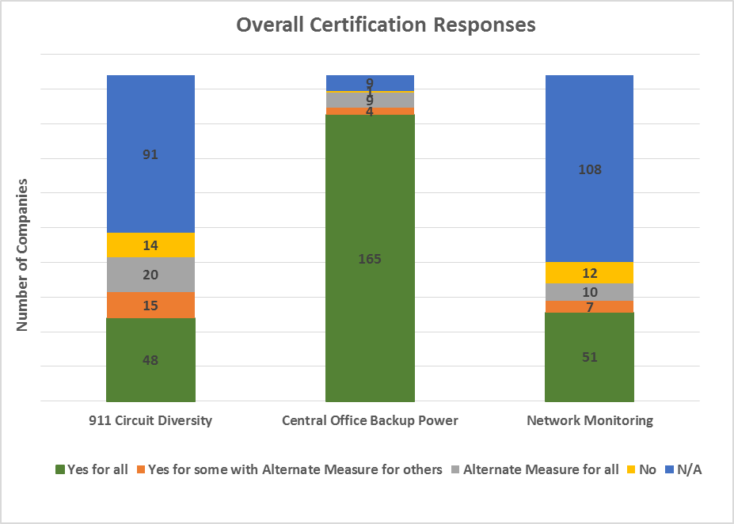
Figure 1: Overall Responses to 911 Certifications

911 Circuit Diversity
The Commission’s rules require covered entities to indicate whether they have conducted diversity audits of critical 911 circuits or equivalent data paths to any PSAPs that they serve. They must further certify whether they have marked or labelled (“tagged”) critical 911 circuits to reduce inadvertent loss of diversity to these circuits when they rearrange their network connections. Additionally, these covered entities must certify whether they have eliminated all single points of failure in critical 911 circuits serving each PSAP. Covered entities that do not certify that they have diverse circuits must certify whether they have implemented alternative measures to mitigate the risk of a lack of physical diversity among critical 911 circuits, and must describe the alternative measures.
The following table summarizes responses on 911 circuit diversity. As indicated in the table below, about half of the covered entities that filed certifications indicated that the circuit audit requirement did not apply to them.

911 Circuits Certified as Diverse | Number of Covered Entities
Yes for all PSAPs | 48
Yes for some PSAPs, but alternative measures for other PSAPs | 15
No, but alternative measures for all audited PSAPs | 20
No | 14
Not applicable | 91
Total | 188
Table 1: Overall Certification - Circuit Audit Results
The filings listed a total of 6,769 PSAPs for 911 circuit diversity. Of these PSAPs, covered entities certified that 3,855 are served by diverse circuits. With respect to alternative measures to circuit diversity, covered entities have implemented such measures for 2,914 of the total 6,769 PSAPs.
The covered entities’ selections from the drop-down menu which contains key alternative measures, but not necessarily all alternative measures, are shown below:
Certified Alternative Measure Chosen From the Drop-down Menu | Number of PSAPs | Percent of Certified PSAPs
Circuits are logically diverse | 1121 | 16.6%
NG 911 has been implemented allowing for automatic alternate route selection | 76 | 1.1%
Reroute to a backup PSAP on diverse path | 92 | 1.4%
Reroute to a secondary PSAP on diverse path | 25 | 0.4%
Reroute to a wireline alternative (10-digit number) | 115 | 1.7%
Two PSAPs treat each other as alternates | 239 | 3.5%
Used separate common equipment (channel bank, multiplexer, transport equipment) | 950 | 14.0%
Other | 296 | 4.4%
Total | 2914 | 43.0%
Table 2: Number of PSAPs with Various Alternative Measures
In addition to selecting the main alternative measures from the drop-down menu, covered entities also described specific details of these alternative measures in a text field. The following table presents a breakdown of these measures into categories derived from responses to the text field:

Alternative Measure Details | Number of PSAPs
Build/groom common equipment (channel bank, mux, transport equipment) | 970
Multiple potential measures | 566
Circuit on standalone D4 channel bank or DCS | 266
Two PSAPs treat each other as alternates | 223
Circuits are logically diverse | 118
Reroute to a wireline alternative (10-digit number) | 112
NG 911 has been implemented allowing for automatic alternate route selection | 105
Reroute to a backup PSAP on diverse path | 101
Diversify timing source | 61
Build diverse route/fiber path | 58
Service provider attests to circuits/trunks/meet-points | 54
Migration to NGN | 52
Other | 43
Customer provided secondary circuit | 39
PSAP shares ALI circuits with another PSAP | 33
No alternative indicated | 25
Customer specified single circuit | 22
Reroute via circuit controlled by service provider | 15
Reroute to a secondary PSAP on diverse path | 13
Reroute via IP to another PSAP | 11
Circuit on different entrance facility | 10
Call service provider for rerouting to alternate | 6
Circuit on diverse SONET path | 6
Used separate common equipment (channel bank, multiplexer, transport equipment) | 4
Establish/lease new circuits | 1
Total | 2914
Table 3: Number of PSAPS with Other Various Alternative Measures
We note that all covered entities (except one) indicated that their 911 circuits are tagged to reduce the risk of inadvertent loss of diversity between audits.

Backup Power
The Commission’s rules require that covered entities certify annually whether they provision and maintain backup power equipment for every central office they operate that directly serves a PSAP. Covered entities may certify that they provide backup power to central offices in one of two ways: (1) through the use of fixed generators, portable generators, batteries, fuel cells, or a combination of these methods; or (2) through alternative measures.
Under the Commission’s rules, covered entities are required to certify whether each central office providing circuits to one or more PSAPs had 72 hours of backup power for selective routers and 24 hours for non-selective routers. Covered entities indicated that 98 percent of central offices serving PSAPs directly satisfy the certification elements for backup power with respect to the amount of back-up power. All covered entities certified that they either directly meet or have implemented alternative measures that address each of the backup power certification elements. Some covered entities rely exclusively on alternative measures, while others directly meet the certification element in some cases, but otherwise have implemented alternative measures for backup power.
The following table summarizes the certifications on backup power:
Backup Power Requirements for Central Offices | Number of Covered Entities
Yes for all central offices | 165
Yes for some central offices but alternative measures for other central offices | 4
No, but alternative measures for all central offices that directly serve a PSAP or host a selective router | 9
No | 1
Not applicable | 9
Total | 188
Table 4: Overall Certification – Central Office Backup Power Results
Of 5,315 total central offices, 1,979 have certified backup power for all four elements of backup power, as specified in the rules and the other 3,336 have certified alternative measures for at least one element of the back-up power requirements.

Amount of Back-up Power
Covered entities are required to certify whether each central office providing circuits to one or more PSAPs had 72 hours of backup power for selective routers and 24 hours for non-selective routers.
Covered entities indicated that of their 5,315 central offices, only 126 did not directly satisfy the certification element for the amount of back-up power. For these 126 central offices, covered entities indicated that they have implemented alternative measures.
The following table lists the alternative measures implemented in these 126 central offices.
Alternative Measure | Count
Have refueling procedures | 63
Portable generator | 48
Co-located equipment | 6
Installing new generator | 4
Repairing generator | 3
Getting new, bigger fuel tank | 1
Standby generator | 1
Total | 126
Table 5: Summary of the Alternative Measures for Meeting the Backup Power Requirement

Testing to Manufacturer’s Specifications
The Commission’s rules require that covered entities certify whether they test and maintain all backup power equipment in central offices in accordance with the manufacturer’s specifications, or take alternative measures to mitigate the risk of a loss of 911 service resulting from a loss of power. Of the 16 covered entities that indicated that they implement alternative measures for some aspect of backup power to central offices, 11 certified that they test equipment in accordance with manufacturer’s specifications, and five indicated that they have alternative testing methods (industry specifications designed for communications equipment).

Automatic Generator Start or Quick Manual Start
Covered entities must certify whether generators either start automatically or can easily be started manually. For this requirement, covered entities certified that they have implemented alternative measures for only 109 of the 5,315 central offices. Of these 109 central offices, 108 have portable generators available and one has manual start procedures with training on those procedures.

Tandem Generators
Tandem generators are a pair of connected generators in a central office that work together to power equipment. Covered entities must certify that offices with tandem generators are able to function if one of the generators fails or have alternative measures in place. While most offices with tandem generators satisfy this certification element, alternative measures were provided for 12 central offices with tandem generators. In ten of those central offices, the covered entities implemented load shedding arrangements so that the central office would continue to function with only one working generator.

Network Monitoring
The third certification element is diverse monitoring for 911 service areas. The Commission’s rules require that covered entities certify whether they have conducted diversity audits of both the aggregation points that they use to gather network monitoring data in each 911 service area, and the monitoring links between these aggregations points and Network Operations Centers for each 911 service area. Additionally, covered entities must certify whether they have implemented physical diverse aggregation points and monitoring links for those aggregation points in each 911 service area. Covered entities that do not directly meet this element must certify whether they have taken alternative measures to mitigate the risk of network monitoring facilities that are not physically diverse.
The following table summarizes the diverse monitoring certifications that covered entities submitted:
Diverse Monitoring Requirement | Number of Covered Entities
Yes for all 911 service areas | 51
Yes for some 911 service areas but alternative measures for other 911 service areas | 7
No, but alternative measures for all 911 service areas | 10
No | 12
Not applicable | 108
Total | 188
Table 6: Overall Certification - Diverse Monitoring Results
One hundred and twenty covered entities selected “No” or “Not applicable” for this requirement because those covered entities do not operate selective routers or their service area is too small to require diverse network monitoring.
The covered entities that indicated they have diverse monitoring in all 1,084 911 service areas are shown in the table below:
 | Total 911 Service Areas with Diverse Monitoring
Companies with 10 or more 911 service areas | 897
Companies with fewer than 10 911 service areas | 187
Table 7: Number of 911 Service Areas with Certified Diverse Monitoring
A covered entity that cannot certify that it has diverse monitoring must certify with respect to each such 911 service area whether it has taken alternative measures. Nineteen covered entities stated that they have implemented alternative measures for diverse monitoring. Some alternative measures include:
- Installing a new, updated network monitoring system or migrating to a next generation network monitoring system;

- Updating network monitoring equipment, such as circuits and nodes, to incorporate redundancy and transition to a diverse environment;

- Moving circuits to additional paths to optimize network efficiency and increase diversity;

- Implementing a satellite solution as a backup route should the main circuits fail; and

- Adding redundant physical (e.g., different cable entrance) or virtual access (e.g., different portal) to the network monitoring system.

Conclusion
As described above, 188 covered providers filed the required certifications to demonstrate steps they have taken to ensure reliable 911 service and effective communication during 911 outages. The Bureau will continue to analyze this data, and to use the data in its work to improve network and 911 reliability. The Bureau also notes that the Commission plans to review its 911 certification rules by January 2019 “to determine whether they are still technologically appropriate and both adequate and necessary to ensure reliability and resiliency of 911 networks.”

47 CFR § 12.4(a)(4)(i)(A).
47 CFR § 12.4(a)(4)(i)(B). For purposes of this report, the Bureau refers to these providers as “covered entities.”
47 CFR § 12.4(c).
See 47 CFR § 12.4(c)(1)(ii)(A); 47 CFR § 12.4(c)(2)(ii)(A); 47 CFR § 12.4(c)(3)(ii)(A).
47 CFR § 12.4(c)(1)-(3).
The 2017 filing deadline was extended from October 15, 2017 to October 30, 2017, due to the effects of Hurricanes Harvey, Irma, and Maria. See Public Safety and Homeland Security Bureau Extends Annual Reliability Certification Deadline, PS Docket Nos. 13-75, 11-60, Public Notice, 32 FCC Rcd 7340 (PSHSB 2017).
Fourteen covered entities do not have circuit diversity; and 91 covered entities stated that the circuit diversity requirement is not applicable to them.
One covered entity responded “no” to the backup power requirement, but should have responded “yes” because it does in fact have backup power to its central office; and nine covered entities stated that the backup power requirement is not applicable to them.
Twelve covered entities do not have diverse network monitoring; and 108 covered entities stated that the network monitoring requirement is not applicable to them.
47 CFR § 12.4(c)(1)(i)(A).
47 CFR § 12.4(c)(1)(i)(B).
47 CFR § 12.4(c)(1)(i)(C).
47 CFR § 12.4(c)(1)(ii)(A). Providers must describe their alternative measures in a text field or select an option from a drop-down menu.
47 CFR § 12.4(a)(4)(ii). While the 90 covered entities that indicated the requirement was “not applicable,” we note that all of these covered entities are small carriers. Smaller carriers do not typically operate selective routers and do not have to certify with respect to circuit diversity. Similarly, 14 small carriers responded “no” to this certification element rather than “not applicable.”
None of the 14 covered entities that checked “no” are covered entities for this element of the certification, because they do not operate the selective routers in the areas in which they operate. Therefore, all 14 companies should have indicated “not applicable” for this element.
Bureau staff has reached out to this entity, which confirmed that it has since tagged all of the 911 circuits.
47 CFR § 12.4(c)(1)(i)(A).
47 CFR § 12.4(c)(2). Backup power may include fixed or portable generators, batteries, fuel cells, or a combination of these and other measures to maintain full functionality of 911 service when the primary power source is unavailable. See 47 CFR § 12.4(c)(2)(i)(A).
47 CFR § 12.4(c)(2)(i)(A).
47 CFR § 12.4(c)(2)(ii)(A).
47 CFR § 12.4(c)(2)(i)(A).
47 CFR § 12.4(c)(2)(i)(A).
See 47 CFR § 12.4(c)(2)(i)(A)-(D).
47 CFR §§ 12.4(c)(2)(i)(B), 12.4(c)(2)(ii)
47 CFR § 12.4(c)(2)(i)(C). For offices without permanent generators, the automatic generator start element is unnecessary as its only needed for offices with permanent generators.
47 CFR §§ 12.4(c)(2)(i)(D), 12.4(c)(2)(ii).
Of the remaining two central offices, one has more than two generators, which provide a backup power source when one generator fails. The other central office has an arrangement that starts up a second generator when necessary.
47 CFR § 12.4(c)(3)(i)(A). Aggregation points are connected to multiple 911 service areas and used to gather network monitoring data.
47 CFR § 12.4(c)(3)(i)(B).
47 CFR § 12.4(c)(3)(i)(C).
47 CFR § 12.4(c)(3)(ii)(A).
The Commission’s 911 reliability rules permit a covered entity to explain why the certification element is not applicable to its network, and therefore, certification is unnecessary. Some covered entities indicated that the network monitoring certification element is not applicable to them because their service area is too small. See 47 CFR § 12.4(c)(3)(ii)(B).
47 CFR § 12.4(c)(3)(ii)(A), (B).
As reflected in the table for “Overall Certification – Diverse Monitoring Results” (Table 6), 17 covered entities stated they had alternate measure for some or all 911 Service Areas. However, two additional covered entities filed alternative measures reports even though they did not check the box for alternative measures.
See Improving 911 Reliability, Reliability and Continuity of Communications Networks, Including Broadband Technologies, Report and Order, 28 FCC Rcd 17476, 17533, para. 159 (2013) (committing to review the 911 reliability rules adopted in this Report and Order in 5 years “to determine whether they are still technologically appropriate and both adequate and necessary to ensure reliability and resiliency of 911 networks”).

