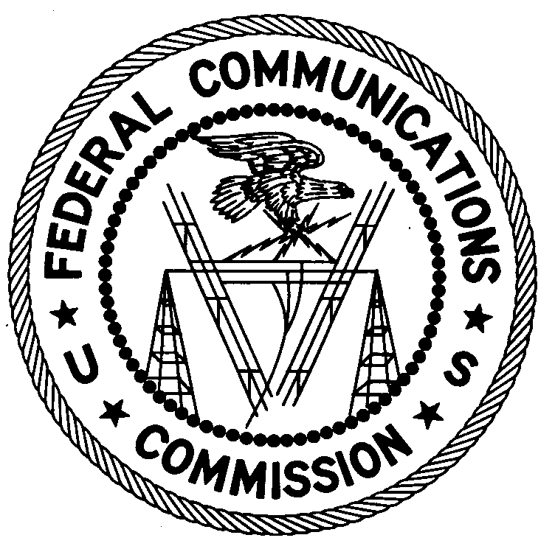
FEDERAL COMMUNICATIONS COMMISSION
ENFORCEMENT BUREAU
REGION THREE

Los Angeles Regional Office
11331 183rd Street, PMB #365
Cerritos, CA 90703
Field@FCC.gov
(562) 860-7474

April 13, 2018

Alexander J. Brittin
Boulder, Colorado

NOTICE OF UNLICENSED OPERATION

Case Number: EB-FIELDWR-18-00026170

On January 9, 2018, Agents from the Denver Office (Denver Office) of the Federal Communications Commission’s (FCC’s or Commission’s) Enforcement Bureau (Bureau) responded to a complaint of an unlicensed FM station operating in Boulder, Colorado. The Agents confirmed by direction finding techniques that radio signals on frequency 95.5 MHz were emanating from your property located on 14th Street in Boulder, Colorado. Public records list you as the owner of this property. The Commission’s records show that no license was issued for a broadcast station on 95.5 MHz at this location in Boulder, Colorado.

On January 12, 2018, an Agent from the Denver Office responded to a complaint of an unlicensed FM station operating in Boulder, Colorado. The Agent confirmed by direction finding techniques that radio signals on frequency 91.0 MHz were emanating from your property located on 14th Street in Boulder, Colorado. The Commission’s records show that no license was issued for a broadcast station on 91.0 MHz at this location in Boulder, Colorado.

On January 19, 2018, Agents from the Denver Office responded to a complaint of an unlicensed FM station operating in Boulder, Colorado. The Agents confirmed by direction finding techniques that radio signals on frequency 104.7 MHz were emanating from your property located on 14th Street in Boulder, Colorado. The Commission’s records show that no license was issued for a broadcast station on 104.7 MHz at this location in Boulder, Colorado.

On January 29, 2018, Agents from the Denver Office responded to a complaint of an unlicensed FM station operating in Boulder, Colorado. The Agents confirmed by direction finding techniques that radio signals on frequency 90.4 MHz were emanating from your property located on 14th Street in Boulder, Colorado. The Commission’s records show that no license was issued for a broadcast station on 90.4 MHz at this location in Boulder, Colorado.

On February 7 and 14, 2018, Agents from the Denver Office responded to a complaint of an unlicensed FM station operating in Boulder, Colorado. The Agents confirmed by direction finding techniques that radio signals on frequency 101.3 MHz were emanating from your property located on 14th Street in Boulder, Colorado. The Commission’s records show that no license was issued for a broadcast station on 101.3 MHz at this location in Boulder, Colorado.

Radio stations operating on a range of frequencies, including 95.5, 91.0, 104.7, 90.4, and 101.3 MHz, must be licensed by the FCC pursuant to Section 301 of the Communications Act of 1934, as amended (Act). The only exception to this licensing requirement is for certain transmitters using or operating at a power level or mode of operation that complies with the standards established in Part 15 of the Commission’s rules. On the dates above, Agents measured the field strength of the signal on the frequencies of 95.5, 91.0, 104.7, 90.4, and 101.3 MHz for the station and found that it exceeded the maximum permitted level of 250 µV/m at 3 meters for non-licensed devices. Thus, the station was operating in violation of Section 301 of the Act.

You are hereby warned that operation of radio transmitting equipment without a valid radio station authorization constitutes a violation of the Federal laws cited above and could subject the operator to severe penalties, including, but not limited to, substantial monetary fines, in rem arrest action against the offending radio equipment, and criminal sanctions, including imprisonment.

UNLICENSED OPERATION OF THIS RADIO STATION MUST BE DISCONTINUED IMMEDIATELY.

You have ten (10) days from the date of this notice to respond with any evidence that you have authority to operate granted by the Commission. Your response should be sent to the address in the letterhead and reference the listed case number. Under the Privacy Act of 1974, we are informing you that the Commission’s staff will use all relevant material information before it to determine what, if any, enforcement action is required to ensure your compliance with FCC Rules. This will include any information that you disclose in your reply.

You may contact this office if you have any questions.

Lark Hadley
Regional Director
Region Three
Enforcement Bureau

Attachments:
Excerpts from the Communications Act of 1934, As Amended
Enforcement Bureau, "Inspection Fact Sheet", March 2005

47 CFR § 73.201.
47 U.S.C. § 301.
47 CFR §§ 15.1 et seq.
47 U.S.C. § 301.
See 47 U.S.C. §§ 401, 501, 503 and 510.
5 U.S.C. § 552a(e)(3).

