FEDERAL COMMUNICATIONS COMMISSION
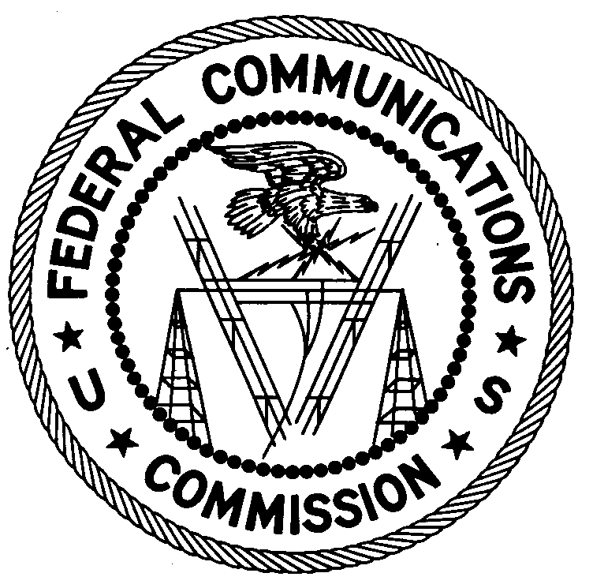
ENFORCEMENT BUREAU
REGION ONE

Columbia Regional Office

9200 Farm House Lane

Columbia, Maryland 21046

(301) 725-1996

April 27, 2017

Carlo Pierre-Louis
Mattapan, Massachusetts

NOTICE OF UNLICENSED OPERATION

Case Number: EB-FIELDNER-16-00021767

The Enforcement Bureau’s Boston Office received a complaint of an unlicensed FM station operating on frequency 93.9 MHz and causing harmful interference to licensed broadcast stations in Boston, Massachusetts. On April 19, 2017, an agent from the Boston Office confirmed by direction finding techniques that radio signals on frequency 93.9 MHz were emanating from your residence in Mattapan, Massachusetts. The Commission’s records show no license issued for operation of a radio station on 93.9 MHz at this location in Mattapan, Massachusetts.

Radio stations operating on many frequencies, including 93.9 MHz, must be licensed by the FCC pursuant to 47 U.S.C. § 301. The only exception to this licensing requirement is for certain transmitters using or operating at a power level or mode of operation that complies with the standards established in Part 15 of the Commission’s rules, 47 CFR §§ 15.1 et seq. The agent found that the station at your home was operating at a power level that exceeds the level permitted by Part 15. The field strength of the signal on frequency 93.9 MHz was measured at 69,681 microvolts per meter (µV/m) at 142 meters, which exceeded the maximum permitted level of 250 µV/m at 3 meters for non-licensed devices. Therefore, this station is operating in violation of 47 U.S.C. § 301.

You are hereby warned that operation of radio transmitting equipment without a valid radio station authorization constitutes a violation of the Federal laws cited above and could subject the operator to severe penalties, including, but not limited to, substantial monetary fines, in rem arrest action against the offending radio equipment, and criminal sanctions including imprisonment. (See 47 U.S.C. §§ 401, 501, 503 and 510.)

UNLICENSED OPERATION OF THIS RADIO STATION MUST BE DISCONTINUED IMMEDIATELY.

You have ten (10) days from the date of this notice to respond with any evidence that you have authority to operate granted by the FCC. Your response should be sent to the address in the letterhead and reference the listed case number. Under the Privacy Act of 1974, 5 U.S.C. § 552a(e)(3), we are informing you that the Commission’s staff will use all relevant material information before it to determine what, if any, enforcement action is required to ensure your compliance with FCC Rules. This will include any information that you disclose in your reply.

You may contact this office if you have any questions.

David C. Dombrowski
Regional Director
Region One
Enforcement Bureau
Federal Communications Commission

Attachments:
Excerpts from the Communications Act of 1934, As Amended
Enforcement Bureau, "Inspection Fact Sheet", March 2005

