Communications Status Report for

Areas Impacted by Hurricane Maria

October 7, 2017

The following is a report on the status of communications services in geographic areas impacted by Hurricane Maria as of October 07, 2017 at 11:00 AM EDT. This report incorporates network outage data submitted by communications providers to the Federal Communications Commission’s Disaster Information Reporting System (DIRS). DIRS is currently activated for all counties in Puerto Rico and the U.S. Virgin Islands. Note that the operational status of communications services during a disaster may evolve rapidly, and this report represents a snapshot in time. It should also be noted that some communications providers have not yet reported in DIRS, so outage information almost certainly is not complete.

The following counties are in the geographic area that was covered by the DIRS activation as of this morning (the “disaster area”).

Puerto Rico: Adjuntas, Aguada, Aguadilla, Aguas Buenas, Aibonito, Anasco, Arecibo, Arroyo, Barceloneta, Barranquitas, Bayamon, Cabo Rojo, Caguas, Camuy, Canovanas, Carolina, Catano, Cayey, Ceiba, Ciales, Cidra, Coamo, Comerio, Corozal, Culebra, Dorado, Fajardo, Florida, Guanica, Guayama, Guayanilla, Guaynabo, Gurabo, Hatillo, Hormigueros, Humacao, Isabela, Jayuya, Juana Diaz, Juncos, Lajas, Lares, Las Marias, Las Piedras, Loiza, Luquillo, Manati, Maricao, Maunabo, Mayaguez, Moca, Morovis, Naguabo, Naranjito, Orocovis, Patillas, Penuelas, Ponce, Quebradillas, Rincon, Rio Grande, Sabana Grande, Salinas, San German, San Juan, San Lorenzo, San Sebastian, Santa Isabel, Toa Alta, Toa Baja, Trujillo Alto, Utuado, Vega Alta, Vega Baja, Vieques, Villalba, Yabucoa and Yauco
U.S. Virgin Islands: St. Croix, St. John, St. Thomas

911 Services
The Public Safety and Homeland Security Bureau (PSHSB) learns the status of each Public Safety Answering Point (PSAP) through the filings of 911 Service Providers in DIRS, reporting to the FCC’s Public Safety Support Center (PSSC), coordination with state 911 Administrators, and, if necessary, from individual PSAPs.

Both PSAPs in Puerto Rico are reported as operational. In the U.S. Virgin Islands, both the St. Croix and the St. Thomas 9-1-1 Call Centers are reported as operational but unable to retrieve Phase I and Phase II location information for wireless callers and ANI/ALI for VoIP Callers.

Wireless Services
The following section describes the status of wireless communications services and restoration in the disaster area, including the percentage of cell sites out of service for each county.

The following map of the disaster area illustrates which counties in Puerto Rico are most affected:

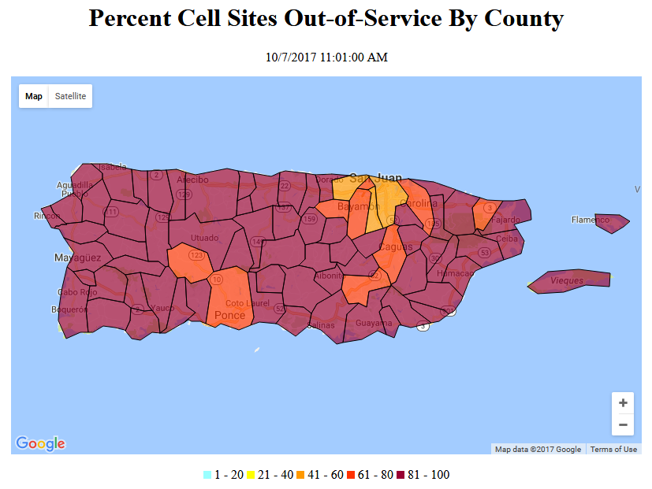

The information shown was provided by the signatories to the Wireless Resiliency Cooperative Framework and several additional companies that agreed to allow us to include their data in the aggregated data:

Puerto Rico: Overall, 81.9% (slightly down from 83.0% yesterday) of cell sites are out of service. All counties in Puerto Rico, except Bayamon, Catano, Carolina, Guaynabo, San Juan, Toa Alta and Toa Baja, have greater than 75% of their cell sites out of service. 22 (same as yesterday) out of the 78 counties in Puerto Rico have 100% of their cell sites out of service. Wireless communications providers are deploying to Puerto Rico Cell Sites on Wheels and Cell Sites on Light Trucks.
U.S. Virgin Islands: Overall, 57.9% (slightly up from 57.0% yesterday) of cell sites are out of service. 100% of cell sites in St. John are still out of service.

The tables below provide the percentage of cell sites out of service by county per state or territory. Counties highlighted in red have 100% of their cell sites out of service.

Puerto Rico:
State | Affected Counties | Cell Sites Served | Cell Sites Out | Percent Out
PR | ADJUNTAS | 10 | 8 | 80.0%
PR | AGUADA | 18 | 17 | 94.4%
PR | AGUADILLA | 47 | 44 | 93.6%
PR | AGUAS BUENAS | 20 | 20 | 100.0%
PR | AIBONITO | 46 | 43 | 93.5%
PR | ANASCO | 15 | 15 | 100.0%
PR | ARECIBO | 68 | 63 | 92.6%
PR | ARROYO | 10 | 9 | 90.0%
PR | BARCELONETA | 24 | 22 | 91.7%
PR | BARRANQUITAS | 37 | 34 | 91.9%
PR | BAYAMON | 143 | 94 | 65.7%
PR | CABO ROJO | 51 | 47 | 92.2%
PR | CAGUAS | 86 | 66 | 76.7%
PR | CAMUY | 17 | 15 | 88.2%
PR | CANOVANAS | 29 | 26 | 89.7%
PR | CAROLINA | 116 | 77 | 66.4%
PR | CATANO | 21 | 15 | 71.4%
PR | CAYEY | 90 | 69 | 76.7%
PR | CEIBA | 12 | 10 | 83.3%
PR | CIALES | 13 | 11 | 84.6%
PR | CIDRA | 27 | 27 | 100.0%
PR | COAMO | 21 | 20 | 95.2%
PR | COMERIO | 18 | 18 | 100.0%
PR | COROZAL | 22 | 21 | 95.5%
PR | CULEBRA | 9 | 8 | 88.9%
PR | DORADO | 51 | 43 | 84.3%
PR | FAJARDO | 35 | 32 | 91.4%
PR | FLORIDA | 6 | 6 | 100.0%
PR | GUANICA | 24 | 20 | 83.3%
PR | GUAYAMA | 30 | 28 | 93.3%
PR | GUAYANILLA | 10 | 9 | 90.0%
PR | GUAYNABO | 82 | 46 | 56.1%
PR | GURABO | 33 | 28 | 84.8%
PR | HATILLO | 29 | 28 | 96.6%
PR | HORMIGUEROS | 10 | 9 | 90.0%
PR | HUMACAO | 42 | 40 | 95.2%
PR | ISABELA | 33 | 31 | 93.9%
PR | JAYUYA | 7 | 7 | 100.0%
PR | JUANA DIAZ | 32 | 28 | 87.5%
PR | JUNCOS | 22 | 20 | 90.9%
PR | LAJAS | 19 | 18 | 94.7%
PR | LARES | 15 | 15 | 100.0%
PR | LAS MARIAS | 9 | 9 | 100.0%
PR | LAS PIEDRAS | 18 | 18 | 100.0%
PR | LOIZA | 11 | 11 | 100.0%
PR | LUQUILLO | 13 | 10 | 76.9%
PR | MANATI | 28 | 25 | 89.3%
PR | MARICAO | 5 | 5 | 100.0%
PR | MAUNABO | 11 | 11 | 100.0%
PR | MAYAGUEZ | 66 | 56 | 84.8%
PR | MOCA | 19 | 19 | 100.0%
PR | MOROVIS | 21 | 21 | 100.0%
PR | NAGUABO | 23 | 23 | 100.0%
PR | NARANJITO | 23 | 23 | 100.0%
PR | OROCOVIS | 15 | 14 | 93.3%
PR | PATILLAS | 15 | 15 | 100.0%
PR | PENUELAS | 22 | 19 | 86.4%
PR | PONCE | 100 | 76 | 76.0%
PR | QUEBRADILLAS | 19 | 17 | 89.5%
PR | RINCON | 15 | 14 | 93.3%
PR | RIO GRANDE | 44 | 41 | 93.2%
PR | SABANA GRANDE | 13 | 11 | 84.6%
PR | SALINAS | 29 | 27 | 93.1%
PR | SAN GERMAN | 25 | 23 | 92.0%
PR | SAN JUAN | 309 | 174 | 56.3%
PR | SAN LORENZO | 22 | 22 | 100.0%
PR | SAN SEBASTIAN | 21 | 19 | 90.5%
PR | SANTA ISABEL | 18 | 16 | 88.9%
PR | TOA ALTA | 37 | 25 | 67.6%
PR | TOA BAJA | 47 | 28 | 59.6%
PR | TRUJILLO ALTO | 45 | 40 | 88.9%
PR | UTUADO | 21 | 21 | 100.0%
PR | VEGA ALTA | 27 | 25 | 92.6%
PR | VEGA BAJA | 34 | 32 | 94.1%
PR | VIEQUES | 12 | 12 | 100.0%
PR | VILLALBA | 9 | 9 | 100.0%
PR | YABUCOA | 31 | 31 | 100.0%
PR | YAUCO | 19 | 17 | 89.5%
TOTAL |  | 2,646 | 2,166 | 81.9%

U.S. Virgin Islands:

State | Affected Counties | Cell Sites Served | Cell Sites Out | Percent Out
VI | ST. CROIX | 46 | 27 | 58.7%
VI | ST. JOHN | 9 | 9 | 100.0%
VI | ST. THOMAS | 66 | 34 | 51.5%
TOTAL |  | 121 | 70 | 57.9%

Cable Systems and Wireline (Combined)

Since there are widespread power outages in Puerto Rico and the U.S. Virgin Islands, the FCC has received reports that large percentages of consumers are without either cable services or wireline service (one company has reported that approximately 1% of its consumers have had service restored). In Puerto Rico, there are at least 13 (same as yesterday) switches that are out of service due to either SS7 or toll isolation.

Broadcast

TV stations out of service: WIPR in San Juan, PR and WIPM in Mayaguez, PR are reported as being out of service in DIRS.
WKAQ-TV is reported as being on the air.

Radio stations out of service: WQBS, WCMN-FM, WMIO, WPRM-FM, WNEL, WPRP, WIPR-FM, WZAR and WUNO (all in Puerto Rico) are reported as being out of service in DIRS.
Based on informal reports earlier, it appears the following radio and televisions stations are operational in Puerto Rico:
AM: WKAQ 580, WPAB 550, WIPR 940, WAPA 680, WISO 1260, WTIL 1300, WKUM 1470, WMDD 1480, WDEP 1490, WALO 1240, WSJN 1320, WXEW 840, WEXS 1070, WMIA 610

FM: 91.9, 94.7, 95.7, 96.1, 97.7, 104.1, 104.7, 106.9
TV: Telemundo virtual Ch.2 UHF 28 is on the air.

