FEDERAL COMMUNICATIONS COMMISSION
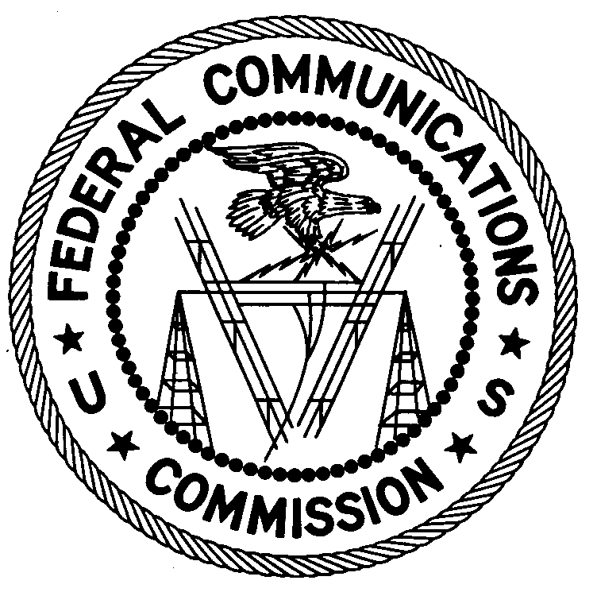
ENFORCEMENT BUREAU
REGION THREE

Los Angeles Regional Office
18000 Studebaker Rd., #660

Cerritos, CA 90703

August 11, 2017

Stewart Kantor
San Jose, California

NOTICE OF UNLICENSED OPERATION

Case Number: EB-FIELDWR-17-00024047

On April 5, 2017, the San Francisco Office (San Francisco Office) of the Federal Communications Commission’s (FCC’s or Commission’s) Enforcement Bureau (Bureau) received a complaint from Verizon Wireless stating that an unknown signal was causing interference to their 776 MHz – 787 MHz C Block Upper 700 MHz band service in San Jose, California. This unknown signal interfered with over 200 sites of Verizon Wireless in the San Jose area. Agents from this office confirmed by direction finding techniques that a wide band radio signal on frequency 785 MHz – 790 MHz was emanating from a residence on Mt. Hamilton Road in San Jose, California. You were identified as the owner/operator of the device, Full Spectrum, Cobalt-Plus, model CP-1000 that was emanating the interfering signal. The Commission’s records show that no license was issued for operation of your station at this location on 785 MHz – 790 MHz in San Jose, California.

At the time of inspection, the agents found that the device, Full Spectrum, Cobalt-Plus, model CP-1000 operating on 785 MHz - 790 MHz had no label with FCC ID on it and was not certified by the FCC as required by 47 CFR § 27.51(a). This device cannot be operated legally without proper certification. In addition, to operate this device on the 776 MHz – 787 MHz frequency band, you must have a station license as specified in Sections 27.5(b)(3) and 27.11(a) of the Commission’s rules. You stated that you do not have an FCC station license on this band.

Radio stations must be licensed by the FCC pursuant to Section 301 of the Communications Act of 1934, as amended (Act). The only exception to this licensing requirement is for certain transmitters using or operating at a power level that complies with the standards established in Part 15 of the Commission’s rules. This station is operating in violation of Section 301 of the Act.

You are hereby warned that operation of radio transmitting equipment without a valid radio station authorization constitutes a violation of the Federal laws cited above and could subject the operator of this illegal operation to severe penalties, including, but not limited to, substantial monetary forfeitures, in rem arrest action against the offending radio equipment, and criminal sanctions including imprisonment.

UNLICENSED OPERATION OF THIS RADIO STATION MUST BE DISCONTINUED IMMEDIATELY.

You have ten (10) days from the date of this notice to respond with any evidence that you have authority to operate granted by the FCC. Your response should be sent to the address in the letterhead and reference the listed case number. Under the Privacy Act of 1974, we are informing you that the Commission’s staff will use all relevant material information before it to determine what, if any, enforcement action is required to ensure your compliance with FCC Rules. This will include any information that you disclose in your reply.

You may contact this office if you have any questions.

Lark Hadley
Regional Director
Region Three
Enforcement Bureau

Attachments:
Excerpts from the Communications Act of 1934, As Amended
Enforcement Bureau, "Inspection Fact Sheet," March 2005

47 CFR § 27.51(a): “Each transmitter utilized for operation under this part must be of a type that has been authorized by the Commission under its certification procedure.”
47 CFR §§ 27.5(b)(3), 27.11(a).
47 U.S.C. § 301.
47 C.F.R. §§ 15.1 et seq.
47 U.S.C. § 301.
See 47 U.S.C. §§ 401, 501, 503 and 510.
5 U.S.C. § 552a(e)(3).

