FEDERAL COMMUNICATIONS COMMISSION
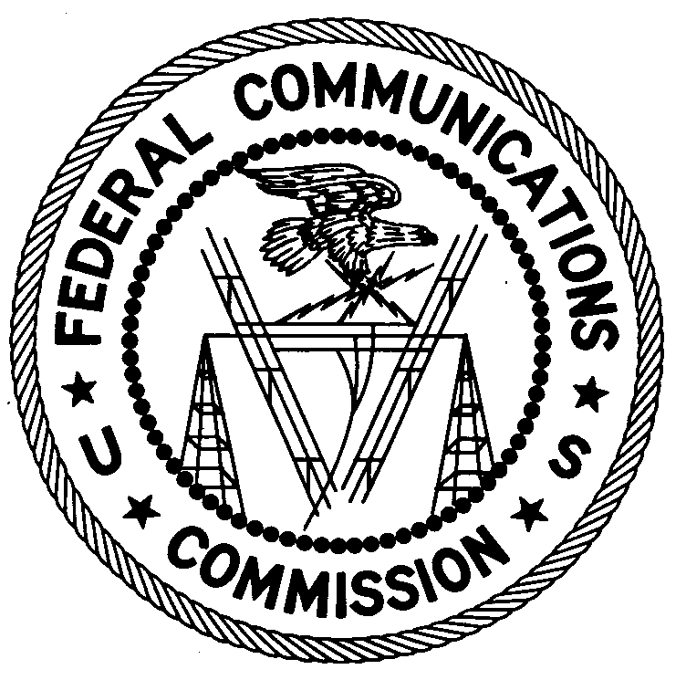
ENFORCEMENT BUREAU
Office of Director – Region Two
3600 Hiram Lithia Spring Rd. SW
Powder Springs, GA 30127

May 17, 2017

Bradley C. Pike
Dallas, TX 75249

NOTICE OF UNLICENSED OPERATION

Case Number: EB-FIELDSCR-17-00024019

On April 3, 2017, Agents from the Dallas Office of the Federal Communications Commission’s (FCC’s) Enforcement Bureau responded to a complaint from Dallas County (Dallas County Consolidated Services) concerning interference to their VHF public safety communications system. The Agents confirmed by direction finding techniques that radio emissions in the VHF band were emanating from Mr. Pike’s residence in Dallas, Texas, and were causing the interference. Mr. Pike surrendered his radio signal jammer after admitting to using the device during an interview with the Agents at his residence.

Persons operating or using radio transmitters must be licensed or authorized by the FCC, pursuant to Section 301 of the Communications Act of 1934, as amended. In addition, radio transmitting equipment must comply with FCC rules. Section 333 of the Act prohibits willful or malicious interference with any radio communications of any station licensed or authorized by or under the Act or operated by the United States Government. In addition, Section 302(b) of the Act, and Section 2.803 of the Commission’s rules, prohibit the manufacture, importation, marketing, sale or operation of devices deliberately designed to jam or disrupt wireless communications.
The operation of a jamming device constitutes a violation of Sections 301, 302(b), and 333 of the Act, as described above. Such operation may subject Mr. Pike to substantial monetary forfeitures, in rem arrest action against the offending radio equipment, and criminal sanctions including imprisonment. Because unauthorized operation creates a danger of interference to important radio communications services, and may subject the operator to severe penalties, this warning emphasizes the importance of complying strictly with these legal requirements.
You may respond with any information you believe relevant to this warning within thirty (30) days from the date of this warning. Your response should be sent to the address in the letterhead and reference the listed case number. Under the Privacy Act of 1974, we are informing you that the Commission’s staff will use all relevant material information before it to determine what, if any, enforcement action is required to ensure your compliance with FCC Rules. This will include any information that you disclose in your reply.
You may contact this office if you have any questions.

Ronald D. Ramage
Regional Director
Region Two
Enforcement Bureau
Federal Communications Commission

Attachments:
Enforcement Bureau, FCC Enforcement Advisory, “Consumer Alert: Using or Importing Jammers is Illegal”, March 2012.

47 U.S.C. § 301. The only exception to this licensing requirement is for certain transmitters using or operating at a power level that complies with the standards established in Part 15 of the Commission's rules. 47 CFR §§ 15.1 et seq.
47 CFR Part 2, Subpart J.
47 U.S.C. § 333.
47 U.S.C. § 302a(b); 47 CFR § 2.803.
47 U.S.C. §§ 301, 302a(b), 333.
See 47 U.S.C. §§ 401, 501, 503, 510.
5 U.S.C. § 552a(e)(3).

