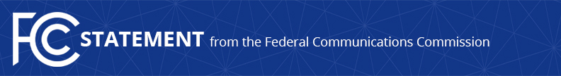

Media Contact:
David Grossman, (202) 418-2100
david.grossman@fcc.gov

For Immediate Release

COMMISSIONER CLYBURN STATEMENT
ON INTRODUCTION OF LEGISLATION TO ENHANCE BROADCAST OWNERSHIP DIVERSITY
--
WASHINGTON, April 5, 2017 – “Congressman G.K. Butterfield has hit the nail on the head when it comes to proposing solutions for a more inclusive media landscape. I heartily support and applaud his introduction of the Expanding Broadcast Ownership Opportunities Act (H.R. 1883).”
“Reinstating a tax certificate program and establishing a pilot incubator program are two of the proposals our office outlined in the recently released #Solutions2020 Call to Action Plan. Transforming the dismal reality of the present ownership landscape, into a future that offers abundant opportunities for women and minorities will not be an easy task. Congressman Butterfield’s legislation is an important step towards greater broadcast ownership diversity and I look forward to working with him and all interested Members of Congress in pursuit of this shared goal.”
###
Office of Commissioner Mignon Clyburn: (202) 418-2100
Twitter: @MClyburnFCC
www.fcc.gov

This is an unofficial announcement of Commission action. Release of the full text of a Commission order constitutes official action. See MCI v. FCC, 515 F.2d 385 (D.C. Cir. 1974).

