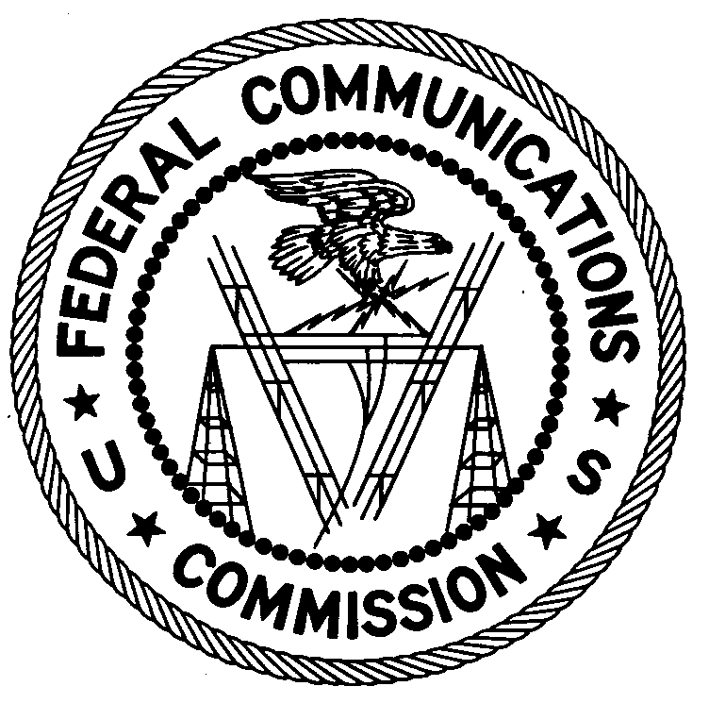
FEDERAL COMMUNICATIONS COMMISSION
ENFORCEMENT BUREAU
REGION ONE

San Francisco Office
5653 Stoneridge Dr. Suite 105

Pleasanton, CA 94588
(925)416-9717
September 6, 2016

Napa Jet Center
Napa, California

NOTICE OF UNLICENSED OPERATION

Case Number: EB-FIELDWR-16-00022519

Document Number: W201632960001

The San Francisco Office of the Federal Communications Commission (FCC) received information that an unlicensed radio station on 462.600 MHz and 467.600 MHz was allegedly operating in Napa, California. On August 3 and 5, 2016, an agent from this office confirmed by direction finding techniques that radio signals on frequency 462.600 MHz and 467.600 MHz were emanating from your business location in Napa, California. These frequencies are reserved for the General Mobile Radio Service (GMRS) and require a station license issued by the FCC. The Commission’s records show that no license was issued for operation of a GMRS radio station to the Napa Jet Center on 462.600 MHz and 467.600 MHz at your location in Napa, California.

Radio stations operating on many frequencies, including 462.600 MHz and 467.600 MHz, must be licensed by the FCC pursuant to 47 U.S.C. § 301. The only exception to this licensing requirement is for certain transmitters using or operating at a power level or mode of operation that complies with the standards established in Part 15 of the Commission’s rules, 47 C.F.R. §§ 15.1 et seq.

You are hereby warned that operation of radio transmitting equipment without a valid radio station authorization constitutes a violation of the Federal laws cited above and could subject the operator to severe penalties, including, but not limited to, substantial monetary fines, in rem arrest action against the offending radio equipment, and criminal sanctions including imprisonment. (See 47 U.S.C. §§ 401, 501, 503 and 510.)

UNLICENSED OPERATION OF THIS RADIO STATION MUST BE DISCONTINUED IMMEDIATELY.

You have ten (10) days from the date of this notice to respond with any evidence that you have authority to operate granted by the FCC. Your response should be sent to the address in the letterhead and reference the listed case and document number. Under the Privacy Act of 1974, 5 U.S.C. § 552a(e)(3), we are informing you that the Commission’s staff will use all relevant material information before it to determine what, if any, enforcement action is required to ensure your compliance with FCC Rules. This will include any information that you disclose in your reply.

You may contact this office if you have any questions.

David K. Hartshorn
District Director
San Francisco Office
Region 3
Enforcement Bureau

Attachments:
Excerpts from the Communications Act of 1934, As Amended
Enforcement Bureau, "Inspection Fact Sheet", March 2005

See Title 47 C.F.R. Section 95.3

