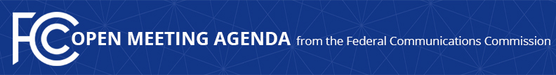

Media Contact:
Will Wiquist, 202-418-0509
will.wiquist@fcc.gov

For Immediate Release

FCC ANNOUNCES TENTATIVE AGENDA FOR JANUARY OPEN MEETING
--
WASHINGTON, January 10, 2017 – Federal Communications Commission Chairman Tom Wheeler announced that the following item is tentatively on the agenda for the January Open Commission Meeting scheduled for Tuesday, January 31, 2017:

Streamlining the Public File Rules: The Commission will consider a Report and Order that would eliminate the requirement that commercial broadcast stations retain copies of letters and emails from the public in their public inspection file and the requirement that cable operators retain the location of the cable system’s principal headend in their public inspection file.

The Open Meeting is scheduled to commence at 10:30 a.m. in Room TW-C305 of the Federal Communications Commission, 445 12th Street, S.W., Washington, D.C.

###
Office of Media Relations: 202.418.0500
TTY: 888-835-5322
Twitter: @FCC
ftp.fcc.gov
www.fcc.gov/office-media-relations

This is an unofficial announcement of Commission action. Release of the full text of a Commission order constitutes official action. See MCI v. FCC. 515 F 2d 385 (D.C. Circ 1974).

