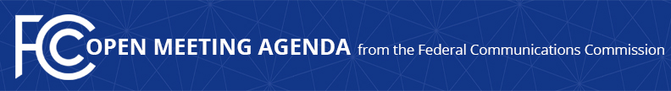

Media Contact:
Mark Wigfield, 202-418-0253
mark.wigfield@fcc.gov

For Immediate Release

FCC ANNOUNCES TENTATIVE AGENDA FOR December OPEN MEETING
--
WASHINGTON, November 22, 2016 – Federal Communications Commission Chairman Tom Wheeler announced that the following items are tentatively on the agenda for the December Open Commission Meeting scheduled for Thursday, December 15, 2016:

Transition from TTY to Real-Time Text Technology: The Commission will consider a Report and Order and Further Notice of Proposed Rulemaking to help achieve the transition from TTY technology to a reliable and interoperable means of providing real-time text communication over wireless Internet protocol-enabled networks and services. (CG Docket No. 16-145, GN Docket No. 15-178).

Improving the Nation’s Public Alert and Warning Systems: The Commission will consider a Report and Order and Further Notice of Proposed Rulemaking to enhance the Emergency Alert System (EAS) as a tool for community emergency preparedness. The Report and Order improves alerting organization at the state and local levels, builds stronger community-based alerting exercise programs, and protects the EAS against accidental misuse and malicious intrusion. The Further Notice seeks comment on proposals to leverage technological advances to improve alerting and additional measures to preserve EAS security. (PS Docket No. 15-94)

The following items that are currently on circulation may be considered, unless voted on circulation prior to the December Open Meeting:

- Update to Parts 2 and 25 Concerning Non-geostationary, Fixed-Satellite Service Systems and Related Matters, Notice of Proposed Rulemaking
- In the Matter of Amendment of Part 0 of the Commission’s Rules Regarding Public Information, the Inspection of Records, and Implementing the Freedom of Information Act
- Maritime Communications/Land Mobile, LLC, Order on Reconsideration and Memorandum Opinion and Order
- Improving the Resiliency of the Nation's Mobile Wireless Communications Networks, Order
- Preferred Long Distance, Inc., Memorandum Opinion and Order

The Open Meeting is scheduled to commence at 10:30 a.m. in Room TW-C305 of the Federal Communications Commission, 445 12th Street, S.W., Washington, D.C.

###
Office of Media Relations: 202.418.0500
TTY: 888-835-5322
Twitter: @FCC
ftp.fcc.gov
www.fcc.gov/office-media-relations

This is an unofficial announcement of Commission action. Release of the full text of a Commission order constitutes official action. See MCI v. FCC. 515 F 2d 385 (D.C. Circ 1974).

