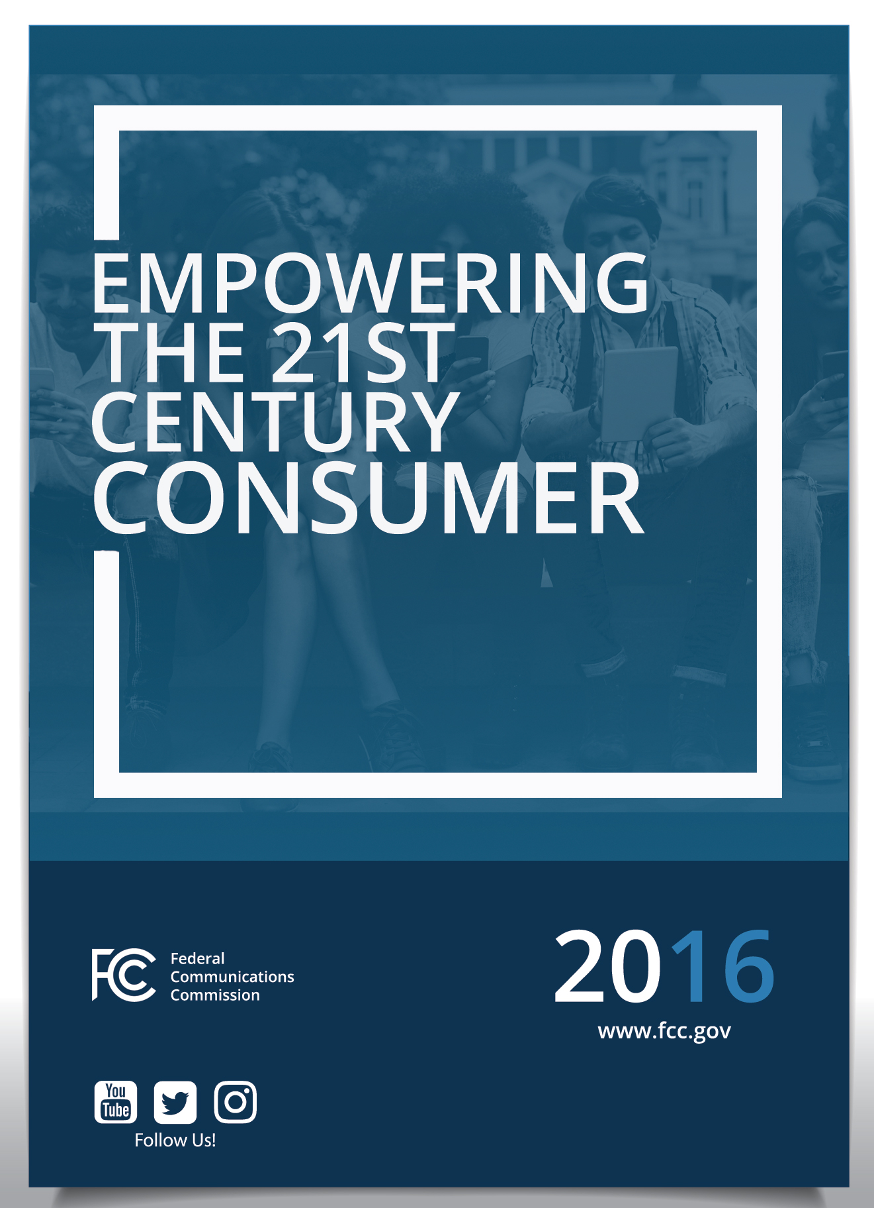
TABLE OF CONTENTS
Introduction
I. Fast, Fair, and Open Networks for All
Protecting Open and Transparent Networks
Open Internet Order
Cell Phone Unlocking
Cracking Down on Wi-Fi Blocking
Inmate Calling Services
Promoting 21st Century Speed and Quality
Benchmark Speed Updates
More Spectrum for Mobile Broadband
Ensuring Universal Access
Access for Working Families
Access for Schools and Libraries
Access in Rural America and Tribal Lands
Access to Next-Generation Technology for All Americans
Access for People with Disabilities

II. Protecting Competition and Improving Consumer Choice
Privacy
Strengthening Small Business
Enhanced Competitive Bidding Rules for Auctions
Competitive Access to Spectrum

III. Protecting Consumers from Frauds, Scams, and Abuse
Robocalls
Cracking Down on Unauthorized Charges
Ending the “Sports Blackout Rule”

IV. Strengthening Public Safety through Emergency Communications
The Future of Emergency Communications
Reliable and Resilient Networks

V. Empowering Consumers
Broadband Labels
Measuring Mobile Speeds
Consumer Help Center
Complaint Database

Introduction
Protecting consumers is part of the Federal Communications Commission’s DNA. The Communications Act directs the FCC to promote fast deployment of communications technologies and networks to all Americans. It calls on the Commission to ensure fair access to those networks. It empowers the Commission to hold network operators and licensees accountable to the public interest – through rulemaking, periodic review of licenses, and effective enforcement.
Our multiple Bureaus work collaboratively to promote unencumbered and fair access to communications technology, transparency in billing, privacy, and safety. Where appropriate, we also collaborate with our partner agencies, including the Federal Trade Commission, Consumer Financial Protection Bureau, Department of Homeland Security, National Telecommunications and Information Administration, and state, local, and tribal authorities.
In a dynamic communications environment, the FCC is adapting and modernizing to keep up with the times and promote competition. In the coming months, the Commission will consider adopting or proposing actions aimed at giving consumers the tools to protect their personal information online, ensuring customer choice in the market for video navigation devices, and expanding high-speed mobile data services to the 3.1 million Americans living in unserved or poorly-served areas. This report outlines the recent actions that the FCC has taken to protect consumers while promoting the competition and ingenuity that keep our markets thriving.

I. Fast, Fair, and Open Networks for All
Consumers today expect America’s communications networks – whether wired or wireless; voice, video, or data – to be lightning-fast, available to all, and free of discrimination. The FCC has made this a top priority through a number of actions.

Protecting Open and Transparent Networks

Open Internet Order
In 2015 the Commission adopted strong net neutrality rules that ban blocking, throttling, and fast lanes online and provide for enhanced disclosure requirements to ensure consumers have information to make informed decisions – all to preserve the Open Internet as a platform for free expression and innovation.

- Reached a settlement with T-Mobile requiring the company to pay a fine and provide consumer benefits totaling $48 million for misleading consumers about restrictions on its “unlimited” data plans.
- Announced a proposed $100 million fine against AT&T Mobility for misleading its customers about “unlimited” mobile data plans.

Cell Phone Unlocking
The Commission has worked on behalf of consumers to loosen restrictive wireless carrier policies that prevent customers from using the phone they’ve purchased from one carrier on another carrier’s network.

- Brought about broad policy change by large carriers to help unlock pre-paid cellphones for 27 million consumers.
- Forged an industry agreement to permit consumers to unlock their cellphones, a commitment that industry met in early 2015.

Cracking Down on Wi-Fi Blocking
FCC rules prohibit willful or malicious blocking of FCC-approved Wi-Fi connections. That means hotels and convention centers can’t force consumers to connect to the companies’ own Wi-Fi service – usually for a substantial fee – by blocking the use of consumers’ personal mobile hotspots or mobile data plans.
The Commission has brought enforcement actions against several major hotel chains and convention center service providers across the country for blocking personal Wi-Fi connections on their properties and in some cases even the surrounding area.

- Entered into $600,000 consent decree with Marriott International https://apps.fcc.gov/edocs_public/attachmatch/DA-14-1444A1.pdfto resolve an FCC investigation into whether Marriott intentionally interfered with and disabled Wi-Fi networks at the Gaylord Opryland Convention Center in Nashville, TN.
- Proposed a $718,000 fine against M.C. Dean for blocking Wi-Fi hotspots at the Baltimore Convention Center.
- Fined Smart City $750,000 for blocking Wi-Fi hotspots in convention centers across the country.

Inmate Calling Services
For 2 million American families, keeping in contact with loved ones behind bars has been all but prohibitively expensive, with rates as high as $14 per minute.

- In 2015 the Commission adopted rules designed to ensure that inmate calling service rates are just, reasonable and fair for inmates and their families, and that jails, prisons and providers are fairly compensated for the costs of providing the service.
- In 2016 the Commission further refined those rules to better reflect the legitimate costs incurred by jails and prisons while still resulting in significant savings for inmates and their families, reducing the price for most inmates of an average 15-minute call by nearly 35 percent.

Promoting 21st Century Speed and Quality

Benchmark Speed Updates
The Commission in 2014 updated minimum broadband benchmark speeds to 25 Mbps downstream/3Mbps upstream to reflect consumer demand and establish a standard that anticipates and encourages faster networks, especially in rural America.

More Spectrum for Mobile Broadband
Consumers’ and businesses’ steadily growing demand for faster mobile data speeds and greater capacity can only be met with increased access to spectrum: the public airwaves used to send and receive information. The Commission has taken steps to make more spectrum available for wireless use while promoting efficiency through spectrum sharing and other technologies, including:

- Successfully auctioned 65 megahertz of spectrum in the AWS-3 band, which garnered more than $40 billion in net bids.
- Began the world’s first-ever Incentive Auction to repurpose broadcast TV spectrum for wireless broadband use.
- Established final rules for new sharing technologies and techniques in the “innovation band” of 3.5 GHz using a three-tiered sharing scheme and new sensing technologies to prevent interference.
- Revised rules to increase consumer and business access to Wi-Fi and other unlicensed technologies in the 5 GHz band.
- Adopted new rules to enable higher frequency spectrum for future wireless technologies like 5G in spectrum bands above 24 GHz.

Ensuring Universal Access

Access for Working Families
Some 43% of America’s poorest households cannot afford modern broadband service. Lifeline is the FCC's program to help make communications services more affordable for low-income consumers by providing subscribers a discount on monthly telephone service.

- Approved new rules to modernize the Lifeline program for the Internet age, permitting subscribers to purchase discounted broadband service while building on existing program reforms to enhance the program’s impact and strengthen protections against waste, fraud, and abuse.
- As part of its Lifeline modernization, streamlined and simplified the process for becoming a Lifeline provider to encourage more competition, lower prices and better service.
- Took enforcement actions – including investigations and proposed forfeitures – totaling more than $60 million against carriers charged with violating the Lifeline program’s rules against fraud, waste and abuse. (Total Call Mobile; AT&T; SNET; Blue Jay Wireless)

Access for Schools and Libraries
The schools and libraries universal service support program, commonly known as “E-rate,” helps schools and libraries to obtain affordable Internet access. But with growth in demand for bandwidth in K-12 public schools estimated at 50% per year, access isn’t enough: America’s 21st Century schools and libraries need to grow capacity.

- Modernized the E-rate program for the broadband era, beginning by setting a $1 billion annual target to close the Wi-Fi gap.
- Increased the amount of E-rate funding available to ensure high-speed Internet connections for every school and library.
- Announced a proposed fine against AT&T for $106,425 for overcharging two Florida school districts for telephone service obtained under the E-rate Program.

Access in Rural America and Tribal Lands
The Commission has taken steps to address the persistent rural digital divide.

- Disbursing up to $350 million in one-time support awards to deploy mobile voice and broadband networks in areas that lacked such service through Phase I of the Mobility Fund and Tribal Mobility Fund.
- Completed Phase I of the Connect America Fund (CAF), providing over $438 million to expand broadband to 1.6 million rural Americans in 45 states and Puerto Rico.
- Increased the minimum speed as a condition of CAF support from 4 Mbps to 10 Mbps.
- Launched Phase II of the Connect America Fund providing $9 billion over six years to deploy broadband reaching 7.3 million rural Americans in 45 states and the Northern Mariana Islands.
- Launched Rural Broadband Experiments to test innovative deployment of robust broadband in rural America, providing $37 million to expand broadband to over 28,000 locations in 15 states.
- Modernized and reformed the universal service program supporting the nation’s small rural carriers (known as “rate of return” providers), while providing approximately $20 billion in support over the next 10 years.
- Established the framework for a competitive bidding process that will invest an additional $2 billion in CAF funding for rural networks over the next decade.
- Taking initial steps to prepare for Mobility Fund II to reach approximately 3.1 million people, 575,000 square miles, and 750,000 miles of road in the U.S. that do not have 4G LTE coverage or where it is provided only on a subsidized basis.

Access to Next-Generation Technology for All Americans
As older network technology like copper wire yields to the future, it’s critical that no consumer be left behind. To that end, the Commission adopted rules that accelerate and facilitate the transition to Internet Protocol (IP)-based networks, while protecting consumers by requiring that they be notified if their copper service is being discontinued.

Access for People with Disabilities
Ensuring universal access to next-generation technologies means extending the benefits of those advancements to improve the lives of the nearly 60 million Americans living with disabilities. The Commission’s recent actions are helping these Americans leverage the latest in assistive technology fueled by connectivity.

- Transitioned the National Deaf-Blind Equipment Distribution program from a pilot to a permanent program to ensure that low-income Americans who are deaf-blind can get the communications equipment they need to fully participate in society.
- Established requirements for high quality closed captions for television and strengthened the Commission's ability to enforce these requirements.
- Improved rules requiring access to emergency information on TV for people who are blind or visually impaired by mandating that this information also be available to those watching on “second screens” such as laptops, tablets and cell phones.
- Announced an open source video access platform that will enable Americans who are deaf, hard of hearing, deaf-blind or who have a speech disability to communicate directly with federal agencies and businesses in American Sign Language (ASL).
- Established a Disability Advisory Committee to provide the Commission with actionable recommendations on policies to improve communications access.
- Improved requirements to make wireless handsets hearing aid compatible by expanding the scope of covered devices and creating a timeline to increase over time, the number of handsets that must provide this feature, with an ultimate goal of 100%, if achievable.
- Enhanced availability of 911 (and text-to-911) service to the disabled.
- Fined Purple Communications, Inc. nearly $12 million for non-compliance with the Telecommunications Relay Service (TRS) program rules, including failing to verify the accuracy of program participants’ registration information.

II. Protecting Competition and Improving Consumer Choice
Consumers benefit not only when networks are fast, fair, and open; they benefit when they have a choice among competing providers of network access. Commission policies and rulings must strike a balance that preserves competition where it exists while encouraging competition where it is lacking.

Privacy
Consumers today expect to have control over the data that companies collect and use about their customers. For decades, the FCC has established and enforced consumer privacy protections for telephone service customers. Recent actions include:

- Reached a $7.4 million settlement with Verizon to resolve an investigation into the company’s use of consumers’ personal information for marketing purposes.
- Settled – for $25 million – an investigation into data breaches involving AT&T that exposed the information of almost 280,000 U.S. customers.
- Reached a $1.35 million settlement with Verizon to resolve its practice of inserting “supercookie” identifier headers into its customers’ Internet traffic without their knowledge and consent.
- Settled with TerrCom and YourTel for $3.5 million for several violations of privacy laws that resulted in the sensitive information of 305,000 customers being available to anyone on the Internet; the companies committed to implement a rigorous data security program, and provide free credit monitoring to affected customers to and undertake additional measures to mitigate any potential harm.
- Reached a $595,000 settlement with Cox Communications to resolve an investigation into the company’s failure to employ adequate safeguards to protect consumers’ privacy.
- Sought information from service providers on mobile device security updates and vulnerability response procedures as part of continued work to ensure secure networks and protect consumer information.

Strengthening Small Business
The Commission has at its disposal a number of tools to assist small businesses – from ensuring competitive access to telecommunications services to reducing burdensome regulations to creating incentives to enter the telecom sector.

Enhanced Competitive Bidding Rules for Auctions
- Adopted new rules to ensure small businesses and rural carriers qualify for bidding credits and other incentives to participate in Commission spectrum auctions, beginning with the Incentive Auction.

Competitive Access to Spectrum
- Revised policies around spectrum aggregation to protect and promote a competitive mobile marketplace through spectrum “reserves” and review of spectrum-related transactions.

III. Protecting Consumers from Frauds, Scams, and Abuse
The importance of communications networks and services in American life make users of those service vulnerable to parties who would take advantage of customers to enrich themselves. The Commission exercises its authority to protect consumers from fraud and other abuses.

Robocalls
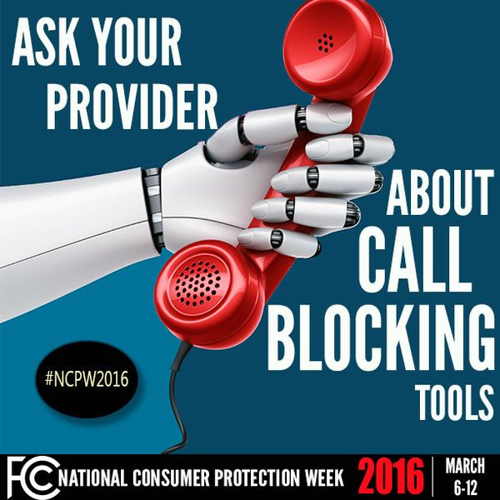
Unwanted “robocalls” have consistently been the top subject of consumer complaints the Commission receives. The FCC has explicit authority to protect consumers from such harassing calls and has taken additional actions to modernize and enforce its rules.

- Issued a series of declaratory rulings affirming customers’ rights to control the calls they receive and removing legal road blocks to innovative “Do Not Disturb” robocall-blocking technologies across all types of carriers, and called on industry to provide consumers with such technology free of charge.
- Adopted an order limiting the number of robocalls that federal government debt collectors can make to wireless customers in a 30-day period.
- Urged mobile wireless carriers to develop technology to block unwanted robocalls, leading to an industry-led “strike force” that will recommend solutions by October 26, 2016.

Cracking Down on Unauthorized Charges
The Commission has taken aggressive action to stop service providers from adding or changing services, equipment, and fees to customers’ bills without their knowledge or consent. Common practices include “cramming” – placing unauthorized charges on wireless and landline phone bills – and “slamming” – unauthorized switching of the provider of a consumer’s landline voice service, but extend to other services like cable television as well.

- Entered into a settlement for approximately $7.75 million in refunds and fines with AT&T Services, Inc. to resolve an investigation into whether the company “crammed” unauthorized third-party charges for a sham directory assistance service on its customers’ wireline telephone bills.
- Announced a $29.6 million proposed fine against four commonly managed long distance carriers for a variety of apparently deceptive and manipulative practices, including cramming, slamming, and targeting consumers with Hispanic surnames.
- Reached a $2.3 million settlement with Comcast to resolve an investigation into whether the company wrongfully charged cable TV customers for services and equipment that those customers never authorized.
- Released a Forfeiture Order imposing a $1.68 million fine against Telseven and its owner for cramming charges on consumers’ telephone bills and for deceptively marketing a directory assistance service.
- Fined long distance carrier Net One International $1.6 million for continuing to charge consumers for services and “late fees” after they affirmatively closed their accounts and paid all final bills.
- Led a joint effort with the Federal Trade Commission and state attorneys general to secure a nationwide record $353 million settlement – much of which went to compensate customers – with the four largest wireless telephone carriers (Verizon and Sprint; AT&T; T-Mobile) for charging consumers for unwanted “premium text message” services.
- Imposed a $1.44 million forfeiture against Preferred Long Distance, Inc., for slamming and misrepresenting the company’s identity during telemarketing calls.

Ending the “Sports Blackout Rule”
In 2014 the Commission voted to eliminate its sports blackout rules, which prohibited cable operators and satellite carriers from retransmitting distant broadcast signals carrying a sporting event if the event is not available live on a local television broadcast station. In doing so, the Commission ended decades of enforcement of league blackout policies that prevent consumers unable to attend live sporting events – whether they are elderly, disabled, or priced out of the market for tickets – from watching their favorite team in the comfort of their own homes.

IV. Strengthening Public Safety through

Emergency Communications
America’s communications networks put emergency help at our fingertips. The Commission’s rules aim to keep it that way, adapting to evolving technology and security needs.

The Future of Emergency Communications
- Adopted rules to promote widespread text-to-911 availability, improving lifesaving access to first responders for people who are deaf, are hard of hearing, have a speech disability, or are unable to make a voice call without endangering the caller.
- Adopted rules to help emergency responders better locate wireless 911 callers by requiring more accurate location information to be transmitted with these calls, especially when placed from indoors.
- Acted to preserve reliable 911 service as technology evolves with proposals that address the increasingly complex nature of the nation’s 911 infrastructure and respond to the recent trend of “sunny day” 911 outages.
- Convened experts to explore the use of apps to connect with emergency services.
- Adopted rules to modernize Wireless Emergency Alerts, including increasing the length of messages, enabling alerts to contain links to photos, requiring Spanish language alerts, and improving geo-targeting of alerts. The Commission also proposed further rules enabling multimedia alerts and other technological advancements.

Reliable and Resilient Networks
- Adopted rules to help Americans communicate during emergencies by giving consumers the tools and information necessary to maintain home landline service during electric outages.
- Worked with Representative Pallone to garner commitments from wireless providers to restore service to consumers faster and provide better information about the state of wireless services during emergencies.
- Adopted rules to promote reliable submarine cable communications by requiring submarine cable licensees to report significant outages to the FCC.
- Adopted rules to make 911 calling more reliable by requiring 911 service providers to annually certify that they have taken measures to ensure resiliency.
- Brought enforcement actions totaling more than $40 million against five voice service providers (GCI; T-Mobile; CenturyLink; Intrado; MCI/Verizon) related to 911 outages.

V. Empowering Consumers
The Commission provides consumers with a host of tools enabling them to make informed decisions in the marketplace and register possible violations of FCC rules.

Broadband Labels
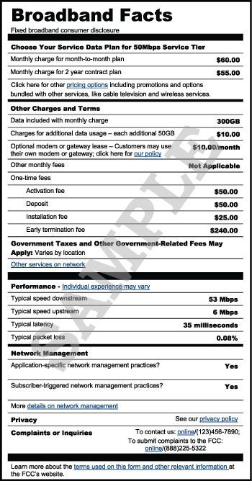
Pursuant to the adoption of the Open Internet transparency rules, the Commission developed new broadband labels to provide consumers with easy-to-understand information about the price and performance of broadband services.

Measuring Mobile Speeds
To help consumers assess the performance of their mobile device and service plan, the Commission launched the Mobile Broadband Speed Test App, which has been downloaded by nearly 90,000 Android and about 70,000 iPhone users.

Consumer Help Center
The Commission created a new Consumer Help Center that more efficiently links consumers to the information they need and simplifies the process for filing and tracking complaints. The Consumer Help Center averages more than 1 million page views each year.

Complaint Database
In 2016 the Commission launched the Consumer Help Center Data site to provide a transparent means for the public to review data on the thousands of consumer complaints the Commission receives each week.

