**FEDERAL COMMUNICATIONS COMMISSION**

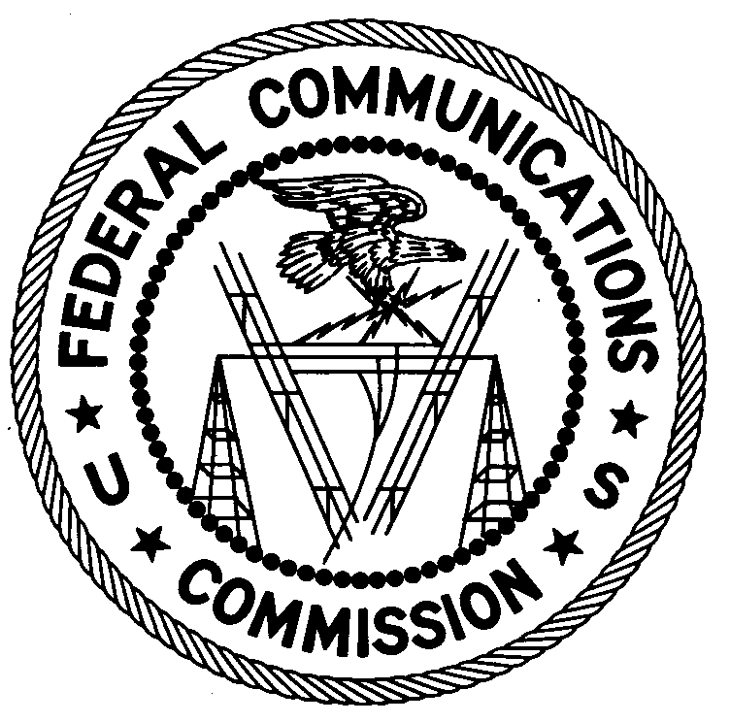**ENFORCEMENT BUREAU**

**REGION ONE**

**New York Office**

201 Varick Street, Suite 1151

New York, New York 10014

212-337-1865

August 25, 2016

Oliviero Construction Corporation

New York, New York

**NOTICE OF UNLICENSED OPERATION**

Case Number: EB-FIELDNER-16-00022373 Document Number: W201632380063

The New York Office received a complaint of unlicensed operation on 455.2125 MHz in New York, New York. On August 17, 2016, agents from this office confirmed by direction finding techniques that radio signals on frequency 455.2125 MHz were emanating from Kenwood portable two-way radio equipment used by employees of Oliviero Construction Corporation (OCC) at a construction site at 685 1st Street New York, New York. These same portable radios also operated on the frequencies 465.7125 MHz, 466.8125 MHz, 452.2125 MHz, and 430.2125 MHz. The Commission’s records show that no license was issued for operation of a radio station on 455.2125 MHz, or any of the aforementioned frequencies, at this location in New York, New York.

Radio stations operating on many frequencies, including 455.2125 MHz and the other frequencies mentioned above, must be licensed by the FCC pursuant to 47 U.S.C. § 301. The only exception to this licensing requirement is for certain transmitters using or operating at a power level or mode of operation that complies with the standards established in Part 15 of the Commission’s rules, 47 C.F.R. §§ 15.1 *et seq*. The Kenwood transmitters used by OCC are authorized under Part 90 of the Commission’s Rules and may only be operated with a valid FCC radio station license. Thus, this station is operating in violation of 47 U.S.C. § 301.

You are hereby warned that operation of radio transmitting equipment without a valid radio station authorization constitutes a violation of the Federal laws cited above and could subject the operator to severe penalties, including, but not limited to, substantial monetary fines, *in rem* arrest action against the offending radio equipment, and criminal sanctions including imprisonment. (*see* 47 U.S.C. §§ 401, 501, 503 and 510).

**UNLICENSED OPERATION OF THIS RADIO STATION MUST BE DISCONTINUED IMMEDIATELY**.

You have ten (10) days from the date of this notice to respond with any evidence that you have authority to operate granted by the FCC. Your response should be sent to the address in the letterhead and reference the listed case and document number. Under the Privacy Act of 1974, 5 U.S.C. § 552a(e)(3), we are informing you that the Commission’s staff will use all relevant material information before it to determine what, if any, enforcement action is required to ensure your compliance with FCC Rules. This will include any information that you disclose in your reply.

You may contact this office if you have any questions.

David C. Dombrowski

Regional Director

Region One

Enforcement Bureau

Federal Communications Commission

Attachments:

Excerpts from the Communications Act of 1934, As Amended

Enforcement Bureau, "Inspection Fact Sheet", March 2005