FEDERAL COMMUNICATIONS COMMISSION
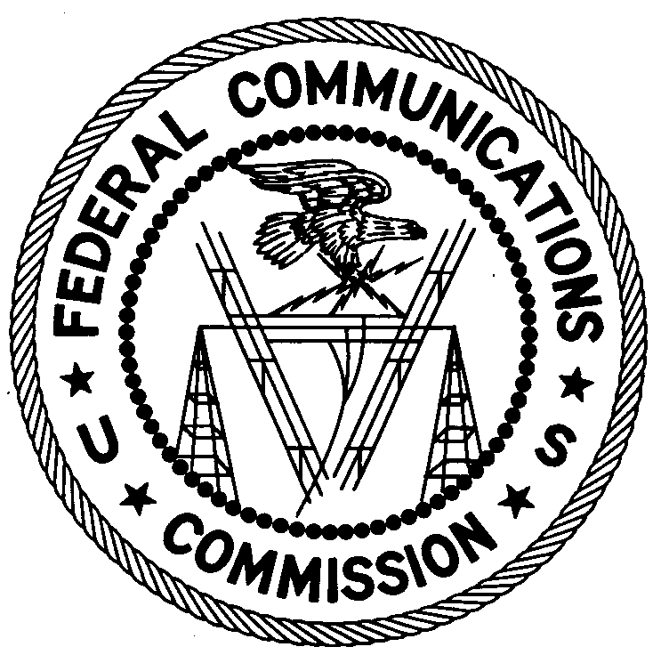
ENFORCEMENT BUREAU
REGION 2

Miami Office
P.O. Box 266468

Weston, FL 33326

July 13, 2016

Brindley Marshall
Miami, Florida

NOTICE OF UNLICENSED OPERATION

Case Number: EB-FIELDSCR-16-00021914

Document Number: W201632600015

On June 7, 2016, agents from this office confirmed by direction finding techniques that radio signals on frequency 97.7 MHz were emanating from your residence on NW 12th Ave. in Miami, Florida. Information received by this office indicates that you an operator of this station. The Commission’s records show that no license was issued for operation of a broadcast station at this location on 97.7 MHz in Miami, Florida.

Radio stations operating on many frequencies, including 97.7 MHz, must be licensed by the FCC pursuant to 47 U.S.C. § 301. The only exception to this licensing requirement is for certain transmitters using or operating at a power level that complies with the standards established in Part 15 of the Commission’s rules, 47 C.F.R. §§ 15.1 et seq. On June 7, 2016, the field strength of the signal on frequency 97.7 MHz exceeded the maximum permitted level of 250 microvolts per meter (µV/m) at 3 meters for non-licensed devices. Thus, this station is operating in violation of 47 U.S.C. § 301.

You are hereby warned that operation of radio transmitting equipment without a valid radio station authorization constitutes a violation of the Federal laws cited above and could subject the operator to severe penalties, including, but not limited to, substantial monetary fines, in rem arrest action against the offending radio equipment, and criminal sanctions including imprisonment. (See 47 U.S.C. §§ 401, 501, 503 and 510.)

UNLICENSED OPERATION OF THIS RADIO STATION MUST BE DISCONTINUED IMMEDIATELY.

You have ten (10) days from the date of this notice to respond with any evidence that you have authority to operate granted by the FCC. Your response should be sent to the address in the letterhead and reference the listed case and document number. Under the Privacy Act of 1974, 5 U.S.C. § 552a(e)(3), we are informing you that the Commission’s staff will use all relevant material information before it to determine what, if any, enforcement action is required to ensure your compliance with FCC Rules. This will include any information that you disclose in your reply.

You may contact this office if you have any questions.

Ronald Ramage
Regional Director

Attachments:
Excerpts from the Communications Act of 1934, As Amended
Enforcement Bureau, "Inspection Fact Sheet," March 2005

