FEDERAL COMMUNICATIONS COMMISSION
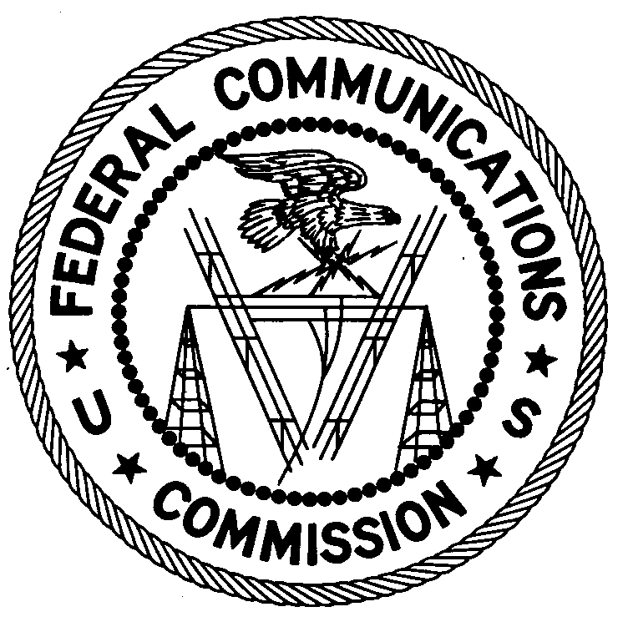
ENFORCEMENT BUREAU
Region 2

Miami Office
P.O. Box 266468

Weston, FL 33326

July 13, 2016

Wide Cloud Communications
Hialeah, Florida

NOTIFICATION OF HARMFUL INTERFERENCE

Case Number: EB-FIELDSCR-16-00021831

Document Number: W201632600019

The Miami Office, in response to a complaint from the Federal Aviation Administration (FAA) that its Terminal Doppler Weather Radar (TDWR) serving the Fort Lauderdale-Hollywood International Airport (FLL) was experiencing harmful interference from radio emissions on or adjacent to the TDWR frequency of 5645 MHz, conducted an investigation in the area. On July 6, 2016, an agent from this office confirmed by direction finding techniques that radio emissions on the frequency band 5655 - 5675 MHz were emanating from one of your wireless transmitters located on the roof of 1840 W. 49th St, Hialeah, FL 33012. Wide Cloud Communications personnel confirmed that it was operating a Ubiquiti Rocket M5 Unlicensed National Information Infrastructure (U-NII) device on the frequency band 5655 – 5675 MHz, and agreed to change the operating frequency when notified of the interference. The interference to the TDWR then ceased.

Nonlicensed operation of a U-NII device is subject to the condition that it must not cause harmful interference and, if harmful interference occurs, operation of the device must cease. See 47 C.F.R. §§ 15.5(c), 15.405. Harmful interference is defined as “[a]ny emission, radiation or induction that endangers the functioning of a radio navigation service or of other safety services or seriously degrades, obstructs or repeatedly interrupts a radio communications service.” 47 C.F.R. § 15.3(m).

Your operation of a U-NII device on 5655 – 5675 MHz caused harmful interference to the TDWR serving Fort Lauderdale-Hollywood International Airport and your operation of this device on these frequencies must not resume. You are also warned that operation of otherwise authorized equipment that continues to cause harmful interference after your receipt of this warning, constitutes a violation of Federal law and could subject the operator to severe penalties, including, but not limited to, substantial monetary fines, in rem arrest action against the offending radio equipment, and criminal sanctions including imprisonment. (see 47 U.S.C. §§ 301, 401, 501, 503 and 510).

NONLICENSED OPERATION OF U-NII DEVICES, AT ANY SITE, THAT CAUSE INTERFERENCE TO ANY TDWR OR OTHER LICENSED RADIO COMMUNCIATIONS SERVICE MUST NOT RESUME. NONLICENSED OPERATION OF U-NII DEVICES MAY NOT RESUME UNLESS YOU ARE IN FULL COMPLIANCE WITH PART 15 OF THE FCC’S RULES.

You have ten (10) days from the date of this notice to respond with any evidence that your transmitters were not the source of the interference to the FLL TDWR. Your response should also describe the steps you are taking to ensure that none of your U-NII devices interfere with the TDWRs serving the Fort Lauderdale-Hollywood and Miami International Airports. Your response should be sent to the address in the letterhead and reference the listed case number and document number. Under the Privacy Act of 1974, 5 U.S.C. § 552a(e)(3), we are informing you that the Commission’s staff will use all relevant material information before it to determine what, if any, enforcement action is required to ensure your compliance with FCC Rules. This will include any information that you disclose in your reply.

You may contact this office if you have any questions.

Ronald Ramage
Regional Director

Attachments:

Excerpts from the Communications Act of 1934, As Amended
Enforcement Bureau, "Inspection Fact Sheet," March 2005
Joint OET and EB Memo dated July 27, 2010 regarding interference to Terminal Doppler Weather Radars
FCC Enforcement Advisory, “TDWR and U-NII Devices” dated September 27, 2012, DA 12-459

