FEDERAL COMMUNICATIONS COMMISSION
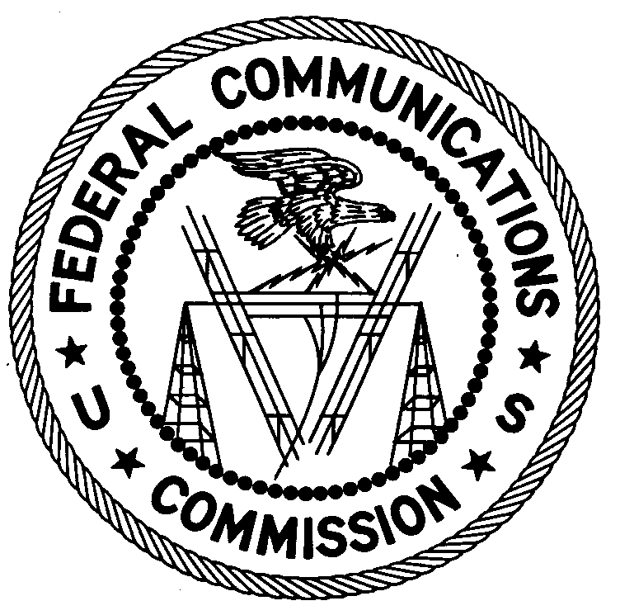
ENFORCEMENT BUREAU
SOUTH CENTRAL REGION

Dallas Office
9330 LBJ Freeway, Suite 1170

Dallas, Texas 75243

April 29, 2016

Walmart Supercenter
4810 North St
Nacogdoches, TX 75965

NOTICE OF UNLICENSED OPERATION

Case Number: EB-FIELDSCR-16-00021371
Document Number: W201632500007

On April 13, 2016, in response to a complaint from Cellular One of radio frequency interference (RFI) affecting the frequency range of 824 MHz to 834 MHz in Nacogdoches, TX, an agent from this office investigated the source of the RFI. Using direction finding techniques, the interference signal at 825.07 MHz was determined to be emanating from the Walmart Supercenter located at 4810 North Street, Nacogdoches, Texas. When the power was removed from the amplifier, the interference signal ceased. The Commission’s records show that no license has been issued to Walmart Supercenter for operation of this station from this location in Nacogdoches, Texas.

The Commission limits the use of both Consumer Signal Boosters and Industrial Signal Boosters by requiring the signal booster operator, in the case of a Consumer Signal Booster, to obtain the consent of the licensee providing service to the subscriber, or, in the case of an Industrial Signal Booster, to obtain an FCC license or the express consent of the licensee(s) whose frequencies are being retransmitted by the device. In either scenario, the operation of the signal booster is only “on a secondary, non-interference basis to primary services licensed for the frequency bands on which they transmit, and to primary services licensed for the adjacent frequency bands that might be affected by their transmissions.”
Operation of radio transmitting equipment without a valid FCC authorization or license is a violation of Section 301 of the Communications Act of 1934, as amended, and may subject the responsible parties to substantial monetary forfeitures. Because unlicensed operation creates a danger of interference to important radio communications services and may subject the operator to severe penalties, this notice emphasizes the importance of complying strictly with these legal requirements.
Please respond within thirty (30) days from the date of this notice with information: 1) showing that Walmart has authority granted by the FCC to operate a signal booster; 2) showing that Walmart has obtained consent from a commercial mobile radio licensee to operate a signal booster; or 3) that Walmart is no longer operating a signal booster. In addition, provide an explanation as to what has been done to correct the interference issue and to ensure that it will not recur; provide the equipment authorization for the equipment involved; and identify the make, model and serial number of each piece of equipment including the antennas if applicable.
Your response should be sent to the address in the letterhead and reference the listed case and document number. Under the Privacy Act of 1974, 5 U.S.C. § 552a(e)(3), we are informing you that the Commission’s staff will use all relevant material information before it to determine what, if any, enforcement action is required to ensure your compliance with FCC Rules. This will include any information that you disclose in your reply.

You may contact this office if you have any questions.

Ronald Ramage
Regional Director

Attachments:
Excerpts from the Communications Act of 1934, As Amended
Enforcement Bureau, "Inspection Fact Sheet", March 2005
Consumer Guide, “Information for Consumers Who Own Signal Boosters”, February 26, 2013

See 47 C.F.R. § 20.21(a). Section 20.21(a) of the Rules states that a “subscriber in good standing of a commercial mobile radio service system may operate a Consumer Signal Booster for personal use under the authorization held by the licensee providing service to the subscriber provided that the subscriber complies with paragraphs (a)(1) through (6). Failure to comply with all applicable rules in this section and all applicable technical rules for the frequency band(s) of operation voids the authority to operate the Consumer Signal Booster. (1) Prior to operation, the subscriber obtains the consent of the licensee providing service to the subscriber; (2) Prior to operation, the subscriber registers the Consumer Signal Booster with the licensee providing service to the subscriber; (3) The subscriber only operates the Consumer Signal Booster with approved antennas, cables, and/or coupling devices as specified by the manufacturer of the Consumer Signal Booster; (4) The subscriber operates the Consumer Signal Booster on frequencies used for the provision of subscriber-based services under parts 22 (Cellular), 24 (Broadband PCS), 27 (AWS–1, 700 MHz Lower A–E Blocks, and 700 MHz Upper C Block), and 90 (Specialized Mobile Radio) of this chapter. Operation on part 90 (Specialized Mobile Radio) frequencies is permitted upon the Commission's release of a public notice announcing the date Consumer Signal Boosters may be used in the band; (5) The Consumer Signal Booster complies with paragraphs (e), (f), (g), and (h) of this section and § 2.907 of this chapter; and (6) The subscriber may not deactivate any features of the Consumer Signal Booster which are designed to prevent harmful interference to wireless networks. These features must be enabled and operating at all times the signal booster is in use.” 47 C.F.R. § 20.21(a).
See 47 C.F.R. § 20.21(c). Section 20.21(c) of the Rules states that “an individual or non-individual, other than a representative of a foreign government, may operate an Industrial Signal Booster provided that the individual or non-individual: (1) Has an FCC license or obtains the express consent of the licensee(s) whose frequencies are being retransmitted by the device on a regular basis, and (2) Uses an Industrial Signal Booster which complies with paragraph (f) of this section.” 47 C.F.R. § 20.21(c). Section 20.21(f) of the Rules details Signal Booster labeling requirements. See 47 C.F.R. § 20.21(f).
See 47 C.F.R. § 20.21(d). “Operation of signal boosters under this section is on a secondary, non-interference basis to primary services licensed for the frequency bands on which they transmit, and to primary services licensed for the adjacent frequency bands that might be affected by their transmissions. (1) The operation of signal boosters must not cause harmful interference to the communications of any primary licensed service. (2) Upon request of an FCC representative or a licensee experiencing harmful interference, a signal booster operator must: (i) Cooperate in determining the source of the interference, and (ii) If necessary, deactivate the signal booster immediately, or as soon as practicable, if immediate deactivation is not possible.”
See 47 U.S.C. § 301.
See 47 U.S.C. §§ 401, 501, 503, 510.

