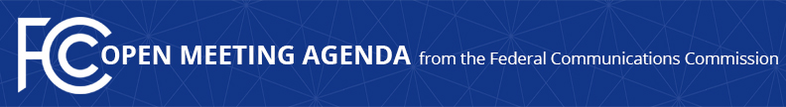

Media Contact:
Will Wiquist, 202-418-0509
will.wiquist@fcc.gov

For Immediate Release

FCC ANNOUNCES TENTATIVE AGENDA FOR JULY OPEN MEETING
--
WASHINGTON, June 25, 2015 – Federal Communications Commission Chairman Tom Wheeler announced that the following items are tentatively on the agenda for the July Open Commission Meeting scheduled for Thursday, July 16, 2015:

Incentive Auction Procedures – The Commission will take the next step to commencing the incentive auction in the first quarter of 2016 by considering the Procedures Public Notice, which adopts a balanced set of auction procedures that will ensure an effective, efficient, and timely auction. The Public Notice establishes and provides information on final procedures for setting the initial spectrum clearing target, qualifying to bid, and bidding in the reverse and forward auctions.

Mobile Spectrum Holdings – The Commission will consider an Order on Reconsideration addressing petitions for reconsideration of certain aspects of the Mobile Spectrum Holdings Report and Order.

Competitive Bidding – The Commission will consider a Report and Order, Order on Reconsideration, Third Order on Reconsideration and a Third Report and Order that provides meaningful opportunities for small businesses, rural telephone companies, and businesses owned by members of minority groups and women to participate in the provision of spectrum-based services, and also strengthens the Commission’s rules to protect against unjust enrichment to ineligible entities.

The Open Meeting is scheduled to commence at 10:30 a.m. in Room TW-C305 of the Federal Communications Commission, 445 12th Street, S.W., Washington, D.C.

###
Office of Media Relations: 202.418.0500
TTY: 888-835-5322
Twitter: @FCC
ftp.fcc.gov
www.fcc.gov/office-media-relations

This is an unofficial announcement of Commission action. Release of the full text of a Commission order constitutes official action. See MCI v. FCC. 515 F 2d 385 (D.C. Circ 1974).

