Broadband Availability in America

With Rural Americans Looking for High-Speed Services,
Adequate Broadband Speeds Remain Out of Reach for Many

Federal Communications Commission
January 30, 2015

“High-speed Internet access has become fundamental to modern life, whether we are on the job, at home, or going to school. Broadband connectivity can overcome geographic isolation and put a world of information and economic opportunity at the fingertips of citizens in even the most remote communities.”

Tom Wheeler, Chairman
Federal Communications Commission

Summary

Access to robust broadband service is a necessity in today’s world for jobs, education, civic engagement and economic competitiveness. Yet many American homes and businesses – especially those in rural communities – do not currently have access to broadband at the speeds necessary to meet these modern needs.

An FCC analysis of data shows that as of December 2013, 53 percent of rural Americans do not have access to service delivering broadband speeds of 25 Mbps for downloads and 3 Mbps for uploads. Nationwide, 55 million Americans lack access to this service, or 17 percent of all Americans.

FCC research shows that these speeds are necessary today to accommodate the increasingly bandwidth- intensive demands from homes and businesses. In today’s world, bandwidth-intensive video is the dominant broadband application. Indeed, streaming video and audio comprises 63 percent of downstream traffic with each video stream typically requiring from 5 to 25 Mbps.

Today’s users need more than 10 Mbps to, for example, participate in an online class, download files, and stream a movie at the same time within one household; to view two high definition videos on separate devices at the same time; or to stream one 4K (aka UltraHD) television service. The average American household with children has more than four people living in it and using seven Internet-connected devices on a shared, broadband network.

Demand for 25 Mbps/3 Mbps broadband service is the same regardless of location: when rural Americans have access to this service, they adopt it at the same rate as urban Americans. Yet it is clear that deployment of advanced telecommunications services is lagging far behind in rural areas. Charts provided in this report below demonstrate this gap, as well as variations in availability from state to state.

Findings
- 17 percent of all Americans (55 million people) lack access to 25 Mbps/3 Mbps service.
- 53 percent of rural Americans (22 million people) lack access to 25 Mbps/3 Mbps.
  - By contrast, only 8 percent of urban Americans lack access to 25 Mbps/3 Mbps broadband.
  - Rural America continues to be underserved at all speeds: 20 percent lack access even to service at 4 Mbps/1 Mbps, down only 1 percent from 2011, and 31 percent lack access to 10 Mbps/1 Mbps, down only 4 percent from 2011.
- 63 percent of Americans living on Tribal lands (2.5 million people) lack access to 25 Mbps/3 Mbps broadband
  - 85 percent living in rural areas of Tribal lands (1.7 million people) lack access.
- 63 percent of Americans living in U.S. territories (2.6 million people) lack access to 25 Mbps/3 Mbps broadband.
  - 79 percent of those living in rural territorial areas (880,000 people) lack access.
- Overall, the gap in availability of broadband at 25/3 closed by only 3 percentage points last year, from 20% lacking access in 2012 to 17% in 2013.
- Americans living in rural and urban areas adopt broadband at similar rates where 25 Mbps/ 3 Mbps service is available, 28 percent in rural areas and 30 percent in urban areas.
- Approximately 35 percent of schools lack access to fiber, and thus likely lack access to broadband at the Commission’s shorter term benchmark (adopted in its July 2014 E-rate Modernization Order) of 100 Mbps per 1,000 users, and even fewer have access at the long term goal of 1 Gbps per 1,000 users.
- The average household has seven Internet-connected devices, according to Verizon and comments filed by the Fiber to the Home Council.
- Video is the dominant broadband application, and is the most bandwidth-intensive.
- Streaming video and audio comprises 63 percent of downstream traffic, according to the 2014 Sandvine Global Internet Phenomena Report, with each video stream typically requiring from 5-25 Mbps.
- Consumer demand for 25/3 broadband more than quadrupled from 2011 to 2013, from 7 percent to 29 percent of consumers adopting where it is available.
- In the states with the least population density – Alaska, Wyoming, Montana, North Dakota, South Dakota and New Mexico – 37 percent of the population lack access to25/3.
- In the states with the most population density – New Jersey, Rhode Island, Massachusetts, Connecticut, Maryland and Delaware – only 3.4 percent of the population lacks access to 25/3 service.
  - Americans residing in the states with the lowest population density are 10 times more likely to lack access then Americans residing in the states with the highest density.

25 Mbps/3 Mbps Broadband Deployment Map
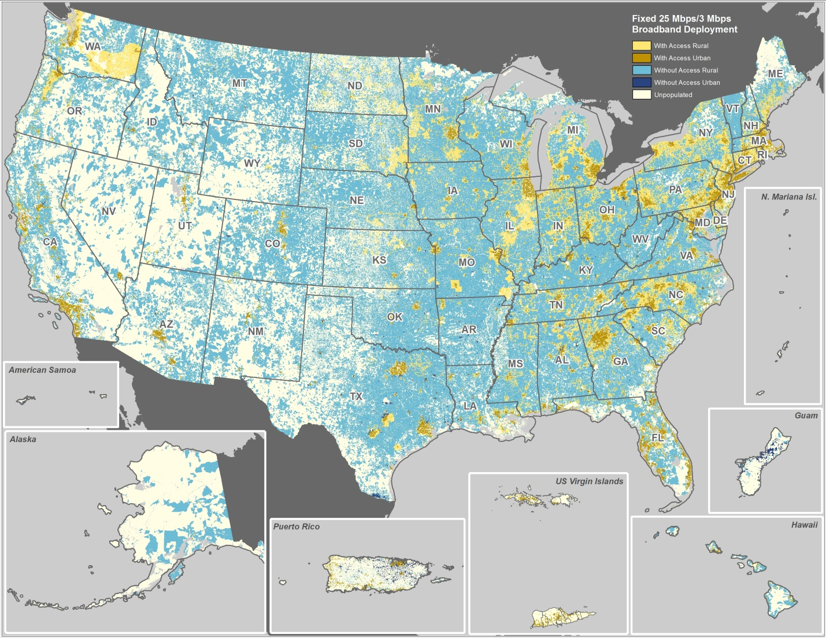

Americans in Urban and Rural Areas Without Access to
25 Mbps/3 Mbps Broadband by State & U.S. Territory
(population in millions)
 | All Areas |  |  | Urban Areas |  |  | Rural Areas
 | Pop. | Pop. Without Access | % of Pop. | Pop. | Pop. Without Access | % of Pop. | Pop. | Pop. Without Access | % of Pop.
United States | 321.325 | 54.560 | 17% | 260.007 | 21.932 | 8% | 61.318 | 32.628 | 53%
All States & the District of Columbia | 317.264 | 51.988 | 16% | 257.061 | 20.240 | 8% | 60.203 | 31.748 | 53%
Alabama | 4.880 | 1.701 | 35% | 2.898 | 0.588 | 20% | 1.982 | 1.113 | 56%
Alaska | 0.740 | 0.285 | 38% | 0.493 | 0.086 | 17% | 0.247 | 0.199 | 81%
Arizona | 6.751 | 1.162 | 17% | 6.079 | 0.622 | 10% | 0.671 | 0.540 | 80%
Arkansas | 2.992 | 1.751 | 59% | 1.704 | 0.668 | 39% | 1.288 | 1.084 | 84%
California | 38.338 | 2.601 | 7% | 36.451 | 1.335 | 4% | 1.888 | 1.266 | 67%
Colorado | 5.262 | 0.943 | 18% | 4.553 | 0.438 | 10% | 0.709 | 0.504 | 71%
Connecticut | 3.619 | 0.050 | 1% | 3.184 | 0.029 | 1% | 0.435 | 0.021 | 5%
Delaware | 0.931 | 0.030 | 3% | 0.775 | 0.010 | 1% | 0.156 | 0.020 | 13%
District of Columbia | 0.622 | 0.009 | 2% | 0.622 | 0.009 | 2%
Florida | 19.631 | 1.278 | 7% | 17.903 | 0.571 | 3% | 1.728 | 0.708 | 41%
Georgia | 10.129 | 1.403 | 14% | 7.632 | 0.303 | 4% | 2.497 | 1.100 | 44%
Hawaii | 1.406 | 0.057 | 4% | 1.295 | 0.007 | 1% | 0.111 | 0.050 | 45%
Idaho | 1.645 | 0.820 | 50% | 1.174 | 0.446 | 38% | 0.472 | 0.374 | 79%
Illinois | 12.958 | 0.710 | 5% | 11.499 | 0.139 | 1% | 1.459 | 0.570 | 39%
Indiana | 6.606 | 0.947 | 14% | 4.816 | 0.160 | 3% | 1.790 | 0.787 | 44%
Iowa | 3.090 | 0.761 | 25% | 2.009 | 0.109 | 5% | 1.081 | 0.652 | 60%
Kansas | 2.908 | 0.794 | 27% | 2.190 | 0.282 | 13% | 0.718 | 0.512 | 71%
Kentucky | 4.435 | 1.767 | 40% | 2.616 | 0.445 | 17% | 1.819 | 1.322 | 73%
Louisiana | 4.584 | 1.325 | 29% | 3.348 | 0.531 | 16% | 1.237 | 0.793 | 64%
Maine | 1.340 | 0.291 | 22% | 0.511 | 0.033 | 6% | 0.829 | 0.258 | 31%
Maryland | 5.925 | 0.418 | 7% | 5.168 | 0.216 | 4% | 0.757 | 0.202 | 27%
Massachusetts | 6.624 | 0.238 | 4% | 6.092 | 0.140 | 2% | 0.532 | 0.098 | 18%
Michigan | 9.858 | 1.250 | 13% | 7.344 | 0.282 | 4% | 2.514 | 0.968 | 39%
Minnesota | 5.424 | 0.725 | 13% | 4.000 | 0.055 | 1% | 1.424 | 0.669 | 47%
Mississippi | 3.006 | 1.196 | 40% | 1.483 | 0.261 | 18% | 1.523 | 0.935 | 61%
Missouri | 6.103 | 1.792 | 29% | 4.307 | 0.523 | 12% | 1.796 | 1.269 | 71%
Montana | 1.018 | 0.882 | 87% | 0.574 | 0.482 | 84% | 0.444 | 0.400 | 90%
Nebraska | 1.867 | 0.502 | 27% | 1.390 | 0.154 | 11% | 0.477 | 0.349 | 73%
Nevada | 2.876 | 0.173 | 6% | 2.722 | 0.075 | 3% | 0.155 | 0.098 | 64%
New Hampshire | 1.335 | 0.228 | 17% | 0.801 | 0.037 | 5% | 0.534 | 0.191 | 36%
New Jersey | 8.900 | 0.172 | 2% | 8.430 | 0.112 | 1% | 0.470 | 0.060 | 13%
New Mexico | 2.136 | 0.643 | 30% | 1.672 | 0.287 | 17% | 0.465 | 0.356 | 77%
New York | 19.531 | 0.518 | 3% | 17.199 | 0.022 | 0% | 2.333 | 0.496 | 21%
North Carolina | 9.977 | 1.446 | 14% | 6.671 | 0.292 | 4% | 3.307 | 1.154 | 35%
North Dakota | 0.690 | 0.102 | 15% | 0.427 | 0.004 | 1% | 0.263 | 0.098 | 37%
Ohio | 11.587 | 1.935 | 17% | 9.053 | 0.705 | 8% | 2.535 | 1.230 | 49%
Oklahoma | 3.856 | 1.882 | 49% | 2.563 | 0.738 | 29% | 1.293 | 1.145 | 89%
Oregon | 3.957 | 0.276 | 7% | 3.228 | 0.029 | 1% | 0.730 | 0.248 | 34%
Pennsylvania | 12.842 | 1.695 | 13% | 10.111 | 0.717 | 7% | 2.731 | 0.979 | 36%
Rhode Island | 1.052 | 0.007 | 1% | 0.953 | 0.000 | 0% | 0.098 | 0.006 | 6%
South Carolina | 4.812 | 1.085 | 23% | 3.229 | 0.387 | 12% | 1.583 | 0.698 | 44%
South Dakota | 0.837 | 0.160 | 19% | 0.489 | 0.003 | 1% | 0.348 | 0.157 | 45%
Tennessee | 6.547 | 1.148 | 18% | 4.369 | 0.159 | 4% | 2.177 | 0.989 | 45%
Texas | 26.549 | 9.987 | 38% | 22.585 | 6.653 | 29% | 3.964 | 3.334 | 84%
Utah | 2.931 | 0.149 | 5% | 2.662 | 0.044 | 2% | 0.268 | 0.105 | 39%
Vermont | 0.630 | 0.502 | 80% | 0.247 | 0.157 | 63% | 0.383 | 0.346 | 90%
Virginia | 8.290 | 1.734 | 21% | 6.295 | 0.453 | 7% | 1.995 | 1.281 | 64%
Washington | 6.998 | 0.277 | 4% | 5.887 | 0.039 | 1% | 1.111 | 0.238 | 21%
West Virginia | 1.869 | 1.042 | 56% | 0.909 | 0.328 | 36% | 0.960 | 0.714 | 74%
Wisconsin | 5.783 | 0.962 | 17% | 4.071 | 0.052 | 1% | 1.712 | 0.910 | 53%
Wyoming | 0.585 | 0.175 | 30% | 0.378 | 0.023 | 6% | 0.207 | 0.152 | 74%
U.S. Territories | 4.061 | 2.572 | 63% | 2.946 | 1.692 | 57% | 1.116 | 0.880 | 79%
American Samoa | 0.055 | 0.055 | 100% | 0.042 | 0.042 | 100% | 0.013 | 0.013 | 100%
Guam | 0.160 | 0.160 | 100% | 0.108 | 0.108 | 100% | 0.052 | 0.052 | 100%
Northern Mariana Islands | 0.051 | 0.051 | 100% | 0.034 | 0.034 | 100% | 0.018 | 0.018 | 100%
Puerto Rico | 3.690 | 2.259 | 61% | 2.719 | 1.506 | 55% | 0.970 | 0.752 | 78%
U.S. Virgin Islands | 0.105 | 0.047 | 45% | 0.043 | 0.002 | 5% | 0.062 | 0.045 | 72%

