FEDERAL COMMUNICATIONS COMMISSION
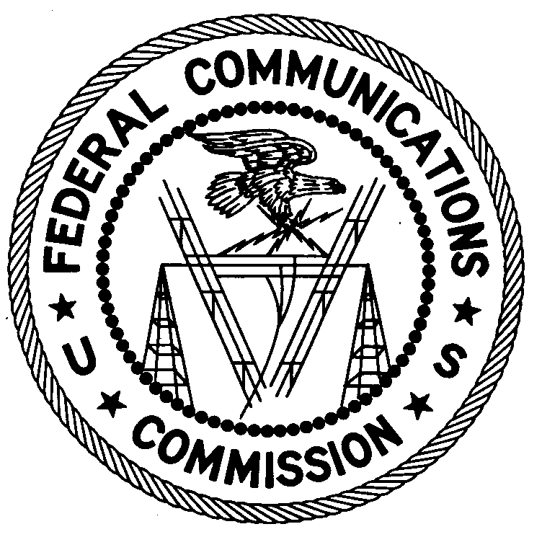
ENFORCEMENT BUREAU
WESTERN REGION

Los Angeles District Office
18000 Studebaker Rd., #660
Cerritos, CA 90780

December 31, 2014

Martin K. Elliott
Inyokern, CA

NOTICE OF UNLICENSED OPERATION

Case Number: EB-FIELDWR-14-00017931 Document Number: W201532900003

On December 17 and 18, 2014, in response to a complaint of unlicensed operation on multiple H.F. frequencies, including those allocated to aeronautical stations, agents from this office confirmed by radio direction finding techniques that radio signals operating on frequencies of 6280 kHz and 11595 kHz were emanating from a residence located near Inyokern, California. A search of the property records for this location found that you are the current owner and resident. The Commission’s records show that no license was issued for operation of a station on either the frequencies of 6280 kHz or 11595 kHz at this location.

Radio stations must be licensed by the FCC pursuant to 47 U.S.C. § 301. You are hereby warned that operation of radio transmitting equipment without a valid radio station authorization constitutes a violation of 47 U.S.C. § 301 and could subject the operator of this illegal operation to severe penalties, including, but not limited to, substantial monetary forfeitures, in rem arrest action against the offending radio equipment, and criminal sanctions including imprisonment. (See 47 U.S.C. §§ 401, 501, 503 and 510.)

UNLICENSED OPERATION OF THIS RADIO STATION MUST BE DISCONTINUED IMMEDIATELY.

You have ten (10) days from the date of this notice to respond with any evidence that you have authority to operate granted by the FCC. Your response should be sent to the address in the letterhead and reference the listed case and document number. Under the Privacy Act of 1974, 5 U.S.C. § 552a(e)(3), we are informing you that the Commission’s staff will use all relevant material information before it to determine what, if any, enforcement action is required to ensure your compliance with FCC Rules. This will include any information that you disclose in your reply.

Be advised that this notice does not preclude this office from pursuing additional sanctions based upon our investigation of this incident.
You may contact this office if you have any questions.

Charles A. Cooper
District Director
Los Angeles District Office
Western Region
Enforcement Bureau

Attachments:
Excerpts from the Communications Act of 1934, As Amended
Enforcement Bureau, "Inspection Fact Sheet," March 2005

