FCC Chairman Tom Wheeler: More Competition Needed in High-Speed Broadband Marketplace

Speaking at 1776, a startup incubator in Washington, D.C., FCC Chairman Tom Wheeler addressed the state of competition in the market for high-speed broadband. In his prepared remarks, Chairman Wheeler told an audience of technology startups, innovators, consumer advocates and industry that “meaningful competition for high-speed wired broadband is lacking and Americans need more competitive choices for faster and better Internet connections, both to take advantage of today’s new services, and to incentivize the development of tomorrow’s innovations.” The Chairman laid out his Agenda for Broadband Competition – a policy framework aimed at helping deliver meaningful competitive choices for high-speed Internet to consumers and innovators.

Consumers, innovators and businesses demand faster, better high-speed Internet. As these demands are changing, competition in the broadband marketplace isn’t keeping pace. The FCC’s current definition of broadband is 4 Mbps download speed/1 Mbps upload speed. But 60 percent of peak-period Internet activity consists of delivering bandwidth-intensive content, like video.
By most calculations, a single HD movie requires 5 Mbps and super HD requires 7 Mbps of download speed. The average U.S. Internet-connected homes have six connected devices – televisions, desktops, laptops, tablets, smartphones, etc. When those devices are in use at the same time, it’s not difficult to strain the capacity of a 25 Mbps connection, and completely overwhelm a 4 Mbps connection.
Most American homes lack competitive choices for fixed high-speed Internet.
One in five American homes does not have access to high-speed Internet, the essential infrastructure of the 21st century economy, of 25 Mbps.
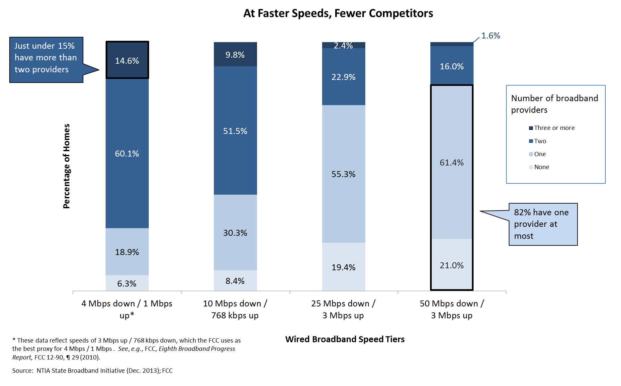
Source: NTIA, State Broadband Initiative Data (Dec. 2013); FCC
In the 25 Mbps downstream/ 3 Mbps upstream speed tier:
- 20 percent of American homes do not have access to high-speed Internet Service.
- 55.3 percent of homes have access to only one provider.
- Taken together, nearly 75 percent of homes have no choice in providers.

Even at lower speeds, there are too many American homes that lack competitive choice.
In the mid-tier 10 Mbps downstream/1 Mbps upstream:
- Only 30.3 percent of homes have a choice of one provider.
- 8.4 percent of homes have no provider offering these speeds.
- Taken together, nearly 39 percent of homes have no choice in providers.

At the current FCC benchmark for high-speed Internet service, 4 Mbps downstream/1 Mpbs upstream, the majority of Americans have a choice of only two providers.

Rural Americans enjoy even less competition, fewer high-speed Internet service and wireless choices.
- Nearly one-fourth of Americans who live in rural areas —14.5 million people—lack access to the most basic broadband services (4 Mbps up/1 Mbps down).
- Americans living in urban areas are three times more likely to have access to Next Generation broadband than Americans in rural areas.
- Only 37 percent of rural consumers are covered by at least four 3G or 4G mobile wireless providers’ networks.

More Competition Leads to Better, Faster, Cheaper Broadband
- Kansas saw a 97 percent surge in speeds to 34.4 Mbps after Google announced its fiber deployment – the largest year over year jump in bandwidth of any state in the country. Similar competitive responses occurred in Austin with TWC announcing that it will offer 300 Mbps – a six fold increase as well as plans to cover Austin in a Wi-Fi network and AT&T announcing plans to build its own gigabit network.
- Cox and CenturyLink have announced plans to roll out 1 Gbps service in portions of their territories, including in areas where they compete with one another such as Omaha, Phoenix and Las Vegas, among others.
- After Lafayette, LA launched its fiber service, Cox selected Lafayette, LA as the first market for its 50 Mbps DOCSIS 3.0 service tier.

FCC Chairman Wheeler laid out a policy framework – the Agenda for Broadband Competition – to help deliver greater competition and more choice for consumers and businesses. The principles are:
- One: Where competition exists, the Commission will protect it.
- Two: Where greater competition can exist, we will encourage it.
- Three: Where meaningful competition is not available, the Commission will work to create it.
- Four: Where competition cannot be expected to exist, we must shoulder the responsibility of promoting the deployment of broadband for the sake of consumers and innovators.

