FEDERAL COMMUNICATIONS COMMISSION
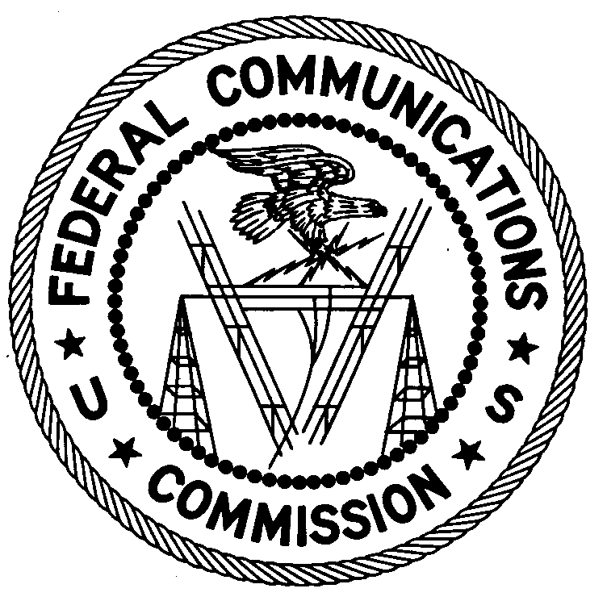ENFORCEMENT BUREAU
WESTERN REGION

San Francisco Office
5653 Stoneridge Drive, Suite 105

Pleasanton, California 94588-8543
(925) 416-9717

June 19, 2014

Cesar Ascarrunz
San Francisco, CA 94131

NOTICE OF UNLICENSED OPERATION

Case Number: EB-FIELDWR-14-00014691

Document Number: W201432960002

The San Francisco Office received information that an unlicensed broadcast radio station on 102.5 MHz was allegedly operating in San Francisco, California. On March 8, 2014, an agent from this office confirmed by direction finding techniques that radio signals on frequency 102.5 MHz were emanating from your residence in San Francisco, California. The Commission’s records show that no license was issued for operation of a broadcast station at that location on 102.5 MHz in San Francisco, California.

Radio stations must be licensed by the FCC pursuant to 47 U.S.C. § 301. The only exception to this licensing requirement is for certain transmitters using or operating at a power level that complies with the standards established in Part 15 of the Commission’s rules, 47 C.F.R. §§ 15.1 et seq. The field strength of the signal on frequency 102.5 MHz exceeded the maximum permitted level of 250 microvolts per meter (µV/m) at 3 meters for non-licensed devices. Thus, this station is operating in violation of 47 U.S.C. § 301.

You are hereby warned that operation of radio transmitting equipment without a valid radio station authorization constitutes a violation of the Federal laws cited above and could subject the operator of this illegal operation to severe penalties, including, but not limited to, substantial monetary forfeitures, in rem arrest action against the offending radio equipment, and criminal sanctions including imprisonment. (See 47 U.S.C. §§ 401, 501, 503 and 510.)

UNLICENSED OPERATION OF THIS RADIO STATION MUST BE DISCONTINUED IMMEDIATELY.

You have ten (10) days from the date of this notice to respond with any evidence that you have authority to operate granted by the FCC. Your response should be sent to the address in the letterhead and reference the listed case and document number. Under the Privacy Act of 1974, 5 U.S.C. § 552a(e)(3), we are informing you that the Commission’s staff will use all relevant material information before it to determine what, if any, enforcement action is required to ensure your compliance with FCC Rules. This will include any information that you disclose in your reply.

You may contact this office if you have any questions.

David K. Hartshorn
District Director
San Francisco Office
Western Region
Enforcement Bureau

Attachments:
Excerpts from the Communications Act of 1934, As Amended
Enforcement Bureau, "Inspection Fact Sheet," March 2005

