DA 16-419
Released: April 18, 2016

PUBLIC SAFETY AND HOMELAND SECURITY BUREAU PROVIDES INFORMATION ON IMPLEMENTATION OF EAS TEST REPORTING SYSTEM
PS Docket No. 15-94

I. Introduction
By this Public Notice, the Public Safety and Homeland Security Bureau (Bureau) of the Federal Communications Commission (Commission) provides initial information about the format and features of the new Emergency Alert System (EAS) Test Reporting System (ETRS) that the Commission will officially launch later this year in coordination with the Federal Emergency Management Agency (FEMA) nationwide test of the EAS.
As described in this Public Notice, the ETRS is designed to increase the reliability and value proposition of the EAS, while minimizing reporting burdens on EAS Participants. The ETRS will be able to accurately chart what happened in a particular test, as well as allow state alert originators and SECCs to understand ahead of time how an alert will propagate through a particular state, thus identifying potential single points of failure, poor transmission paths, and coverage gaps before they can potentially cause a system failure.
The ETRS is built to be scalable and forward-looking. It will deliver reports on a nationwide test, ranging from those national in scope to those that assess one county’s performance. Further, for the first time, the Commission and other authorized entities will be able to view an “FCC Mapbook.” Because the Mapbook will be based on regularly updated information, the FCC, in coordination with its federal partners and state, local, tribal, and territorial stakeholders, can use it to create a continually updated map that reflects a current, accurate EAS architecture and topology.
The ETRS is flexible. It is built on a platform that can be integrated with other FCC databases, such as the outage and licensing databases, so that it can leverage data that enhances the reliability of the EAS while, at the same time, reducing the need to re-collect data that EAS Participants have already provided via other databases. In the future, the ETRS could potentially combine with the State EAS Plan Filing Interface, the new online State EAS Plan filing system proposed in the recent “Alert Paradigm” NPRM, thus providing authorized EAS stakeholders with a complete and dynamic picture of the EAS from the local community to the national level.

II. Background
On June 3, 2015 the Commission released the Sixth Report and Order, in which it adopted rules establishing the ETRS, a mandatory version of the voluntary electronic test reporting system employed for the 2011 nationwide EAS test. The Commission retained the three-form structure of the 2011 version, and adopted new features and data fields responsive to stakeholder comments. The Commission intended the ETRS to contain features that would ease the data-entry burden on EAS Participants, encourage timely filings, and minimize input errors. The Commission directed the Bureau to implement the operational details of the system, pursuant to the principles and requirements established in the Sixth Report and Order.
III. DISCUSSION

Registration
EAS Participants must register an account in order to access the ETRS. A forthcoming public notice, announcing the launch of the ETRS, will contain a URL linking applicants to an ETRS registration form on the Commission’s website. Once at the registration form, filers must enter their names, contact information, the legal name of the EAS Participant for which they are filing, the EAS Participant’s FCC registration number (FRN), and the password associated with that FRN. Upon completion of this registration process, each filer will be e-mailed an ETRS username, an ETRS password, and instructions on how to access ETRS. ETRS accounts will only be provided to EAS Participants that register using a valid FRN and associated password.

ETRS Homepage
Once EAS Participants log into ETRS, they will be taken to the ETRS Homepage and provided with instructions on how to access and fill out Form One. Figure 1 illustrates a draft of the ETRS Homepage.
Figure 1: ETRS Homepage
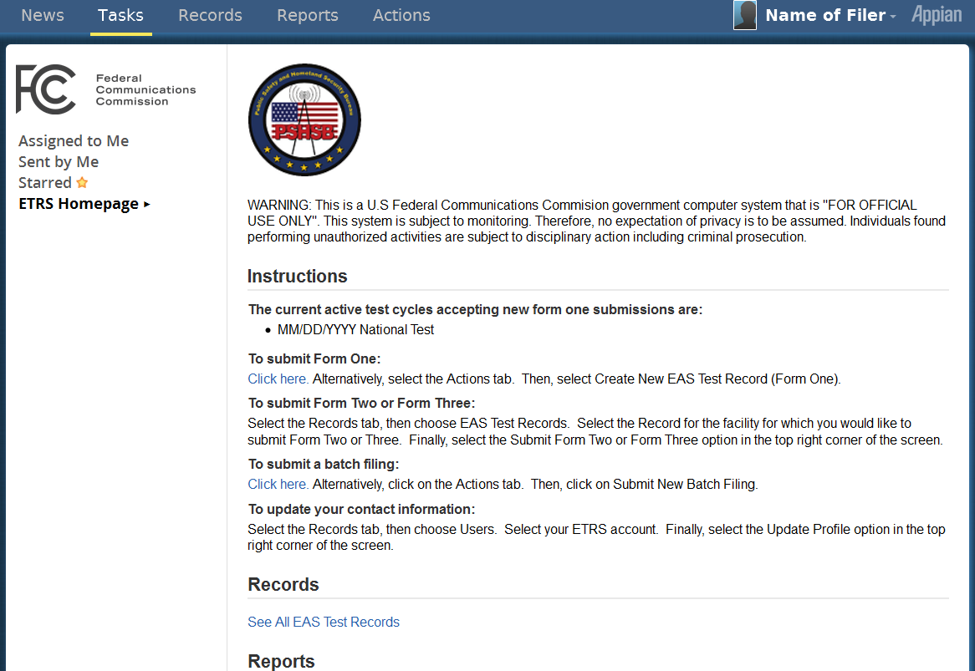
C. Form One – Identifying and Background Information
Form One prompts EAS Participants to supply identifying and background information. EAS participants must submit a completed Form One in the ETRS within sixty days of the Commission’s official launch of the ETRS. EAS Participants must update their Form One filings concurrent with any changes in identifying and background information. In this Section, we discuss each step associated with completion of Form One.
Indicate EAS Participant Type. Form One will prompt EAS Participants to identify themselves by EAS Participant Type. As discussed in the Sixth Report and Order, Form One will allow EAS Participants to identify as one of the following:
- Radio broadcaster
- Television broadcaster
- Cable system
- Wireless cable system
- Direct Broadcast Satellite
- Satellite Digital Audio Radio Service
- Wireline video system
- Other
These EAS Participant types are intended to correspond directly with the description of “EAS Participants” in Section 11.2(d) of the Commission’s EAS rules. EAS Participants will select one of these types from a dropdown menu.
Identify Facility. Form One will present EAS Participants with identifier fields that correspond to the EAS Participant type that they select. Radio broadcasters, television broadcasters, Direct Broadcast Satellites, and Satellite Digital Audio Radio Services will be identified by Facility ID and call sign. Cable systems, wireless cable systems, and wireline video systems will be identified by Physical System ID (PSID) and Community Unit ID (CUID). As required by the Sixth Report and Order, and requested by all commenting stakeholders, once EAS Participants have identified a facility, the ETRS will automatically populate any field for which the EAS Participant has already supplied a response in related Commission databases or the ETRS itself. EAS Participants can either type in their identifiers or select their identifiers from a searchable list.
Figure 2: Form One - Participant Information
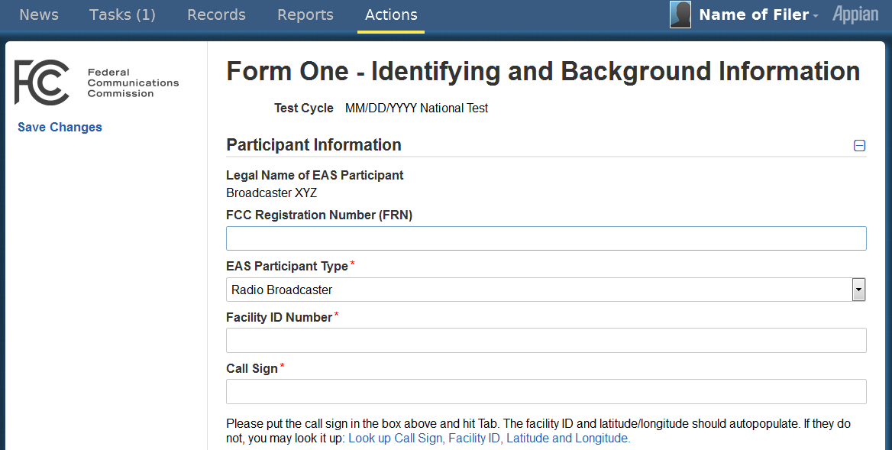
Provide Transmitter Location. As discussed in the Sixth Report and Order, an EAS Participant’s unique identifier may not always be sufficient to indicate the geographic area in which the EAS Participant operates. Accordingly, Form One will prompt EAS Participants to provide more granular information about their location, if appropriate. Form One will now feature a “Geographic Zone of Service” field in which EAS Participants can specify the geographic area in which their facilities deliver EAS alerts. EAS Participants will also supply latitude and longitude values as expressed by the North American Datum of 1983 (NAD83), city, county, and state (or territory). These fields will be pre-populated if the information already exists in Commission databases.
Figure 3: Form One – Transmitter Location
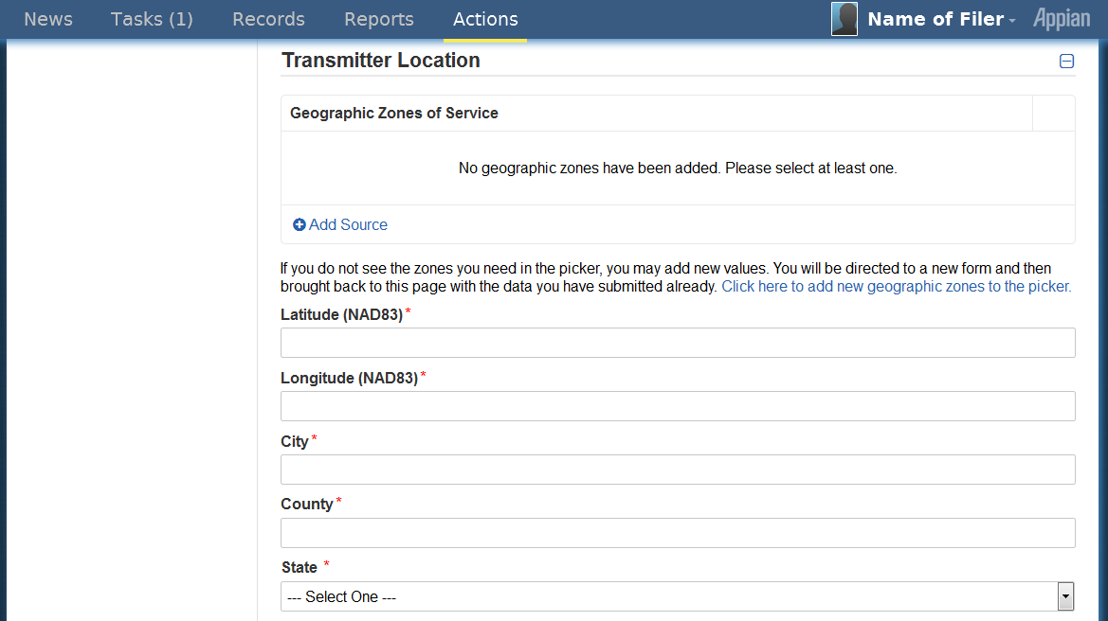
Indicate EAS Designations. Form One will prompt EAS Participants to indicate their EAS Designations, as provided and defined in Part 11 of the Commission’s rules. Specifically, EAS Participants would identify themselves with one or more of the following designations.
- National Primary (NP)
- State Primary (SP)
- State Relay (SR)
- Local Primary 1 (LP-1)
- Local Primary 2 (LP-2)
- Participating National (PN)
Indicate Monitoring Assignments. Just as in the 2011 system, Form One will prompt EAS Participants to report their two required monitoring assignments. EAS Participants will be required to indicate whether either or both of the two required monitoring assignments are pursuant to a waiver that permits the monitoring of sources other than those specified by its EAS State Plan. Form One will also include a field that EAS Participants will use to identify any other sources that they monitor in addition to their two required monitoring assignments.
Figure 4: Form One – Emergency Alert System
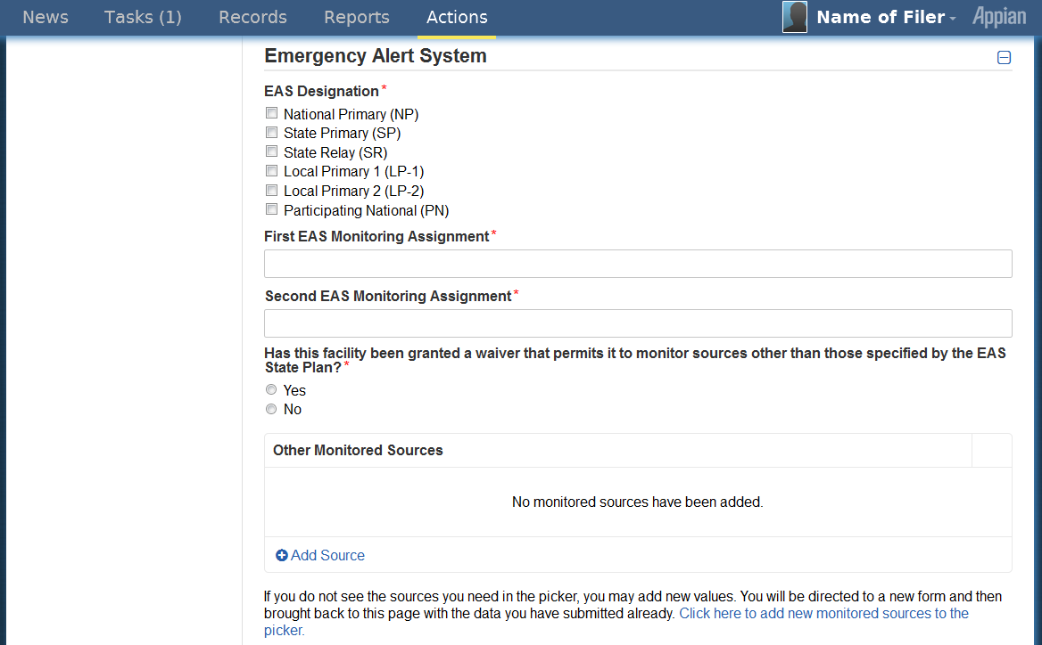
Select Equipment Type and Software Version. In the 2011 precursor to the ETRS, EAS Participants were required to type in the manufacturer, model, and software version of their EAS equipment. Form One of the ETRS will make this process easier by prompting EAS Participants to select their facilities’ equipment make, model, and software version from a dropdown menu of known equipment types and software versions. EAS Participants will also indicate whether their equipment is interfacing with the Federal Emergency Management Agency's Integrated Public Alert and Warning System (IPAWS) as required by Part 11 of the Commission’s rules.

Figure 5: Form One – Emergency Alert System (continued)
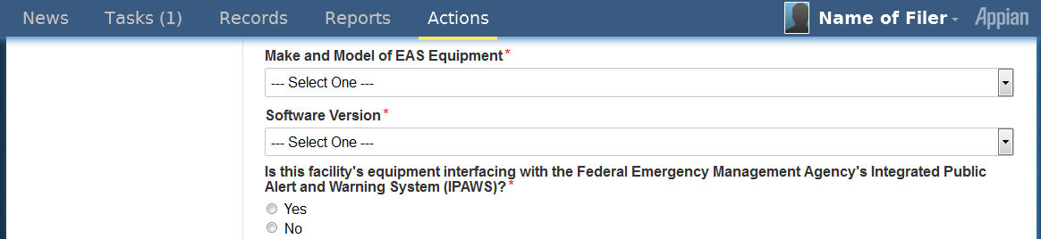
Confirm Contact Information. The Sixth Report and Order states that filers will be required to supply contact information related to the individual who completes their ETRS filing. Accordingly, Form One will prompt filers to provide their contact information. The contact information that filers submitted when registering the account will be used to pre-populate Form One’s contact information fields. If the contact information for the person registering the account is not the same as the contact information for the person completing Form One, filers will be permitted to modify the pre-populated contact information to ensure its accuracy.
Provide Emergency Contact Information. In addition to filer contact information, Form One will prompt EAS Participants to identify an individual who will serve as an emergency contact during a nationwide test. Identification of an emergency contact will allow the Bureau to rapidly communicate with EAS Participants and assist in resolving any complications that may arise during the nationwide EAS test. Filers will be asked if they will serve as their organization’s emergency contact. If filers select “yes,” the previously entered contact information will be automatically populated in the "Emergency Contact Information” fields. If filers select “no,” they will be prompted to manually supply contact information for an appropriate emergency contact person for their organization.
Figure 6: Form One – Contact Information
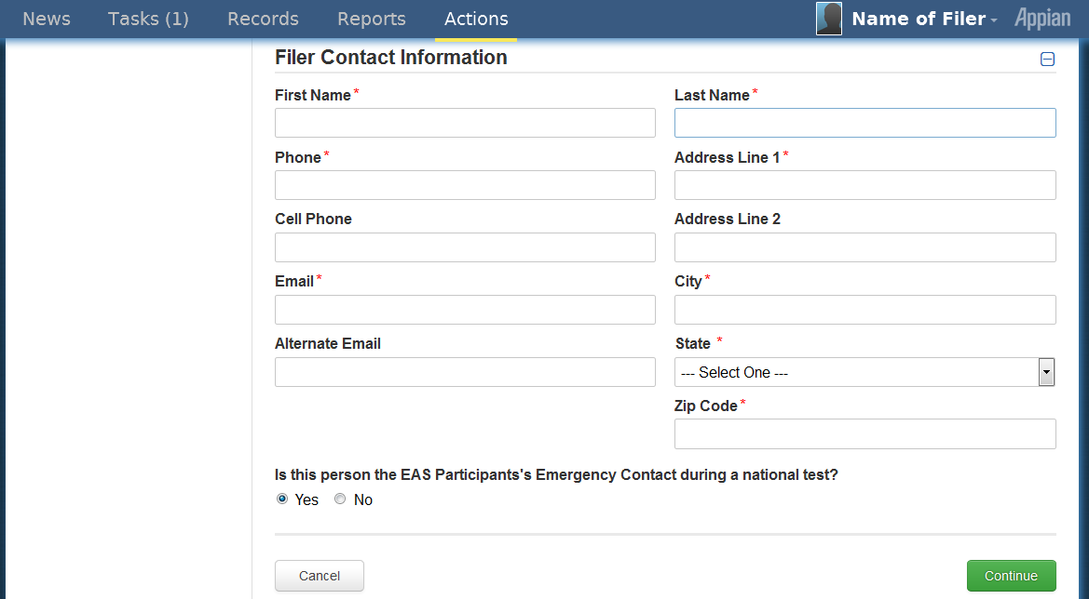
D. Form Two – Day of Test Reporting
Form Two prompts EAS Participants to report whether they received and retransmitted the nationwide EAS test message. Form Two must be completed within 24 hours of a nationwide EAS test or as otherwise required by the Bureau. In this Section, we describe each step of Form Two.
Pre-populated Participant Information. Form Two’s “Participant Information” fields (which will be identical to those presented in Form One) will automatically populate using the data the EAS Participant has provided in Form One.
Indicate EAS Message Receipt and Retransmission. Form Two will prompt EAS Participants to indicate whether they received the nationwide EAS test message and whether they retransmitted the nationwide EAS test message. We will no longer ask EAS Participants if they transmitted the test message “successfully” because we do not expect that EAS Participants will know whether downstream EAS Participants were able to successfully receive and process the test message. We will assume for the purposes of Form Two that the test message is retransmitted in accordance with the requirements of Part 11 of our EAS rules. Any deviation from the nationwide EAS test retransmission requirements contained in our rules should be reported on Form Three.

Figure 7: Form Two
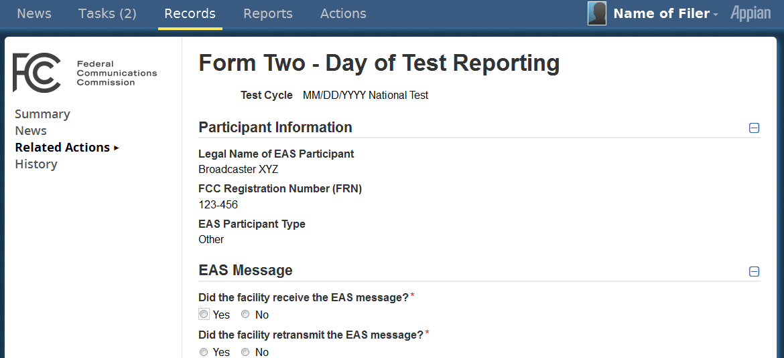
Pre-populated Contact Information. Form Two will prompt filers to confirm their contact information, which will pre-populate from the contact information that filers submitted when registering the account.
E. Form Three – Detailed Test Reporting
Form Three prompts EAS Participants to provide a detailed report on their participation in a nationwide EAS test, including details regarding their receipt and retransmission of the nationwide EAS test message. Form Three must be completed within forty-five days following a nationwide EAS test. In this Section, we describe each step of Form Three.
Pre-populated Participant Information. Form Three’s “Participant Information” fields (which will be identical to those presented in Forms One and Two) will automatically populate using the data the EAS Participant has provided in Forms One and Two.
Provide a Detailed Report on Receipt of EAS Message. The ETRS makes it significantly easier for EAS Participants to submit detailed post-test information. Form Three will prompt the EAS Participant to enter detailed information about its receipt of the test message. This information will include the source of the EAS message, the date and time at which the facility received the nationwide EAS test message, and the time zone in which the facility is located. EAS Participants will then be prompted to indicate any complications that were experienced in receiving the EAS test message. The ETRS will allow the EAS Participant to answer this question by selecting from among six common complications that arose during the first nationwide EAS test:
- Failed to receive alert code
- Audio quality issues
- Received duplicate messages
- Equipment performance issues
- User error
- Other
EAS Participants may select more than one complication, to the extent that multiple complications are applicable. They may also indicate that they experienced “No complications.” EAS Participants will then be prompted to explain their responses using free text. Such responses should include technical information on equipment performance, as necessary.
Figure 8: Form Three – Receipt of EAS Message
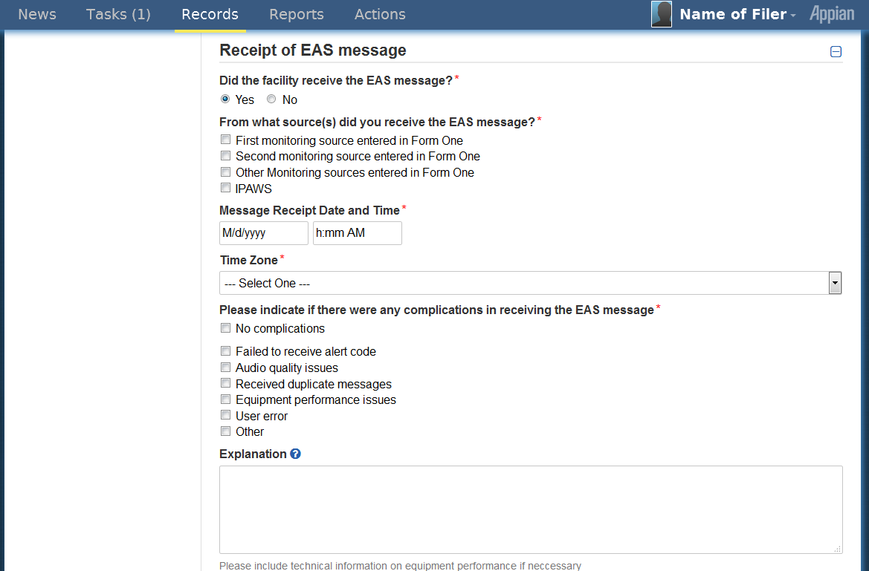

Provide a Detailed Report of Retransmission of EAS Message. After completing the “Message Receipt” section of Form Three, EAS Participants will complete a similar “Message Retransmission” section. After confirming whether the facility retransmitted the test message as specified in Form Two, EAS Participants will enter the retransmission date and time. Form Three will then prompt EAS Participants to indicate any complications that they experienced in retransmitting the EAS test message. This time, EAS Participants will be presented with four complications that arose during the first nationwide EAS test.
- Failed to retransmit alert code
- Equipment performance issues
- User error
- Other
EAS Participants may select multiple complications. If applicable, EAS Participants may also indicate that they experienced “No complications.”

Figure 9: Form Three – Retransmission of EAS Message
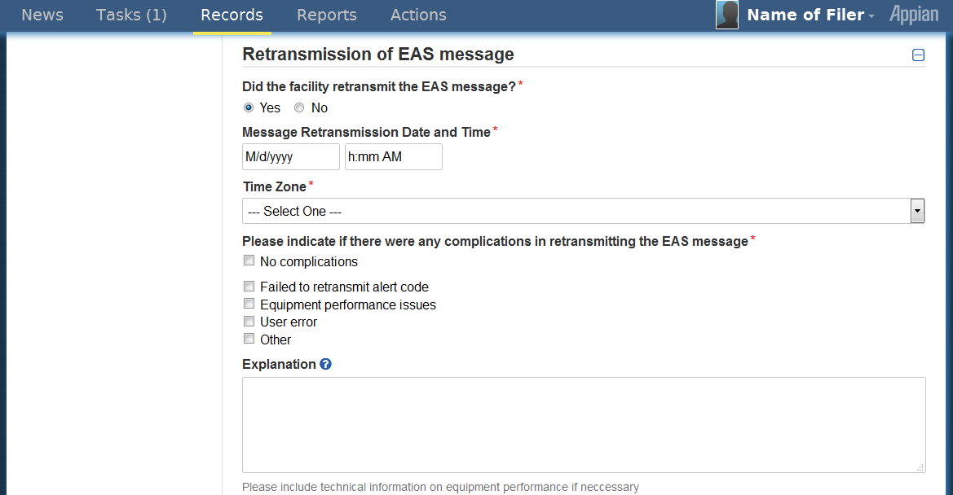
Pre-populated Contact Information. Form Three will conclude by again prompting filers to confirm their contact information.
F. Review and Certification
In the Sixth Report and Order, the Commission agreed that EAS Participants should be able to review their filings prior to submission. The Commission also adopted the requirement that EAS Participants must attest to the truthfulness of their ETRS filings and reminded EAS Participants that they are responsible for the accuracy of the information they file with the Commission, including any pre-populated data. In accordance with these requirements, filers will be presented with a “Review and Certification” page after they have completed each of the aforementioned forms. This page will display the filers’ responses to the respective form and will require filers to certify that their responses are accurate. Once filers certify the accuracy of their responses, the form will be submitted.
The Commission also stated in the Sixth Report and Order that EAS Participants will be provided with a filing receipt to verify their submission of a completed report. EAS Participants that submit a form will be e-mailed a receipt. Further, all forms previously completed in the ETRS will be saved under the “Records” tab of a filer’s account and may be reviewed at the filer’s election. Each form will include a timestamp to indicate the time at which it was completed. Filers may export these completed forms for their records.

G. Additional Features
Feature tabs. Along with the streamlined form filing that constitutes the primary feature of the ETRS, the ETRS interface provides tabs that offer additional information and services that are designed to enhance the experience of using the ETRS. The features provided in these tabs include easy access to Commission- or Bureau-level releases related to any nationwide test, a timeline of form submission deadlines, and the ability to edit forms submitted within the last thirty days, and the ability to create reports that summarize the data they submit to the ETRS.
Batch Filing. The Sixth Report and Order requires the ETRS to allow batch filing, as it will ease the filing burden on large EAS Participants by allowing them to complete the required filings of their many facilities with a single submission. EAS Participants will be permitted to complete a batch filing by submitting a spreadsheet to the ETRS that includes relevant data for each facility for which they file.
Coordinators. Filers may request to serve as a "coordinator" for an EAS Participant. Coordinators have the ability to “batch” file, as well as view records, edit forms, and generate reports from all data associated with the EAS Participants they represent. Coordinators also may assign other coordinators for their respective EAS Participants. Filers that are not coordinators will only be permitted to view records, submit forms, and generate reports from data that they have personally submitted.
IV. FURTHER INFORMATION
For further information regarding the Public Notice contact Austin Randazzo, Attorney Advisor, Policy and Licensing Division, Public Safety and Homeland Security Bureau, at (202) 418-1462 or austin.randazzo@fcc.gov or James Wiley, Attorney Advisor, Policy and Licensing Division, Public Safety and Homeland Security Bureau, at (202) 418-1678 or james.wiley@fcc.gov.

-FCC-

FEMA has announced its intent to conduct a nationwide test of the EAS on September 28, 2016. See Letter from Roger L. Stone, Assistant Administrator (Acting), National Continuity Programs, Federal Emergency Management Agency to David Simpson, Bureau Chief, FCC Public Safety & Homeland Security Bureau (April 14, 2016) (on file in PS Docket No. 15-94). This Public Notice provides provisional initial information only; we will issue a subsequent Public Notice prior to the official launch of the ETRS, consistent with the Commission’s rules. See 47 CFR §11.61(a)(3)(iii) (notice shall be provided at least two months prior to the test).
See 47 CFR §11.21(d).
Amendment of Part 11 of the Commission’s Rules Regarding the Emergency Alert System, Wireless Emergency Alerts, PS Docket Nos. 15-94, 15-91, Notice of Proposed Rulemaking, 31 FCC Rcd 594, 610-13, paras. 25-32 (2016) (Commission seeking comment on proposed rules to bring State EAS Plan filing online).
Review of the Emergency Alert System, Sixth Report and Order, EB Docket No. 04-296, 30 FCC Rcd 6520, 6533, para. 27 (2015) (Sixth Report and Order).
See id. at 6533-34, paras. 27-28 (citing AT&T Comments; National Association of Broadcasters Comments; National Cable and Telecommunications Association Comments; Gary Timm Comments; Society of Broadcast Engineers Comments (SBE Comments); Verizon Comments; Federal Emergency Management Agency Reply Comments; Monroe Electronics, Inc. Reply Comments; Letter from Richard R. Zaragoza, Counsel to Named State Broadcasters Associations, to Marlene H. Dortch, Secretary, FCC.
See id.
See id. at 6536, para. 33.
The FCC Registration Number (FRN) is a 10-digit unique identifying number that is assigned to entities doing business with the Commission. 47 CFR § 1.8001.
The ETRS will be built using the Appian platform. Additional information about Appian is available on its website. See Appian, Why Appian?, http://www.appian.com/about/why-appian/ (last visited Mar. 30, 2016). See also infra Part III.G.
On December 22, 2015, a notice was published in the Federal Register announcing that the Office of Management and Budget approved the information collection associated with the ETRS and that the amendments to Sections 11.21(a) and 11.61(a)(3)(iv) of the Commission’s rules would be effective on December 31, 2015. Federal Communications Commission, Review of the Emergency Alert System, 80 FR 79484 (Dec. 22, 2015). Accordingly, Form One must be completed within sixty days of the Commission’s official launch of the ETRS. See 47 CFR § 11.61(a)(3)(iv)(A). The Bureau will release a public notice triggering the sixty day period later this year.
47 CFR § 11.2(d).
See Sixth Report and Order, 30 FCC Rcd at 6533, para. 27. If a field is pre-populated, filers will be able to edit the field by updating the appropriate Commission database.
Id. at 6534, para. 28.
See id.
See id.
See 47 CFR §§ 11.2; 11.18. In the Alerting Paradigm NPRM, the Commission sought comment on a more precise set of EAS Designations for State Emergency Communications Committees (SECCs) to use in their creation of State EAS Plans. Amendment of Part 11 of the Commission’s Rules Regarding the Emergency Alert System; Wireless Emergency Alerts, PS Docket. Nos. 15-94 and 15-91, Notice of Proposed Rulemaking, FCC 16-5, 14, para. 17 (Jan. 29, 2016). If those EAS Designations are adopted by a subsequent Commission Report and Order and published in the Federal Register prior to the launch of the ETRS, Form One would prompt EAS Participants to choose from among those EAS designations.
For example, the National Public Radio satellite-based “squawk” channel was used by some EAS Participants during the 2011 Nationwide EAS Test. See FCC PSHSB, Strengthening the Emergency Alert System (EAS): Lessons Learned from the First Nationwide EAS Test at 8 (2013), https://www.fcc.gov/document/strengthening-emergency-alert-system.
See 47 CFR § 11.52(d)(2).
Sixth Report and Order, 30 FCC Rcd at 6534, para. 28.
47 CFR § 11.61(a)(3)(iv)(B).
See SBE Comments at 4.
47 CFR § 11.61(a)(3)(iv)(C).
Sixth Report and Order, 30 FCC Rcd at 6533, para. 27.
Id. at 6534, para. 28.
Id. at 6533, para. 27.
See id.
See id.
Id. at 6534, para. 28.
See id. at 6534, para. 28 & n.96.

