Before the
Federal Communications Commission
Washington, D.C. 20554

)
In the Matter of

Rural Health Care Support Mechanism

Northeast Ohio Regional Health Information Organization Consortium and OneCommunity Network Services Request to Restructure Pilot Program Project
)
)
) WC Docket No. 02-60
)
)
)
)
)

ORDER

Adopted: March 11, 2015 Released: March 11, 2015

By the Chief, Wireline Competition Bureau:

introduction

- In this order, we address a request by OneCommunity, a participant in the Rural Health Care Pilot Program (Pilot Program) and the current project coordinator of the Northeast Ohio Regional Health Information Organization (NEO RHIO) Pilot Program project, to restructure the NEO RHIO Pilot Program project. As discussed below, we find that it is in the public interest to allow NEO RHIO to restructure its consortium and network services agreement in order to institute safeguards similar to those applied to other Pilot Program participants. To the extent necessary, on our own motion, we also conditionally waive the Commission’s rules and deadlines necessary to enable the restructuring of the NEO RHIO consortium and network services agreement and to allow USAC to effectuate this Order.

background

- Pilot Program. On September 26, 2006, the Commission established the Pilot Program, pursuant to section 254(h)(2)(A) of the Communications Act of 1934 (the Act), as amended, to examine methods to use the universal service rural health care funding mechanism to enhance public and non-profit health care providers’ access to advanced telecommunications and information services. Under the Pilot Program, participants were eligible to receive funding, up to their maximum support amount, for up to 85 percent of the costs associated with: (1) the construction of state or regional broadband networks, and the advanced telecommunications and information services provided over those networks; (2) connecting to nationwide backbone providers Internet2 or National LambdaRail (NLR); and (3) connecting to the public Internet. On November 16, 2007, the Commission selected 69 applications to participate in the Pilot Program. There are currently 50 active pilot projects in 42 states and three United States (U.S.) territories. Many of these projects are statewide or regional networks of health care providers (HCPs). While no new funding is available under the Pilot Program, some pilot projects continue to accept new HCP sites.

- Pilot Program Applicable Rules and Requirements. Under the Pilot Program, only eligible HCPs and consortia that include eligible HCPs may apply for and receive discounts. While state organizations, entities that provide eligible service offerings, and not-for-profit ineligible entities may apply for funding on behalf of consortium members and may be selected as a service provider by a Pilot Program participant, they are ineligible to receive funding for services under the Pilot Program unless they satisfy the statutory definition of health care provider under the Act. Thus, any funding or other program benefits received by a state entity, organization or other ineligible entity functioning as a consortium leader under the Pilot Program must be passed on to the consortium members that are eligible HCPs. Further, Pilot Program participants are responsible for meeting their minimum 15 percent contribution of eligible network costs. This contribution must be derived from an eligible source, such as from the applicant or eligible HCP participants, state grants, funding, or appropriations. Contributions may not come from ineligible sources such as a local exchange carrier or other telecom carrier, contractors, consultants, service providers, or for-profit participants. While a Pilot Program participant cannot sell its network capacity, it can share network capacity with an ineligible entity as long as the ineligible entity pays its fair share of the network costs attributable to the portion of the network capacity used.

- NEO RHIO Pilot Program Project. In May 2007, NEO RHIO and OneCommunity submitted a joint application to the Commission to receive funding from the Pilot Program to create HealthNet, a northeast Ohio broadband initiative, in support of the telemedicine and health information exchange. NEO RHIO was a non-profit corporation formed of eligible HCPs, including ten founding medical partners representing 32 facilities. OneCommunity is a non-profit corporation established to connect education, healthcare, government and non-profit organizations together through fiber and wireless broadband facilities. Specifically, OneCommunity has a broadband network connecting over 300 sites across Northeast Ohio including 28 hospitals and healthcare facilities. The goal of HealthNet was to extend OneCommunity’s network by installing additional fiber connections to connect 19 rural hospitals located in rural northeastern Ohio. This project became known as the NEO RHIO Pilot Project.

- In November 2007, as part of the Pilot Program Selection Order, the Commission selected the NEO RHIO and OneCommunity application for funding under the Pilot Program. The Commission found that the NEO RHIO Pilot Project demonstrated significant need for Pilot Program funding for health care broadband infrastructure and services to its HCPs and provided the Commission with a sufficiently detailed proposal explaining the goals and objectives of its proposed network. The maximum Pilot Program support the Commission awarded to the NEO RHIO Pilot Project was $11,286,200.

- The Pilot Program Selection Order set a deadline of June 30, 2010 for completion of the Pilot Program projects. Consistent with this timeline, NEO RHIO submitted its request for proposal (RFP) for posting by USAC in August 2008 in time for competitive bidding to be initiated in January 2009. The RFP sought bids for construction of a fiber optic network and equipment required to deliver high bandwidth services to connect hospitals spanning 22 counties in Northeastern Ohio. In late 2009 (with only about half a year left until the intended end of the Pilot Program), OneCommunity informed USAC that it would serve as the project coordinator for the NEO RHIO Pilot Project and submitted requests to USAC for funding on behalf of the eligible HCPs that participated in the NEO RHIO Pilot Project, which were approved in January 2010. USAC subsequently disbursed $10,558,351 to the service providers that provided the equipment and/or constructed the proposed fiber network, and services commenced to the HCPs in February 2010.

- In April 2011, USAC selected the NEO RHIO Pilot Program project for a site visit. In preparation for the visit, USAC discovered that the original NEO RHIO consortium had disbanded in 2009 and that OneCommunity owned the fiber and equipment funded by the Pilot Program. USAC also determined that OneCommunity had paid the HCPs’ 15 percent contribution towards the eligible costs and had dedicated a portion of the Pilot Program-funded network for use by ineligible entities that had not paid a fair share of the network costs. In March 2012, USAC conducted the site visit of the NEO RHIO Pilot Project. USAC’s site visit report indicated that the NEO RHIO Pilot Project provided a broadband network through 20 counties across Northeast Ohio and, through its connection to the larger OneCommunity network, linked rural HCPs in those counties to major health centers in Cleveland. Specifically, the OneCommunity network provided the HCPs the ability to use innovative technologies such as electronic health records, telemedicine, mobile and home monitoring, televideo patient education programs, and statewide health information exchange. As a further benefit, USAC noted that OneCommunity has a core network of 117 hospitals on its own private fiber backbone and interconnects the services supported by the Pilot Program to the core network, allowing for greater connectivity and interoperability between and among HCPs.

- In establishing the Pilot Program, the Commission expected that Pilot Program projects would construct dedicated health care networks, but also allowed for the possibility that a participant would subscribe to carrier-provided transmission services in lieu of building its own broadband network. A key purpose of the Pilot Program was to “explore, from the ground up, how to best encourage the deployment” of such broadband facilities. During the implementation process, USAC recommended that certain Pilot Program projects requesting funding for service provider build-out should consider obtaining safeguards from their service providers to ensure that all of the benefits from Pilot Program funding were passed through to eligible HCPs, and that the Commission’s and the HCPs’ interest in supported facilities would be preserved if the service provider was unable to fulfill its service obligations over the contract term. As one of the early Pilot Program projects, similar safeguards were not instituted for the NEO RHIO Pilot Program project. Therefore, in June 2011, after learning about the structure of the NEO RHIO Pilot Project, the Commission, USAC, and OneCommunity entered into discussions concerning the NEO RHIO Pilot Project and OneCommunity’s compliance with the Commission’s Pilot Program requirements. Subsequently, on June 9, 2014, USAC sent OneCommunity a letter to memorialize OneCommunity’s proposed steps to restructure the NEO RHIO consortium as well as the consortium’s network services agreement with OneCommunity in order to institute safeguards similar to other Pilot Program projects that received funding for service provider build-out. USAC and OneCommunity have taken no further actions on the proposed restructuring plan, and USAC has held the remaining funding associated with the NEO RHIO Pilot Project pending a decision by the Commission addressing One Community’s request.

discussion

- We approve the proposal of NEO RHIO and One Community to restructure the Pilot Program project and designate the restructured NEO RHIO consortium as the lead entity with a prepaid lease agreement and a back-up IRU agreement with its service provider, OneCommunity, for services provided to the HCPs. We find that the restructuring of the NEO RHIO Pilot Program project will address the issues raised by USAC and ensure that Pilot Program funding is disbursed only for the benefit of eligible HCPs. Further, restructuring the NEO RHIO consortium serves the public interest and furthers the goals of the Pilot Program by stimulating the deployment of infrastructure necessary to support innovative telehealth, in particular, telemedicine services in rural areas within Northeast Ohio where the need for those services is most acute.

- USAC has raised three primary concerns regarding the current structure of the NEO RHIO Pilot Project: (1) OneCommunity owns the equipment and facilities funded through the Pilot Program but is not itself an eligible HCP, thus must pass through any funding or benefits from the Pilot Program to eligible HCPs; (2) the individual eligible HCPs failed to pay a contribution of at least 15 percent of the eligible network costs; and (3) a dedicated portion of the Pilot Program-funded network is used by ineligible entities who had not paid a fair share of the network costs. We find that the restructuring of the NEO RHIO consortium and network services agreement will address these concerns.

- As outlined in the proposed restructuring plan:

- Sixteen eligible HCPs from the former NEO RHIO project will join to create the new eligible NEO RHIO consortium and will serve as the lead entity for the restructured NEO RHIO Pilot Project.

- OneCommunity will execute a prepaid lease with a backup IRU agreement, which will provide NEO RHIO’s HCPs greater certainty and the right to use the Pilot Program-funded network. In the event that OneCommunity ceases to exist, is acquired, or is liquidated in bankruptcy, the backup IRU will also require transfer of the Pilot Program-funded assets and equipment to the newly formed NEO RHIO consortium. The prepaid lease and back-up IRU agreement shall have a term that is equivalent to the life of the Pilot Program-funded fiber assets (typically 20 years).

- OneCommunity will execute separate service agreements with each of the 16 individual HCPs, which meet certain rate requirements and contain terms for the life of the lease, and will provide the HCPs with certain minimum levels of service and.

- The required 15 percent Pilot Program participant contribution of $1.99 million, previously provided by OneCommunity, will be repaid to OneCommunity by the 16 NEO RHIO HCPs.

- All ineligible entities on the Pilot Program-funded network will pay to OneCommunity their fair share of the network costs for the use of the excess network capacity and OneCommunity will pass along to the 16 HCPs no less than $11.28 million (representing the Pilot Program funding amount for the NEO RHIO Pilot Project) over the life of the prepaid lease.

Considered together, these proposed changes appropriately ensure that all of the benefits from Pilot Program funding are passed to eligible HCPs, and that the Commission’s and the HCPs’ interest in supported facilities are preserved if OneCommunity is unable to fulfill its service obligations over the contract term.

- Further, in permitting the proposed restructuring plan, we find that granting OneCommunity’s request to restructure the NEO RHIO consortium will also serve the public interest and is consistent with the goals of the Pilot Program. As noted in the Pilot Project Selection Order, one of the goals of the Pilot Program is to “stimulate deployment of the broadband infrastructure necessary to support innovative telehealth and, in particular, telemedicine services to those areas of the country where the need for those benefits is most acute.” In selecting the NEO RHIO Pilot Program project as part of the Pilot Program, the Commission found that the project would advance these goals by bringing the benefits of telemedicine to rural communities. As indicated above, the OneCommunity network is providing important connectivity to rural hospitals in Northeastern Ohio. The network, through its connection to the larger OneCommunity network, links the rural HCPs to major health centers in Cleveland. Specifically, the OneCommunity network is providing the HCPs the ability to use innovative technologies such as electronic health records, telemedicine, mobile and home monitoring, televideo patient education programs, and statewide health information exchange. As a further benefit, the OneCommunity has a core network of 117 hospitals on its own private fiber backbone and interconnects the services supported by the Pilot Program to the core network, allowing for greater connectivity and interoperability between and among HCPs. Restructuring the NEO RHIO consortium and network services agreement with OneCommunity will continue to make Pilot Program funds available for connecting eligible HCPs throughout Ohio to a dedicated broadband infrastructure, bringing the benefits of telemedicine to rural hospitals in the state that otherwise do not have the resources themselves to take over management of the underlying network, and even if they did, would lose the benefits of utilizing a community broadband provider with built-in connectivity to major medical centers in large urban areas. Further, in this instance, there is no evidence of waste, fraud or abuse, intentional misuse of funds, or a failure to adhere to the Pilot Program rules and requirements regarding excess capacity and fair use.

- Moreover, we have previously allowed Pilot Program participants to merge with other pilot projects to further the goals of the Pilot Program and/or in order to use the Pilot Program funds more efficiently. The goal of the Pilot Program was to lay the foundation for a future rulemaking that would institute permanent rules to enhance access to advanced services for public and non-profit healthcare providers. Thus, the Pilot Program was intended in large part to allow the Commission to explore the type of issues raised in this matter as it considered adoption of rules for a permanent program. NEO RHIO’s and OneCommunity’s initial application stated that the goal of the project was to “extend the current network” to approximately 19 rural HCPs in Northeastern Ohio so that those HCPs could enjoy the benefits of being connected to major health care providers in the greater Cleveland area. The application also disclosed the applicants’ intent to include excess capacity for use by ineligible entities in the Pilot Program-supported network. Although the Pilot Program Selection Order explicitly allowed ineligible entities to participate in a Pilot Program network if the ineligible entities paid their fair share of network costs, implementation of the “fair share” concept was explored and developed over a period of time through the implementation of the numerous Pilot projects. Because NEO RHIO, unlike many other projects, progressed quickly on its network in a timeframe consistent with the original deadlines in the Pilot Program Selection Order, it was unable to take advantage of the additional guidance regarding excess capacity and other structural safeguards that were recommended for other Pilot Program projects. We thus find that NEO RHIO should not be penalized for its efficiency in moving forward with its Pilot Program project in a timely fashion and its compliance with the deadlines in place at the time, despite the lack of guidance available at the time.

- For these reasons, we find that it is in the public interest to allow One Community and NEO RHIO to restructure its consortium and network services agreement consistent with OneCommunity’s proposed restructuring plan as outlined in the USAC June 2014 letter. We direct NEO RHIO and OneCommunity to complete the restructuring consistent with the proposal within one year of the release date of this Order. On our own motion, we also grant any waivers of the Commission’s rules necessary to enable the restructuring of the NEO RHIO consortium and network services agreement, and condition those waivers on compliance with this Order.

- Although we allow NEO RHIO and OneCommunity to restructure their Pilot Program project in order to institute safeguards similar to those applied to other Pilot Program participants, we emphasize the limited nature of this decision. Adherence to Pilot Program rules and requirements is necessary for the efficient administration of the Pilot Program. Thus, this limited waiver does not reduce or eliminate any Pilot Program procedures or lessen the program requirements with which participants must comply to receive funding under the Pilot Program. All existing Pilot Program rules and requirements will apply after the restructuring is complete. Indeed, we retain our commitment to detecting and deterring potential instances of waste, fraud, and abuse by ensuring that USAC continues to scrutinize Pilot Program projects and takes steps to educate selected participants in a manner that fosters program participation and integrity.

ORDERING CLAUSES

- Accordingly, IT IS ORDERED that, pursuant to the authority contained in sections 1-4 and 254 of the Communications Act of 1934, as amended, 47 U.S.C. §§ 151-54, 254, and pursuant to sections 0.91, 0.291, and 1.3 of the Commission’s rules, 47 C.F.R. §§ 0.91, 0.291, 1.3, we allow and direct the Northeast Ohio Regional Health Information and OneCommunity to restructure the NEO RHIO Pilot Project, subject to the conditions described herein.

- IT IS FURTHER ORDERED that NEO RHIO and OneCommunity SHALL COMPLETE the implementation of the restructure of the NEO RHIO consortium and network services agreement within one year of the release date of this Order.

- IT IS FURTHER ORDERED that, pursuant to section 1.102(b)(1) of the Commission’s rules, 47 C.F.R. § 1.102(b)(1), this Order SHALL BE EFFECTIVE upon release.

FEDERAL COMMUNICATIONS COMMISSION

Julie A. Veach
Chief
Wireline Competition Bureau

APPENDIX

Letter from the Universal Service Administrative
Company to OneCommunity

(dated June 9, 2014)

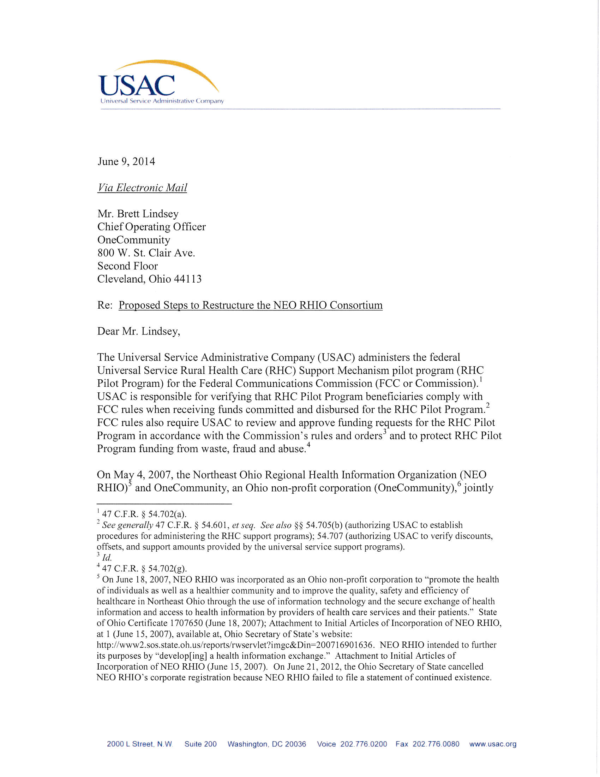
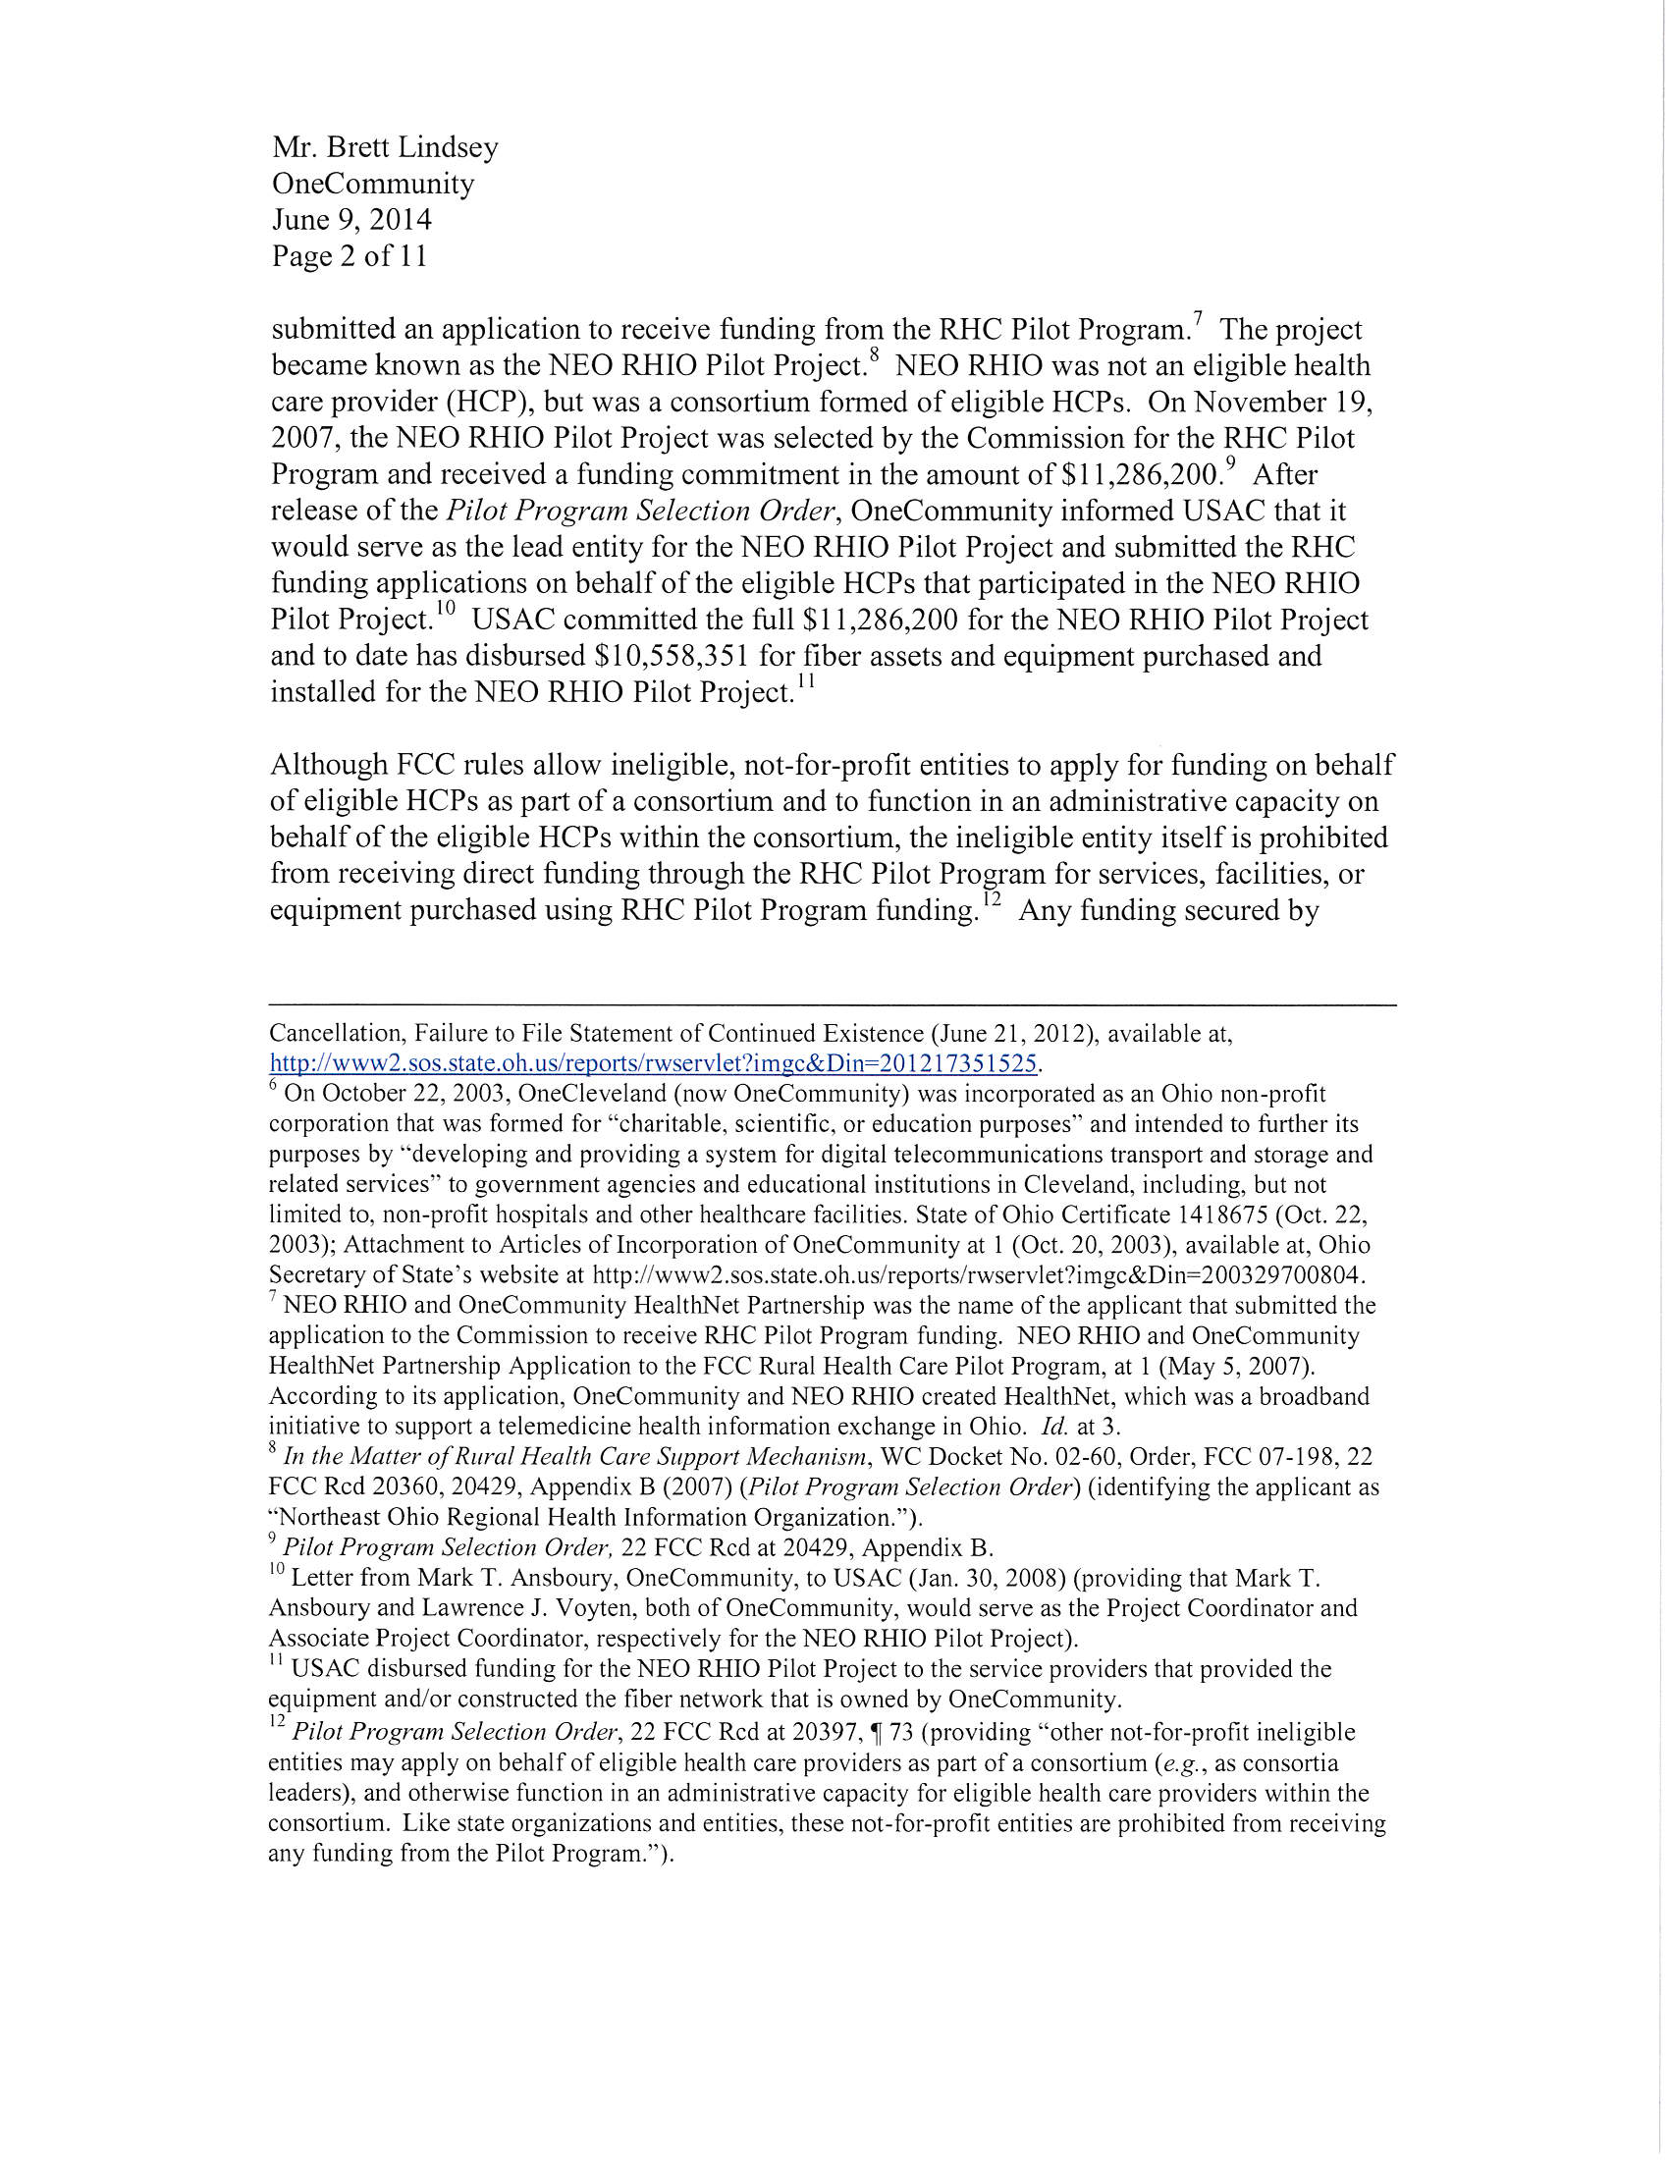

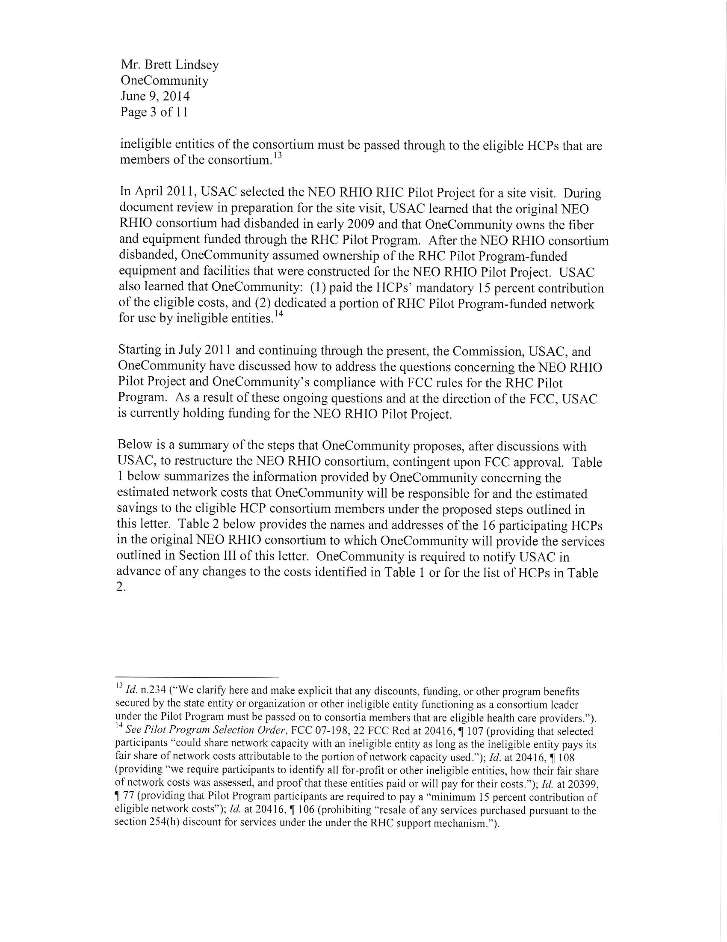

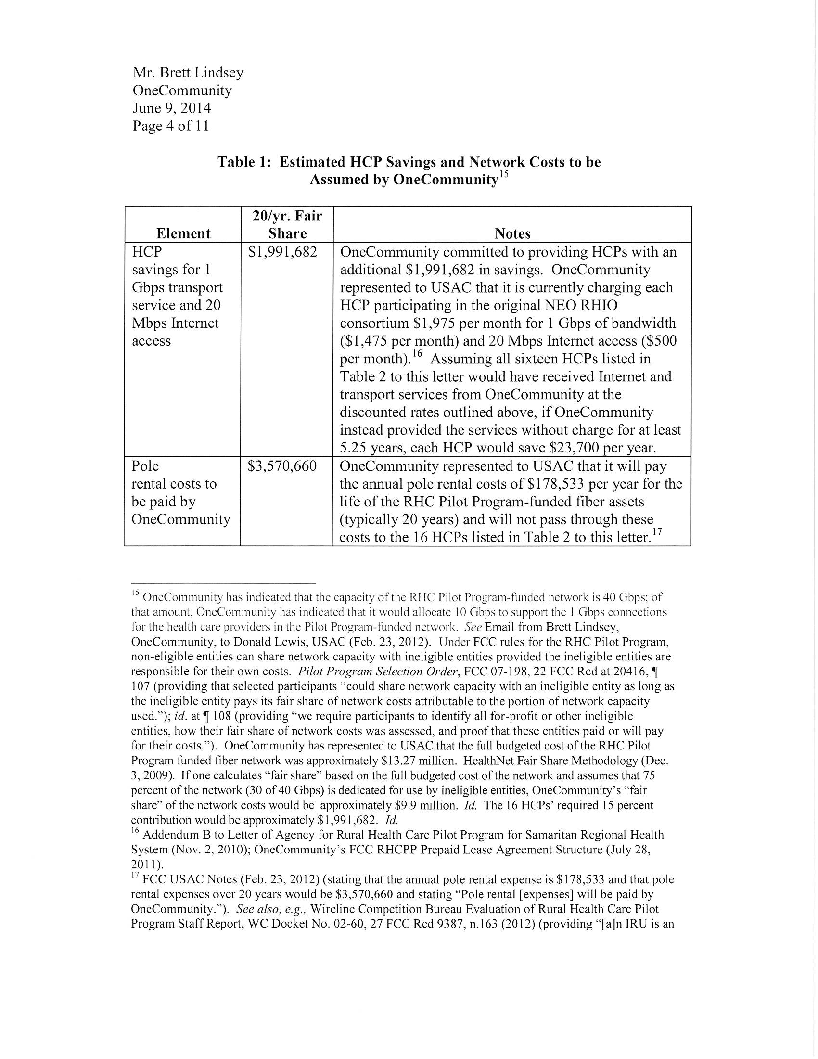

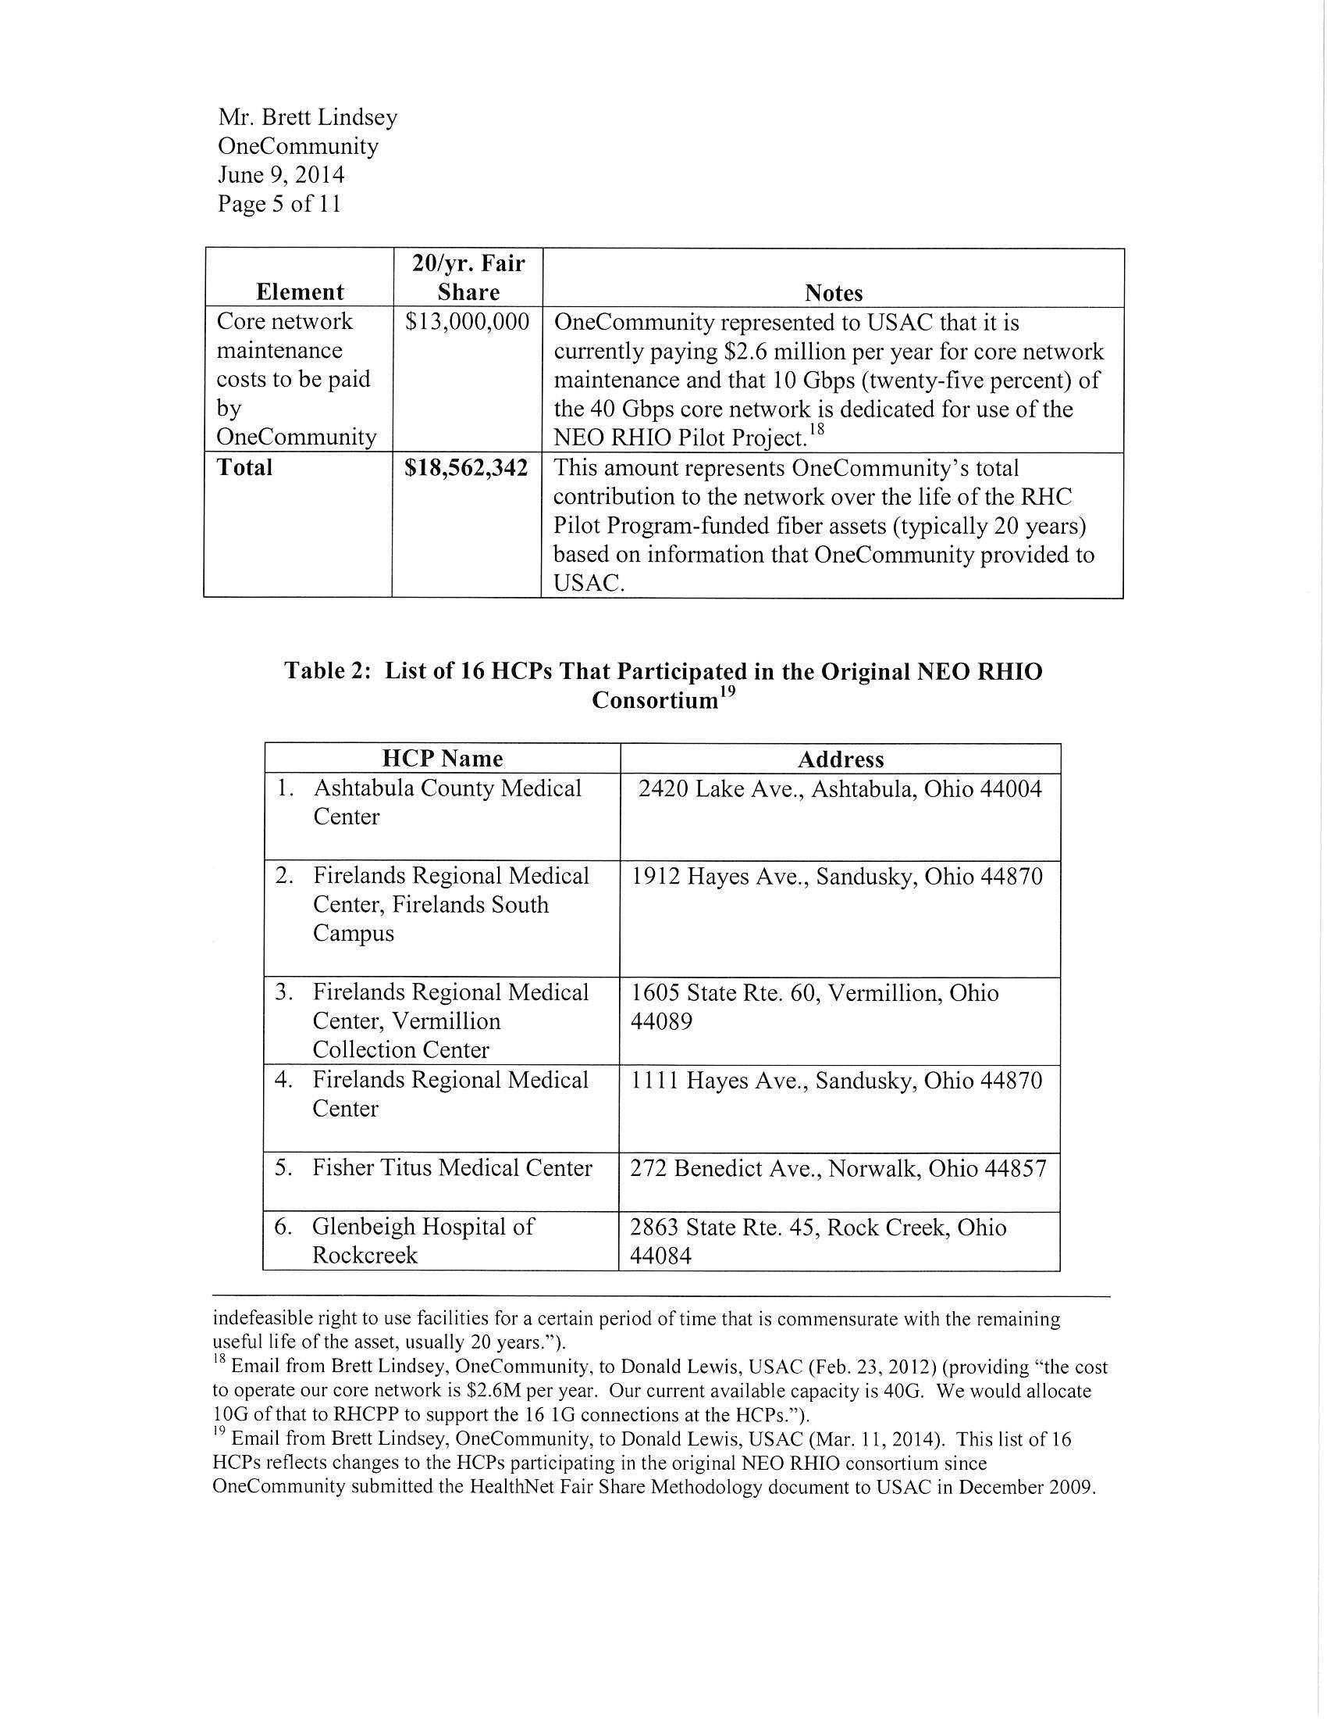

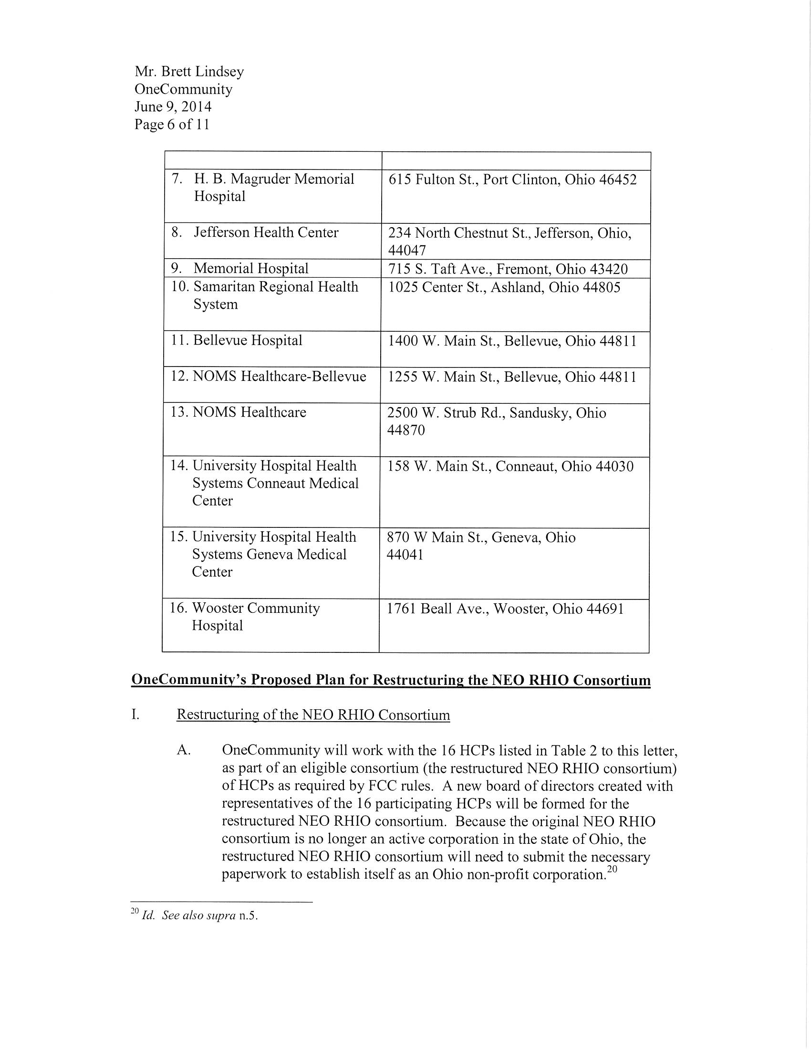

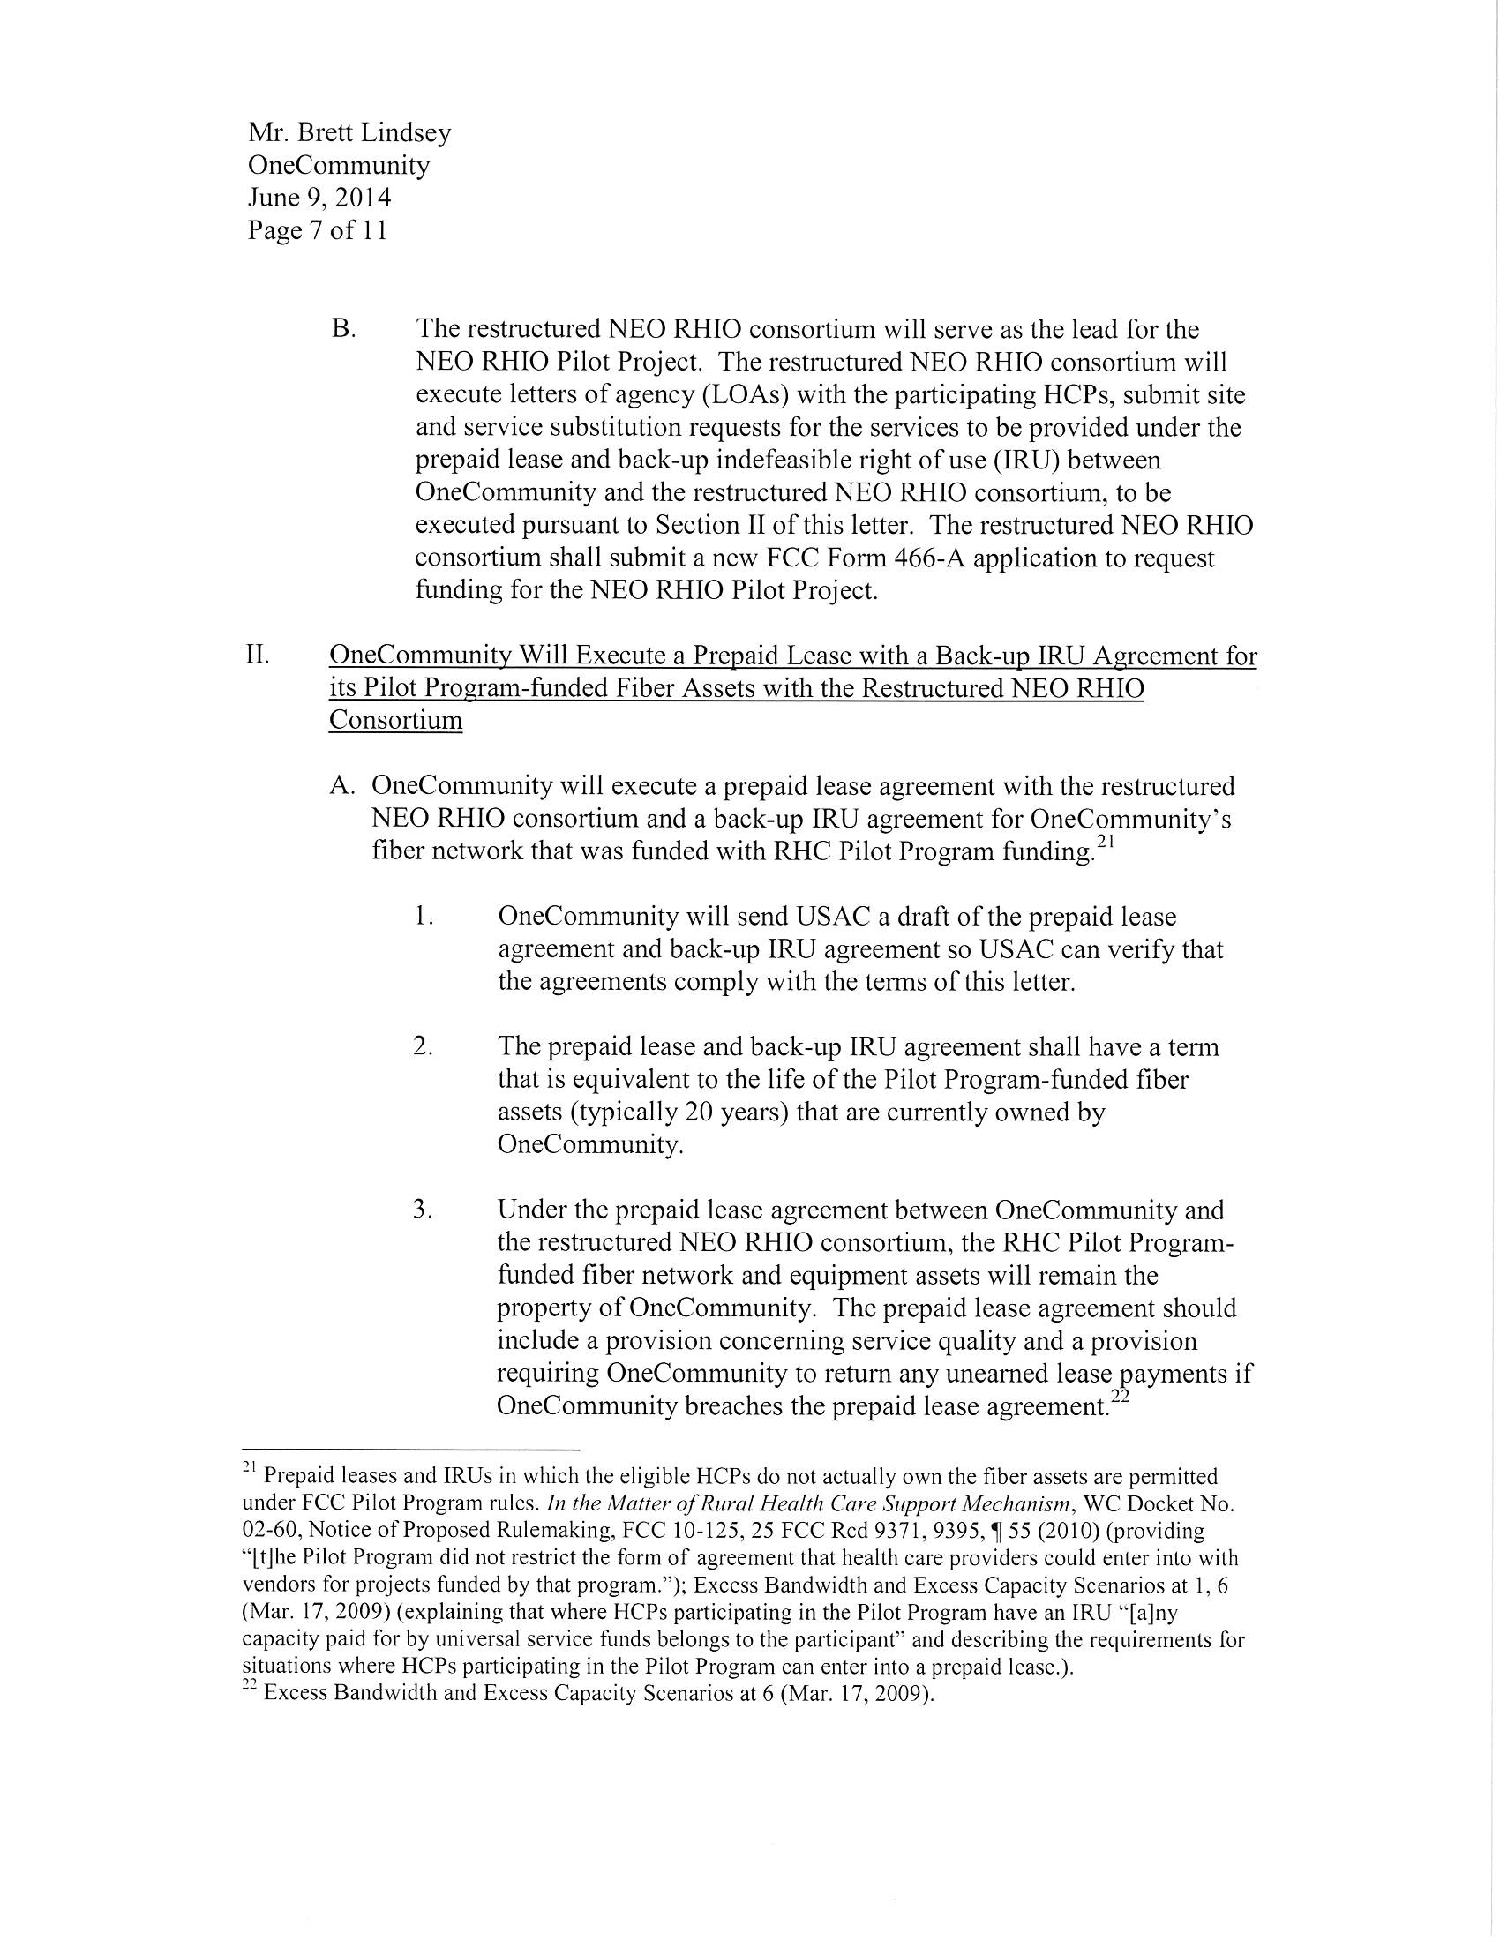

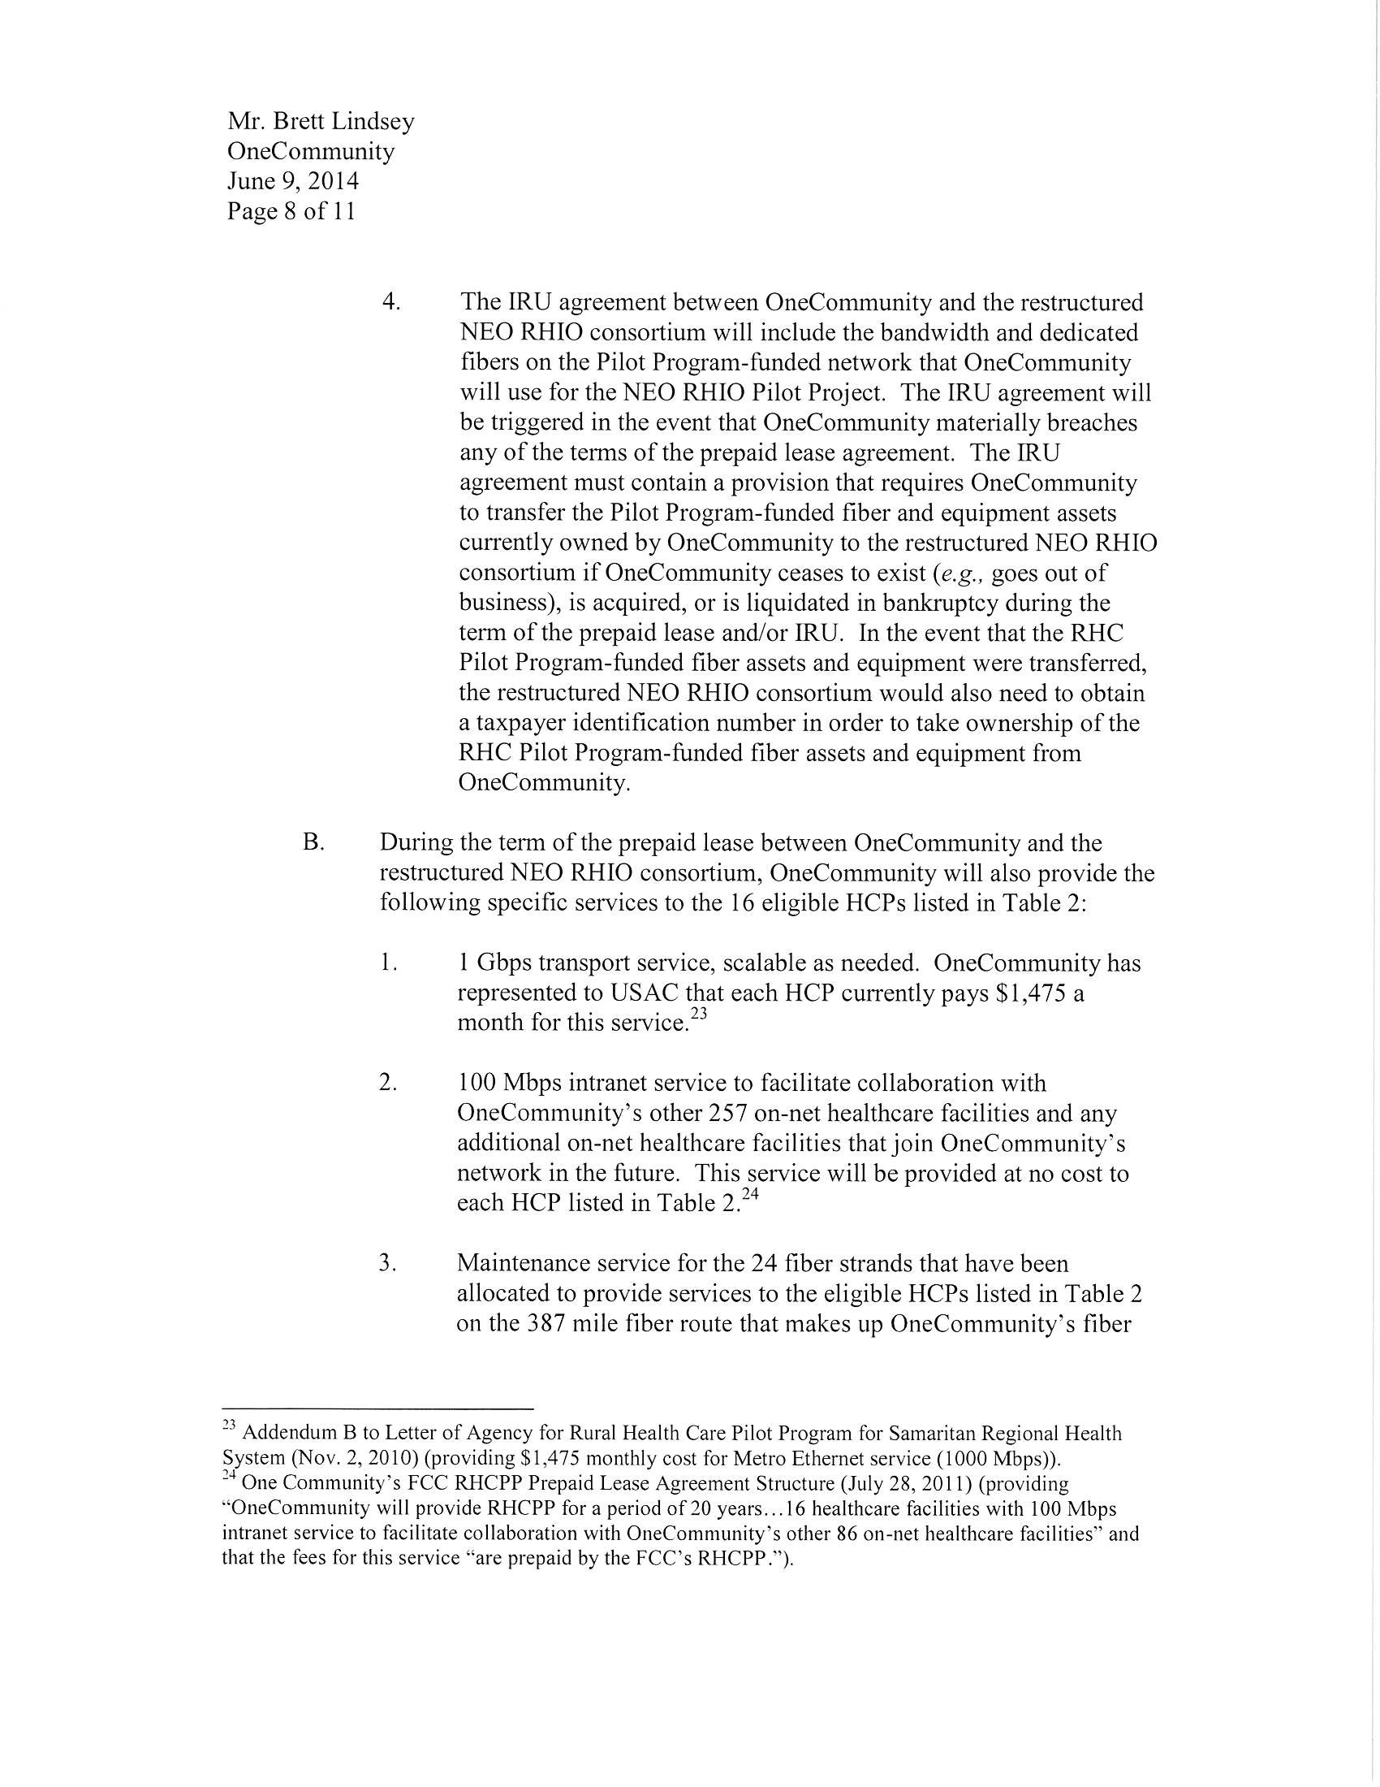

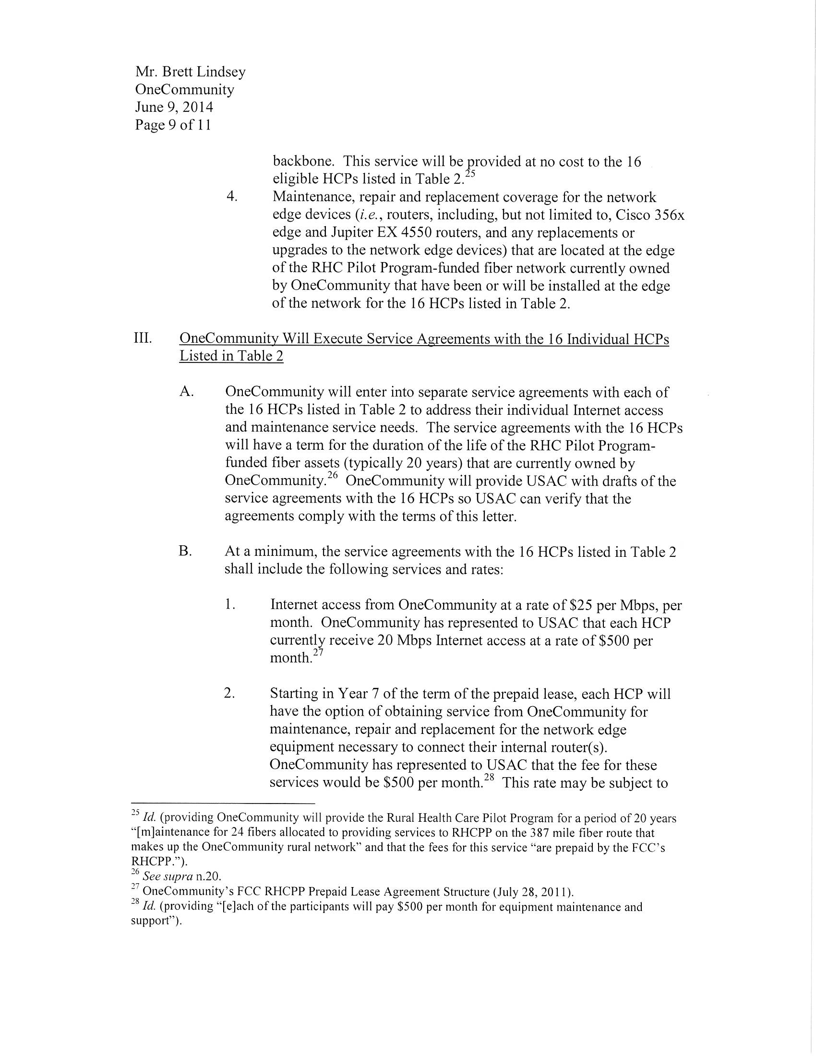

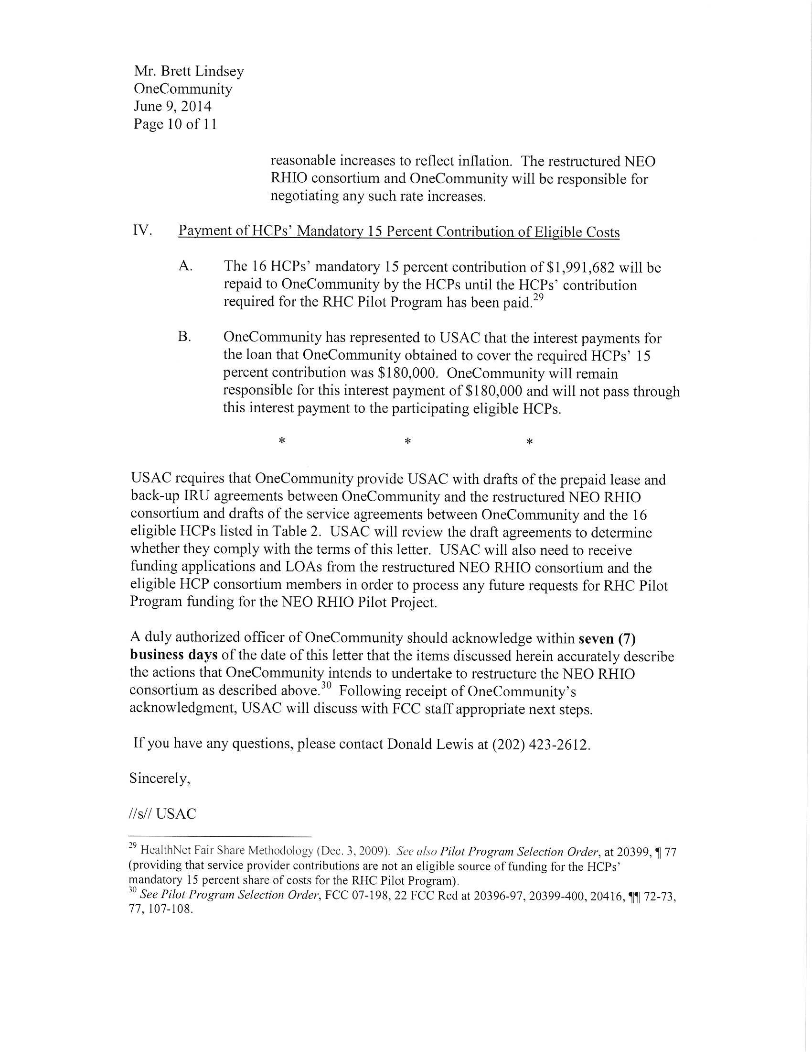

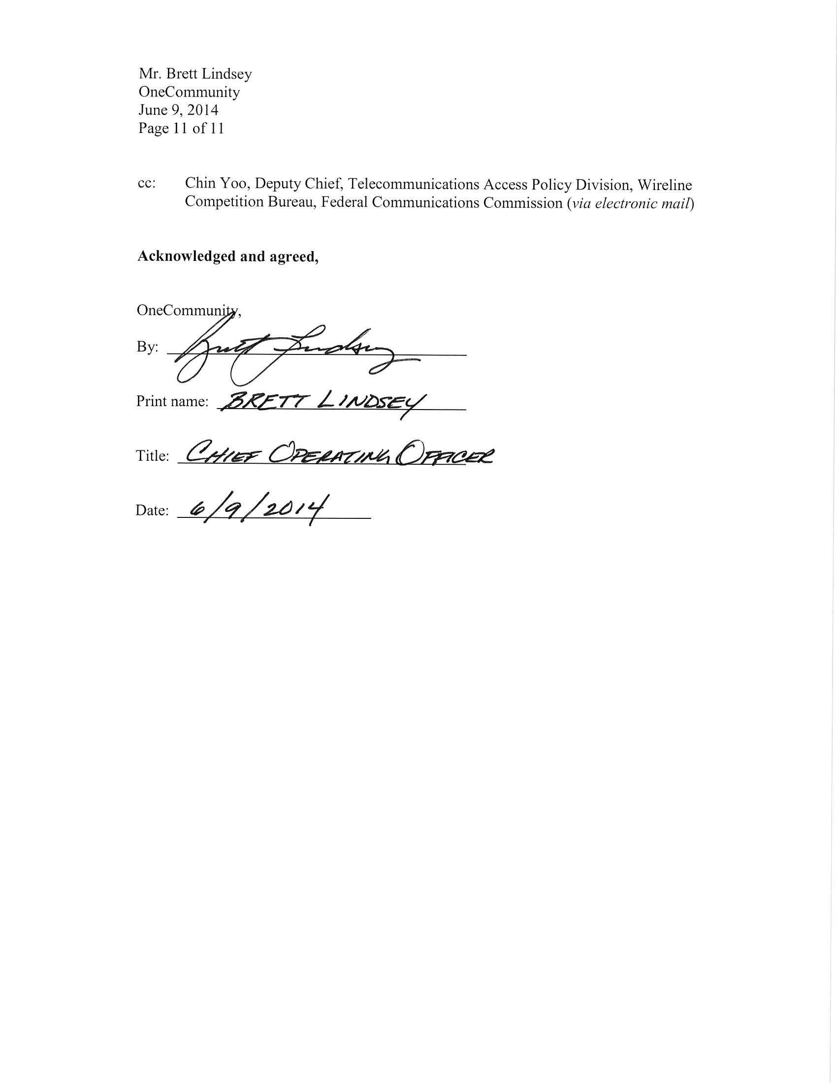

OneCommunity (formerly, OneCleveland) is an Ohio non-profit corporation established in October 2003 for “charitable, scientific, or education purposes” and intended to further its purposes by “developing and providing a system for digital telecommunications transport and storage and related services” to government agencies and educational institutions in Cleveland, including, but not limited to, non-profit hospitals and other healthcare facilities. See State of Ohio Certificate 1418675 (dated Oct. 22, 2003), Attachment to Articles of Incorporation of OneCommunity, at 1 (dated Oct. 20, 2003), available at State of Ohio, Ohio Secretary of State, http://www2.sos.state.oh.us/reports/rwservlet?imgc&Din=200329700804 (last visited Mar. 11, 2015). See also OneCommunity, About, http://www.onecommunity.org/about-onecommunity/ (last visited Mar. 11, 2015).
NEO RHIO is an Ohio non-profit corporation established in June 2007 to “promote the health of individuals as well as a healthier community and to improve the quality, safety and efficiency of healthcare in Northeast Ohio through the use of information technology and the secure exchange of health information and access to health information by providers of health care services and their patients.” See State of Ohio Certificate 1707650 (dated June 18, 2007), Attachment to Initial Articles of Incorporation of NEO RHIO, at 1 (dated June 15, 2007), available at State of Ohio, Ohio Secretary of State, http://www2.sos.state.oh.us/reports/rwservlet?imgc&Din =200716901636 (last visited Mar. 11, 2015). In June 2012, the Ohio Secretary of State cancelled NEO RHIO’s corporate registration because NEO RHIO failed to file a statement of continued existence. See Cancellation, Failure to File Statement of Continued Existence (dated June 21, 2012), available at State of Ohio, Ohio Secretary of State http://www2.sos.state. oh.us/reports/rwservlet?imgc&Din=201217351525 (last visited Mar. 11, 2015).
See Appendix (Letter from Universal Service Administrative Company (USAC), to Brett Lindsey, Chief Operating Officer, OneCommunity (dated June 9, 2014)) (USAC June 2014 Letter). A copy of this letter is included in the Appendix at the end of this document.
See infra para. 8 and note 43.
See 47 U.S.C. § 254(h)(2)(A); Rural Health Care Support Mechanism, WC Docket No. 02-60, Order, 21 FCC Rcd 11111, para. 1 (2006) (Pilot Program Order).
See Pilot Program Order, 21 FCC Rcd at 11115, para. 14.
Rural Health Care Support Mechanism, WC Docket No. 02-60, Order, 22 FCC Rcd 20360, 20429, Appendix B (2007) (Pilot Program Selection Order).
See Letter from Craig Davis, Vice President, Rural Health Care Division, USAC, to Sharon Gillett, Chief, Wireline Competition Bureau, FCC, WC Docket No. 02-60, at 1-2 (filed May 4, 2012) (USAC May 2012 Letter); USAC, Rural Health Care Program, Getting Started, http://www.usac.org/rhcp/about/default.aspx (last visited Mar. 11, 2015). Of the original 69 projects, several projects merged, withdrew from the program, or failed to meet program deadlines, leaving the total number of projects at 50. See Wireline Competition Bureau Interim Evaluation of Rural Health Care Pilot Program Staff Report, WC Docket No. 02-60, Staff Report, 27 FCC Rcd 9387, 9399-9400, para. 20 (2012) (Pilot Program Evaluation).
See USAC May 2012 Letter.
See USAC, Rural Health Care Program, http://www.usac.org/rhc/ (last visited Mar. 11, 2015).
See 47 C.F.R. §§ 54.601(a)(1), (c)(1); Pilot Program Selection Order, 22 FCC Rcd at 20395-96, para. 71.
See Pilot Program Selection Order, 22 FCC Rcd at 20396-97, paras. 72-73.
Id. at 20396-97, paras. 72-73, note 234.
Id. at 20399-400, para. 77.
Id.
Id.
See 47 U.S.C. § 254(h)(3) (stating that “telecommunications services and network capacity provided to a public institutional telecommunications user under this subsection may not be sold, resold, or otherwise transferred by such user in consideration for money or any other thing of value”); Pilot Program Selection Order, 22 FCC Rcd at 20416, paras. 107-108. See also id. at 20416, para. 18 (requiring participants to identify all for-profit or other ineligible entities, how their fair share of network costs was assessed, and proof that these entities paid or will pay for their costs).
See NEO RHIO and OneCommunity Application, WC Docket No. 02-60, at 3 (filed May 5, 2007) (NEO RHIO and OneCommunity Application).
Id. at 4, 43-44; supra note 1.
See NEO RHIO and OneCommunity Application at 3; supra note 1.
See NEO RHIO and OneCommunity Application at 3.
Id. at 5-6.
Id. at 2.
See Pilot Program Selection Order, 22 FCC Rcd at 20429, Appendix B. In the Pilot Program Selection Order, the Commission also provided additional guidance on the administration of the Pilot Program. See Pilot Program Selection Order.
See id. at 20374-75, para. 37.
See id. at 20429, Appendix B.
See Pilot Program Selection Order, 22 FCC Rcd at 20370, para. 23. The Bureau subsequently extended the time for projects to receive funding commitments from USAC for the entirety of their awards from June 30, 2010 to June 30, 2012. See Rural Health Care Support Mechanism, WC Docket No. 02-60, Order, 25 FCC Rcd 1423 (Wireline Comp. Bur. 2010).
See NEO RHIO HealthNet, FCC Form 465, Health Care Providers Universal Service, Description of Services Requested & Certification Form (dated Sept. 12, 2008); NEO RHIO, Request for Proposal, Rural Health Care Pilot Program, HealthNet Network Construction and Services (dated Aug. 12, 2008) (NEO RHIO RFP).
See NEO RHIO RFP.
See Letter from Mark T. Ansboury, OneCommunity, to USAC (dated Jan. 30, 2008) (providing that Mark T. Ansboury and Lawrence J. Voyten, both of OneCommunity, would serve as the Project Coordinator and Associate Project Coordinator, respectively, for the NEO RHIO Pilot Project); USAC June 2014 Letter at 2. See, e.g., NEO RHIO, FCC Form 466-A, Health Care Providers Universal Service, Internet Service Funding Request and Certification Form (dated Aug. 15, 2009) (for services from OneCommunity). NEO RHIO, FCC Form 466-A, Health Care Providers Universal Service, Internet Service Funding Request and Certification Form (dated Aug. 15, 2009) (for services from MultiLink). See also Pilot Program Selection Order, 22 FCC Rcd at 20396-97, paras. 72-73; USAC, Rural Health Care, Automated Search of Commitments, available at https://www.rhc.universalservice.org/funding/asc/ (last visited Mar. 11, 2015).
See USAC June 2014 Letter at 2, note 11.
See, e.g., NEO RHIO, FCC Form 467, Health Care Providers Universal Service, Connection Certification (dated Feb. 23, 2010) (for services from OneCommunity); NEO RHIO, FCC Form 467, Health Care Providers Universal Service, Connection Certification (dated Mar. 9, 2010) (for services from MultiLink).
See USAC June 2014 Letter at 3; Pilot Program Selection Order, 22 FCC Rcd at 20411, para. 98 (directing USAC to conduct random site visits to ensure support is being used for its intended purposes, as well as to conduct site visits as necessary and appropriate based on USAC’s review of the selected participants’ data submissions).
Id.
Id. Specifically, using Pilot Program funds, OneCommunity extended its fiber network to include 24 fibers (25 percent of the network) for healthcare use and 72 additional fibers (75 percent of the network) for use by ineligible entities. See USAC June 2014 Letter at 4, note 15, 8-9.
See Letter from Craig Davis, Rural Health Care Division, USAC, to Sharon Gillett, Chief, Wireline Competition Bureau, FCC (dated Mar. 16, 2012) (USAC March 2012 Site Visit).
See USAC March 2012 Site Visit. See also OneCommunity, Hospital Broadband Services: Building a Platform for Better Health Care, http://www.onecommunity.org/community-technology-programs/hospital-broadband-services/ (last visited Mar. 11, 2015) (OneCommunity Better Health Care).
See USAC March 2012 Site Visit; OneCommunity Better Health Care. See also OneCommunity and NEO RHIO Rural Health Care Pilot Program Annual Data Report, WC Docket No. 02-60 (filed Sept. 12, 2014).
See USAC March 2012 Site Visit. See also OneCommunity Better Health Care.
See USAC March 2012 Site Visit.
See Pilot Program Order, 21 FCC Rcd at 11111-12, para. 3 (stating that “all public and non-profit health care providers may apply for funding to construct a dedicated broadband network that connects health care providers in a state or region”); Pilot Program Selection Order, 22 FCC Rcd at 20397-8, para. 74.
Pilot Program Selection Order, 22 FCC Rcd at 20366, para. 15.
See Pilot Program Evaluation at 9418-19, para. 51 and Fig. 11 (explaining that some Pilot Program projects chose to build their networks by purchasing IRUs or long-term prepaid leases). These safeguards are not specified in the Commission’s rules or orders and were voluntarily instituted by certain individual Pilot Program projects. See, e.g., Southern Ohio Health Care Network Rural Health Care Pilot Program Annual Data Report, WC Docket No. 02-60 (filed Sept. 2, 2014); New England Telehealth Consortium Rural Health Care Pilot Program Annual Data Report, WC Docket No. 02-60 (filed Sept. 30, 2013).
See generally USAC June 2014 Letter; NEO RHIO and OneCommunity Application.
See supra para. 7; USAC June 2014 Letter at 3.
See USAC June 2014 Letter. On this same date, Brett Lindsey, Chief Operating Officer for OneCommunity, signed this letter to acknowledge that it accurately represented OneCommunity’s restructuring proposal for the NEO RHIO Pilot Project. Id. at 11.
See supra para. 7.
See Pilot Program Order at 11111, para. 1, 11113, para. 9.
See USAC June 2014 Letter at 2-3.
Id. at 5-7.
Id. at 7-8.
Id. at 8.
Id. at 7.
Id. at 8-9 (OneCommunity will provide the 16 participating HCPs with: (1) 1 Gbps transport service, scalable as needed; (2) 100 Mbps intranet service at no cost to the HCP; (3) maintenance of the fiber strands dedicated to the HCPs at no cost to the HCP; and (4) maintenance, repair and replacement coverage of the OneCommunity-owned network edge devices that have been or will be installed at the edge of the network for the 16 NEO RHIO HCPs.).
Id. at 9-10 (OneCommunity will enter into the individual service agreements with the 16 HCPs to address their individual internet access and maintenance service needs, and at a minimum will include the following services and rates: (1) Internet access at $25 per month per Mbps; and (2) starting in year seven of the prepaid lease, each HCP will have the option of obtaining service from OneCommunity for maintenance, repair and replacement for the network edge equipment necessary to connect their internal router(s) at a $500 per month rate.).
Id. at 10 (The $180,000 interest payment on the OneCommunity loan, which was secured to pay the mandatory 15 percent contribution, will remain the responsibility of OneCommunity and will not be passed on to the 16 HCPs.).
Id. at 4-5, Table 1. OneCommunity has proposed network contributions of $18.56 million over the term of the lease. Id.
Pilot Program Selection Order, 22 FCC Rcd at 20361, para. 1.
Id. at 20376, para. 39.
See supra paras. 4, 6.
Id.
Id.
Id.
See, e.g., Rural Health Care Support Mechanism, Texas Healthcare Network and Texas Health Information Network Collaborative Request for Merger of Rural Health Care Pilot Program Projects, WC Docket No. 02-60, Order, 24 FCC Rcd 4587 (Wireline Comp. Bur. 2009) (finding that the Pilot project was unable to continue as a participant in the Pilot Program due to the consortium’s resource limitations and resignation and withdrawal of the consortium’s project coordinator, and that appointing a successor was necessary to enable the approved Pilot Program project to fulfill the goals and objectives detailed in its Pilot Program application); Rural Health Care Support Mechanism, North Carolina TeleHealth Network, Albemarle Health, Western Carolina University, and University Health Systems of Eastern Carolina Request for Merger of Pilot Program Projects, WC Docket No. 02-60, Order, 24 FCC Rcd 10040 (Wireline Comp. Bur. 2009) (finding that the Pilot projects were unable to participate in the Pilot Program for the duration of the Pilot Program because each lacked the financial resources to implement and sustain its approved project, and that appointing a successor was necessary to enable the approved Pilot Program projects to fulfill the goals and objectives detailed in its Pilot Program applications); Rural Health Care Support Mechanism, Juniata Valley Network and Pennsylvania Mountains Healthcare Alliance Request for Merger of Rural Health Care Pilot Program Projects, WC Docket No. 02-60, Order, 24 FCC Rcd 10606 (Wireline Comp. Bur. 2009) (finding that the Pilot project was unable to continue in the Pilot Program because it lacked the financial resources to implement and sustain its approved project, and that appointing a successor was necessary to enable the approved Pilot Program project to fulfill the goals and objectives detailed in its Pilot Program application).
See Pilot Program Order, 21 FCC Rcd at 11112, para. 4.
Id. Subsequently, the Commission released the Healthcare Connect Fund Order establishing a fund and providing specific rules related to expanding HCP access to broadband, especially in rural areas, and encouraging the creation of state and regional broadband health care networks. See Rural Health Care Support Mechanism, WC Docket No. 02-60, Report and Order, 27 FCC Rcd 16678 (2012) (Healthcare Connect Fund Order).
See NEO RHIO and OneCommunity Application at 3-5, 15-16, 18. See also USAC March 2012 Site Visit.
See NEO RHIO and OneCommunity Application at 5.
In the Pilot Program Selection Order, the Commission provided additional guidance on the administration of the Pilot Program. See Pilot Program Selection Order, 22 FCC Rcd at 20395-20422, paras. 70-124. This guidance, however, was provided subsequent to NEO RHIO’s and OneCommunity’s application to the Commission and concurrent with the Commission’s selection of the NEO RHIO Pilot Project. Further, among other things, the guidance provided in the Pilot Program Selection Order did not explicitly address the situation where a non-profit entity serves as both the lead entity of a Pilot Program consortium and as the service provider. Id. at 20396-97, paras. 72-73.
A number of other pilot projects experienced difficulties meeting the original timeline. See Pilot Program Evaluation at 9392, 9399-9400, paras. 3, 19-20. NEO RHIO and OneCommunity also made good faith efforts to comply with the Pilot Program Selection Order. For example, while the initial participants in the NEO RHIO Pilot Project were all non-profit hospitals, NEO RHIO and OneCommunity anticipated that a number of for-profit healthcare providers would join the NEO RHIO consortium. NEO RHIO and OneCommunity required these for-profit entities to pay membership fees for participation and pay for any construction and services fees associated with the delivery of services based on their level of participation. See NEO RHIO and OneCommunity Application at 7-8.
See USAC June 2014 Letter.
Generally, the Commission’s rules may be waived if good cause is shown. 47 C.F.R. § 1.3. The Commission may exercise its discretion to waive a rule where the particular facts make strict compliance inconsistent with the public interest. Northeast Cellular Telephone Co. v. FCC, 897 F.2d 1164, 1166 (D.C. Cir. 1990) (Northeast Cellular). In addition, the Commission may take into account considerations of hardship, equity, or more effective implementation of overall policy on an individual basis. WAIT Radio v. FCC, 418 F.2d 1153, 1159 (D.C. Cir. 1969); Northeast Cellular, 897 F.2d at 1166. Waiver of the Commission’s rules is appropriate if (i) special circumstances warrant a deviation from the general rule, and (ii) such deviation will serve the public interest. Northeast Cellular, 897 F.2d at 1166.

