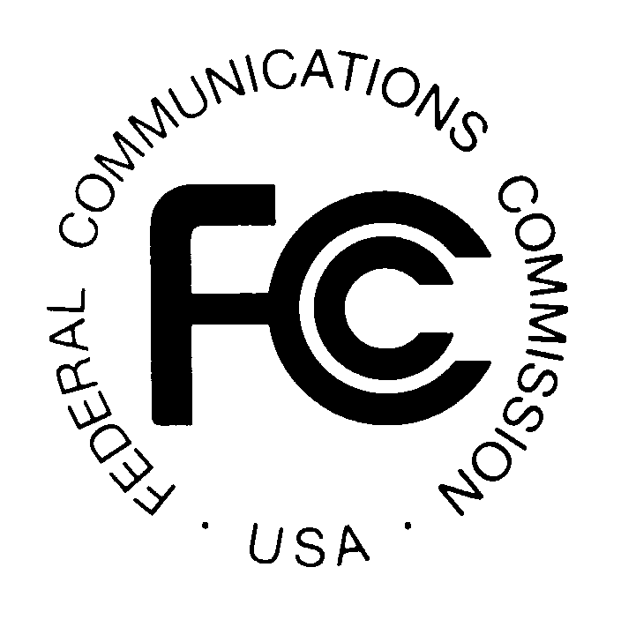PUBLIC NOTICE
Federal Communications Commission
445 12th St., S.W.
Washington, D.C. 20554

News Media Information: 202.418.0500
TTY: 202.418.2555
Internet: http://www.fcc.gov

DA 15-265

February 27, 2015

PUBLIC SAFETY AND HOMELAND SECURITY BUREAU ANNOUNCES

REGION 13 (ILLINOIS) 700 MHZ AND 800 MHZ NPSPAC PUBLIC SAFETY REGIONAL PLANNING COMMITTEES 2015 MEETING SCHEDULE

PR Docket No. 91-228 and WT Docket 02-378

The Region 13 (Illinois) Regional Conference Review and Implementation Committee, also known as the 700 MHz and 800 MHz Public Safety Regional Planning Committees (RPCs), will hold two planning meetings in 2015 to review any pending 700 MHz and 800 MHz applications and to address any outstanding issues. The meetings will be held as follows:

Wednesday, April 15, 2015, 10:00 a.m.
Illinois State Police Headquarters (First Floor Conference Room)
801 South 7th Street
Springfield, Illinois 62703

Wednesday, November 4, 2015, 1:00 p.m. (After the Illinois Public Safety Telecommunications Annual Conference)
Illinois Emergency Management Agency
2200 South Dirksen Parkway
Springfield, Illinois 62764

Both Region 13 700 MHz and 800 MHz Public Safety RPC meetings are open to the public. The meetings are held at locations throughout the Region 13 area to encourage wide participation. It is essential that public safety agencies in all areas of government, including state, municipality, county, and Native American Tribal, and non-governmental organizations eligible under Section 90.523 of the Commission’s rules, 47 C.F.R. § 90.523, be represented in order to ensure that each agency’s future spectrum needs are considered in the allocation process. Administrators who are not oriented in the communications field should delegate someone with this knowledge to attend, participate, and represent their agency’s needs.

All interested parties wishing to participate in planning for the use of public safety spectrum in the 700 MHz and 800 MHz NPSPAC bands within Region 13 should plan to attend. For further information, please contact:

William Carter, Chairperson
700 MHz and 800 MHz Regional Planning Committees
Illinois Department of Public Health
Radio Communications Coordinator
122 South Michigan
Chicago, Illinois 60603
(312) 814-5208
(312) 497-6802 Mobile
Billy.carter@illinois.gov

-FCC-

The Region 13 (Illinois) 800 MHz NPSPAC regional planning area includes the entire state of Illinois, except for the “Southern Lake Michigan” counties of Winnebago, McHenry, Cook, Kane, Kendall, Grundy, Boone, Lake DuPage, DeKalb, Will and Kankakee.

