**FCC/OET REPORT TA-2014-01**

Measurements of   
LTE into DTV Interference

Tests on four ATSC DTV Receivers of OFDM 64 QAM Co- and Adjacent-channel Interference

**Robert Weller**

**Martin Doczkat**

**Uri Livnat**

**Tho Nguyen**

**Barbara Pavón**

**June 17, 2014**



**Background and Introduction**

The 600 MHz Band Plan adopted by the Commission can accommodate variation in the amount of spectrum recovered in different geographic areas in order to avoid restricting the amount of repurposed spectrum that is available in most areas nationwide.[1] Accommodating market variation means that, while reallocated UHF spectrum will be used exclusively for mobile broadband services in most parts of the country, some markets will have one or more television broadcast stations remaining in the otherwise reallocated spectrum.

One of the biggest technical challenges with accommodating market variation is minimizing the potential for Inter-Service Interference (ISIX) between digital television (DTV) broadcasting and mobile broadband signals, which are assumed to be LTE.[2] To avoid ISIX, DTV transmitters must typically be geographically separated from LTE receivers, and vice-versa (LTE transmitters separated from DTV receivers), such that the relative levels of the two signals are above a particular threshold ratio, called the desired-to-undesired signal ratio, or D/U ratio. In January 2014, the FCC’s Office of Engineering and Technology (OET) released a Public Notice[3] on an ISIX methodology that staff developed—based on actual technical characteristics and industry standards of broadcast and LTE facilities—to more accurately predict where potential harmful interference may occur.

To minimize such interference, it is necessary to determine under what conditions LTE-into-DTV interference occurs. The Commission’s rules presently specify protection requirements for DTV-into-DTV interference.[4] Although both LTE and DTV signals are “noise-like,” OET conducted empirical testing to determine whether the current DTV-DTV protection requirements are adequate, as was assumed in the ISIX Public Notice, to protect DTV receivers against interference from the signals generated by LTE base station (Enhanced Node B or eNB) facilities (*i.e*., the base station downlink into DTV receiver case), or whether different requirements are needed. Generally, the effect of a co-channel LTE interfering signal was observed to be similar to a co-channel DTV interfering signal. A summary of all our observations is on the following page of this document. Interference from LTE User Equipment (UE) was not considered during these tests due to resource limitations and because the interfering distance associated with eNB facilities is much greater than for UEs.

More specifically, in April 2014, OET engineers tested the characteristics of LTE-into-DTV interference in the FCC Laboratory, and the results of those measurements are presented in this document. Four DTV receivers were tested in order to obtain a reasonable indication of their behavior in the presence of an interfering LTE eNB signal. One of the receivers was chosen because its performance is typical of the coupon-eligible digital-to-analog converter boxes (CECB set-top boxes) available during the DTV transition, which concluded June 12, 2009[5]. The remaining three receivers are conventional television receivers (with integrated display) of more recent manufacture. Testing was conducted principally to determine LTE-into-DTV co- and adjacent-channel D/U protection ratios, but also included additional tests to determine DTV receiver threshold sensitivity or minimum signal level (including CNR performance) and DTV-into-DTV co-channel D/U protection ratios.

**Summary of Observations**

1. The baseline performance data derived from the measurements seem generally consistent with studies done on older receivers, i.e., the baseline performance data reported in FCC/OET Report TR-05-1017, but suggest that current models show improvements in certain aspects of receiver performance.
2. Consistent with prior studies, the DTV receivers tested were generally more susceptible to interference at very weak signal levels (approaching threshold) than at higher signal levels.
3. The data suggest some variability in MSL of the 2007 set-top box (RX1) from channel to channel at UHF, and all of the 2013-model receivers were noticeably more sensitive than the typical 2007 set-top box that was selected from the CECB program.
4. The co- and adjacent-channel D/U protection ratios presently in FCC rules appear adequate to protect 2013-model receivers from co-channel DTV interference, and in fact, due to the apparent sensitivity improvements, they may be conservative.
5. There are indications that ATSC decoder performance and noise figure performance in some 2013-model receivers have improved compared with the 2007 model (RX1).
6. Generally, the level of co-channel interfering LTE signal required to cause interference to DTV was not very different from the level of a co-channel interfering DTV signal. For the one 2007 receiver model (RX1) that was tested, however, the D/U protection ratio used for co-channel DTV interference was inadequate to protect against LTE interference when the desired DTV signal is very weak. Because of the small number of receivers tested, it is not known whether this behavior is typical.
7. These measurements were intended to identify any gross differences between the interference potential of LTE and DTV signals on DTV reception. The number of receivers tested and the limited test conditions is too small for statistical analysis and so no specific conclusions should be drawn based upon these measurements. These observations may, however, be considered in context with other measured data.

**Minimum Signal Level (MSL)**

Satisfactory reception of ATSC DTV should occur when a combination of field strength, antenna gain, downlead line loss, and receiver noise figure meets or exceeds the planning factor values.[6] At UHF television channels, it is assumed that the nominal carrier power at the receiver input terminals required for proper DTV reception is -84 dBm.[7] This value is called the threshold sensitivity or minimum signal level (MSL). Among other things, the planning factors underlying this threshold sensitivity assume a receiver noise figure (NF) of 7 dB and that the ATSC decoder produces a “clean” (essentially error-free) picture when the level of the DTV signal (total carrier power) is at least 15.19 dB[8] above white (Gaussian) noise.[9] The latter figure is called the carrier-to-noise ratio (CNR). Variations in DTV receiver design and performance can cause the threshold sensitivity to be more or less than the value of -84 dBm derived from the planning factors, and this value can also vary from channel to channel.[10]



Figure 1. Block Diagram of Test Setup for MSL tests

MSL Test procedure summary:

* An ATSC DTV signal is generated on TV Channel 33 (584–590 MHz) or 46 (662–668 MHz). A minimum loss pad (MLP) is placed between the 50-ohm signal generator and the 75-ohm receiver to provide an impedance match between the two.[11]
* The receiver display is observed for a brief time.
* The level of the generated ATSC signal is increased in 0.1-dB increments until an artifact-free image is observed. This level (measured at the receiver antenna input) is recorded as the minimum signal level (MSL).
* The test is repeated per receiver.

Table 1 below summarizes the results of the Minimum Signal Level testing.

|  |  |  |  |  |
| --- | --- | --- | --- | --- |
| Receiver Number | Type | Date of Acquisition | MSL, Channel 46 | MSL, Channel 33 |
| RX1 | Set-top box | 2007 | -84.1 dBm | -83.4 dBm |
| RX2 | 24” LED receiver | 2013 | -87.3 | -87.3 |
| RX3 | 24” LED receiver | 2013 | -87.6 | -87.5 |
| RX4 | 24” LED receiver | 2013 | -86.8 | Not measured |

Table 1. Results of MSL testing.

Observations: While the number of DTV receivers tested is not sufficient for statistical analysis, the data suggest that there can be some variability in threshold sensitivity from channel to channel and that the threshold sensitivity of DTV receivers has improved over the past few years.

**CNR required for ATSC Decoder**

As discussed above, the MSL required for successful reception includes both the receiver NF and the CNR necessary for the ATSC decoder to produce an output with acceptably few errors. Since direct measurement of the DTV receiver noise figure (NF) is difficult, the minimum necessary CNR can be measured by producing a white (Gaussian) noise signal well above the MSL and adding a DTV signal until an artifact-free image is produced by the receiver. Because the signal levels are sufficiently high to make the receiver’s own internal noise insignificant, this measurement can provide an indication of whether variations in the measured MSL of the receiver (relative to the value of -84 dBm derived from the planning factors) are due to differences in noise figure (compared with the planning factor value of 7 dB) or decoder performance (compared with the planning factor CNR value of 15.19 dB), or both. The test equipment diagram is shown in Figure 2 (SFU #2 was used to generate the noise signal).

Test procedure summary:

* The noise level, NU is set to -71.7 dBm in 6 MHz at TV Channel 46.
* For each receiver, the DTV signal power, D, is increased in 0.1-dB increments until an artifact-free image is obtained.

Table 2 below summarizes the results of the Carrier-to-Noise ratio (CNR) testing.

|  |  |  |  |
| --- | --- | --- | --- |
| Receiver Number | “D” level | “NU” level | CNR |
| RX1 | -56.7 dBm | -71.7 dBm | 15.0 dB |
| RX2 | -57.1 | -71.7 | 14.6 |
| RX3 | -57.8 | -71.7 | 14.9 |
| RX4 | -56.6 | -71.7 | 15.1 |

Table 2. Results of CNR testing.

Observations: (1) The measured CNR performance of the four receivers tested is reasonably consistent with the planning factor value of 15.19 dB. However, the CNR measurements suggest that RX2 has improved decoder performance (by about 0.6 dB) compared with the planning factor value. (2) Because the MSL values for RX2 and RX3 are both more than 3 dB below the expected value of -84 dBm (*i.e*., much more than 0.6 dB), the measurements also suggest that RX2 and RX3 may also have a noise figure lower than the planning factor value of 7 dB. (3) These observations do not consider possible confounding factors, such as impedance variation with frequency and non-linear AGC behavior.

**DTV-DTV D/U Ratio**

Although the planning factor value for CNR (15.19 dB) is expected to be approximately correct for other noise-like interfering signals, the statistical properties of “real” interfering signals are typically different from White (Gaussian) noise. These interfering signals include both DTV and LTE.[12] Additionally, the D/U ratio required for artifact-free reception of DTV in the presence of a co-channel interfering DTV signal is known to vary with the level of the desired DTV signal.[13] Of particular concern in market variation is the potential for interference to DTV reception near the “fringe” of a station’s coverage area, so measurements of the D/U ratio required for artifact-free DTV reception in the presence of co-channel DTV interference were conducted at a “very weak” signal level. The level selected for the desired DTV signal was chosen to be 3 dB above the MSL of the receiver having the poorest sensitivity or MSL (*i.e*., RX1 with an MSL of -84.1 dBm resulting in a “very weak” DTV signal level of -81.1 dBm).

As discussed above, the co-channel D/U ratio required for interference-free reception is a function of the level of the desired signal above the CNR, which is assumed to be 15.19 dB in the DTV planning factors, leading to an equivalent MSL of -84 dBm at UHF. The D/U ratio required for successful DTV reception in the presence of a co-channel undesired DTV signal is generally in the range 15–20 dB.[14] For DTV-into-DTV interference, the expected D/U ratio in decibels is given by the relationship:[15]

(Eq. 1)

Thus, the expected D/U ratio is calculated to be 18.0 dB when the desired signal level is 3 dB above the derived planning factor MSL value of -84 dBm (*i.e*., very close to the -81.1 dBm value associated with RX2). From Table 1, it is observed that RX2, 3, and 4 all had better sensitivities than the derived planning factor value and so an improved D/U ratio (*i.e*., less than 18.0 dB) might be expected based on application of the formula given in the rules (Eq. 1).



Figure 2. Block Diagram of Test Setup for CNR and DTV-DTV D/U tests

Test procedure summary:

* A signal generator is adjusted to produce the desired ATSC signal on TV Channel 33   
  (584-–590 MHz) at a level of -80.4 dBm at the input of the receiver under test.
* A second signal generator produces the interfering (undesired) ATSC signal on channel 33.
* The level of the undesired signal is increased in 0.1 dB steps until artifacts were just visible in the image produced by the desired signal. No hysteresis was observed at this very weak signal level. “Just visible” is commonly referred to as the threshold of visibility (TOV) of interference.

Table 3 below summarizes the results of the DTV-into-DTV D/U testing.

|  |  |  |  |  |  |
| --- | --- | --- | --- | --- | --- |
| Receiver Number | Desired Signal Level (D) | Undesired Signal Level (U) | D/U at TOV  (“D”-“U”) | Expected D/U from rules[16] | Expected D/U from formula[17] |
| RX1 | -80.4 dBm | -96.9 dBm | 16.5 dB | 17.5 | 18.0 |
| RX2 | -80.4 | -95.9 | 15.5 | 17.5 | 16.0 |
| RX3 | Not tested |  |  |  |  |
| RX4 | Not tested |  |  |  |  |

Table 3. Results of DTV-into-DTV D/U testing on Channel 33

Observations: (1) While the number of DTV receivers tested is not sufficient for any statistical analysis, the data suggest that D/U protection requirements in the rules are sufficient to protect both newer and older DTV receivers from DTV-into-DTV co-channel interference. (2) Use of the formula in the Commission’s rules appears to provide a realistic prediction of the required D/U ratio when the actual performance of the receiver is considered.

**DTV-LTE D/U Ratio**

Certain technical characteristics of ATSC (8 VSB) and LTE (OFDM) signals differ. In particular, the cumulative distributions of the peak-to-average power ratios (PAPR) are different. LTE signals can also take on a variety of modulation and coding schemes (MCS) and dynamic resource block allocations, which would also be expected to alter the interference potential of an LTE signal. In an OFDM system such as LTE, the PAPR is proportional to the number of subcarriers (assuming each subcarrier is modulated independently with the same type of modulation), so the greatest PAPR would be expected when all resource blocks are allocated (*i.e*., in use) using the highest-order modulation available. For these tests, a fully allocated 64 QAM LTE signal was used. Because the 6 MHz bandwidth of television channels is different from the 5 MHz multiples of blocks to be reallocated for mobile broadband, it is likely that that any 5 MHz wide interfering LTE signal will only partially overlap a channel containing a desired DTV signal.[18] The degree of overlap can vary depending upon how much spectrum is repurposed through the incentive auction, and so the testing considered LTE-into-DTV overlaps in increments of 1 MHz.[19] Examples of LTE-into-DTV overlap are illustrated in Figures 4 and 5 for 5 and 10 MHz LTE bandwidths, respectively.



Figure 3. Block Diagram of Test Setup for DTV-LTE D/U tests.



Figure 4. Illustration of 5 MHz LTE signal partially overlapping 6 MHz DTV channel (Channel 46) by 1 MHz.



Figure 5. Illustration of 10 MHz LTE signal partially overlapping 6 MHz DTV (Channel 46) channel by 4 MHz.

Test procedure summary:

* The desired ATSC Signal is generated on TV Channel 46 (662-668 MHz). Three different desired signal levels are considered: Very Weak, Weak and Moderate.
  + The Very Weak desired DTV signal level is -81.1 dBm, as previously discussed.
  + The Weak signal level is -69.7 dBm, and the Moderate signal level is -54.7 dBm.[20]
* Two interfering LTE signals are tested: 5 MHz and 10 MHz nominal bandwidth, both OFDM with fully allocated 64 QAM subcarriers.[21]
* For each receiver and at each desired DTV signal level, 12 measurements are made using the 5 MHz LTE signal as the interferer and 4 measurements are made using the 10 MHz LTE signal as the interferer. Each measurement includes a different amount of spectral overlap between the 6 MHz channel containing the desired DTV signal and the 5 MHz or 10 MHz undesired LTE signal.
* With the 5 MHz undesired LTE signal fully in the lower-adjacent TV channel (*i.e*., centered at 659.5 MHz), the undesired LTE signal is first adjusted to a high level that blocks DTV reception. The undesired LTE signal is then decreased in 0.1-dB increments until no visible impairments are observed on the DTV display. That undesired signal level is recorded. The level of the undesired signal is further reduced by 1 dB and then increased in 0.1-dB increments to confirm the recorded D/U ratio at which interference is observed is the same.
  + The previous step is repeated after shifting the LTE signal upward in 1 MHz increments, such that it is centered at: 660.5, 661.5, 662.5, 663.5, 664.5, 665.6, 666.5, 667.5, 668.5, 669.5, and 670.5 MHz. This results in the undesired LTE signal overlapping the desired TV channel by 1, 2, 3, 4, and 5 MHz on both the “low” and “high” side of the TV channel, as well as being fully in the adjacent TV channel on both the “low” and “high” side.
  + Where hysteresis is observed (*i.e*., a different D/U ratio was observed when the undesired signal is increased versus decreased), the interfering level is recorded twice: once when moving from high CNR to low CNR regions, and the second time when moving from low CNR to high CNR regions. Hysteresis was observed only in the moderate signal case. In the table below, the average (in dB) of the two values is reported.[22]
* After completing the 5 MHz tests, tests are performed with an undesired 10 MHz LTE signal (also operating with all 64 QAM resource blocks allocated), with the same desired DTV signal. The undesired LTE signals are centered at 661, 663, 667, and 669 MHz. This results in the undesired LTE signal overlapping the desired TV channel by 4 and 6 MHz on both the “low” and “high” side of the TV channel.
* Once all the measurements have been collected, the corresponding D/U ratios are calculated by subtraction: Desired [dBm] – Undesired [dBm] = D/U [dB]
* Tables 4 through 6 summarize the results of the LTE-DTV D/U (in dB) testing for the 5 MHz undesired LTE signal. Note that negative D/U values result when the undesired LTE signal is fully in the channel adjacent to the desired DTV signal.
* Tables 7 through 9 summarize the results of the LTE-DTV D/U (in dB) testing for the 10 MHz undesired LTE signal.
* Tables 10 through 12 summarize the theoretical co-channel DTV-into-DTV D/U (in dB)[23] versus the measured co-channel LTE-into-DTV D/U results (in dB) for the 5 MHz undesired LTE signal. The average of the two measurements taken for 6 MHz overlap is used in these tables.

|  |  |  |  |  |  |  |
| --- | --- | --- | --- | --- | --- | --- |
|  |  |  |  |  |  |  |
| Lower | 659.5 | 0 | -38.1 | -42.8 | -44.0 | -36.7 |
| 660.5 | 1 | 7.7 | 0.5 | 0.9 | 0.8 |
| 661.5 | 2 | 13.9 | 10.4 | 9.9 | 10.2 |
| 662.5 | 3 | 16.8 | 12.7 | 12.6 | 12.9 |
| 663.5 | 4 | 18.4 | 14.3 | 14.5 | 14.8 |
| 664.5 | 5 | 19.2 | 16.1 | 15.7 | 16.4 |
| Upper | 665.5 | 5 | 19.0 | 16.0 | 15.7 | 16.1 |
| 666.5 | 4 | 18.3 | 14.3 | 14.1 | 14.9 |
| 667.5 | 3 | 16.5 | 12.7 | 12.6 | 12.8 |
| 668.5 | 2 | 13.4 | 10.0 | 10.2 | 10.0 |
| 669.5 | 1 | 6.3 | -2.6 | 0.0 | -0.2 |
| 670.5 | 0 | -38.5 | -44.4 | -43.7 | -40.4 |

Table 4. Measured D/U ratios for 5 MHz LTE -into-DTV   
where the Desired Signal is Very Weak (-81.1 dBm)

|  |  |  |  |  |  |  |
| --- | --- | --- | --- | --- | --- | --- |
|  |  |  |  |  |  |  |
| Lower | 659.5 | 0 | -40.7 | -43.4 | -42.3 | -38.1 |
| 660.5 | 1 | 5.3 | -2.3 | -2.2 | 1.4 |
| 661.5 | 2 | 11.3 | 6.7 | 6.1 | 8.5 |
| 662.5 | 3 | 13.5 | 11.7 | 11.9 | 11.5 |
| 663.5 | 4 | 14.2 | 13.6 | 14.2 | 13.1 |
| 664.5 | 5 | 15.2 | 14.6 | 14.6 | 14.5 |
| Upper | 665.5 | 5 | 15.0 | 14.6 | 14.5 | 14.7 |
| 666.5 | 4 | 14.1 | 13.5 | 13.9 | 12.9 |
| 667.5 | 3 | 13.5 | 11.3 | 12.2 | 11.4 |
| 668.5 | 2 | 10.6 | 6.1 | 5.9 | 8.0 |
| 669.5 | 1 | NM | -11.9 | -8.7 | -6.4 |
| 670.5 | 0 | -40.7 | -45.0 | -43.2 | -40.9 |

Table 5. Measured D/U ratios for 5 MHz LTE-into-DTV   
where the Desired Signal is Weak (-69.7 dBm)

|  |  |  |  |  |  |  |
| --- | --- | --- | --- | --- | --- | --- |
|  |  |  |  |  |  |  |
| Lower | 659.5 | 0 | -40.2 | -43.2 | -44.2 | -38.3 |
| 660.5 | 1 | 7.5 | -4.5 | -2.1 | 1.9 |
| 661.5 | 2 | 11.9 | 5.5 | 5.6 | 8.6 |
| 662.5 | 3 | 13.9 | 10.9 | 10.9 | 11.6 |
| 663.5 | 4 | 14.4 | 14.1 | 14.3 | 13.3 |
| 664.5 | 5 | 15.0 | 14.5 | 14.5 | 14.6 |
| Upper | 665.5 | 5 | 14.8 | 14.5 | 14.5 | 14.5 |
| 666.5 | 4 | 15.8 | 13.8 | 14.5 | 13.1 |
| 667.5 | 3 | 13.9 | 11.0 | 11.2 | 11.4 |
| 668.5 | 2 | 10.2 | 4.4 | 4.6 | 8.2 |
| 669.5 | 1 | -3.5 | -12.4 | -8.7 | -6.6 |
| 670.5 | 0 | -40.4 | -43.6 | -44.8 | -40.1 |

Table 6. Measured D/U ratios for 5 MHz LTE-into-DTV   
where the Desired Signal is Moderate (-54.7 dBm)

|  |  |  |  |  |  |  |
| --- | --- | --- | --- | --- | --- | --- |
|  |  |  |  |  |  |  |
| Lower | 661 | 4 | 14.2 | 11.0 | 11.2 | 15.3 |
| 663 | 6 | 16.7 | 14.0 | 13.7 | 17.8 |
| Upper | 667 | 6 | 16.7 | 14.1 | 13.7 | 18.0 |
| 669 | 4 | 14.0 | 11.0 | 10.8 | 15.2 |

Table 7. Measured D/U ratios for 10 MHz LTE-into-DTV   
where the Desired Signal is Very Weak (-81.1 dBm)

|  |  |  |  |  |  |  |
| --- | --- | --- | --- | --- | --- | --- |
|  |  |  |  |  |  |  |
| Lower | 661 | 4 | 11.0 | 10.3 | 11.1 | 14.0 |
| 663 | 6 | 13.1 | 12.8 | 12.5 | 16.9 |
| Upper | 667 | 6 | 12.9 | 12.8 | 12.6 | 16.8 |
| 669 | 4 | 11.2 | 10.3 | 10.8 | 13.8 |

Table 8. Measured D/U ratios for 10 MHz LTE-into-DTV   
where the Desired Signal is Weak (-69.7 dBm)

|  |  |  |  |  |  |  |
| --- | --- | --- | --- | --- | --- | --- |
|  |  |  |  |  |  |  |
| Lower | 661 | 4 | 11.8 | 10.5 | 10.7 | 13.8 |
| 663 | 6 | 12.8 | 12.8 | 12.4 | 16.7 |
| Upper | 667 | 6 | 12.8 | 12.7 | 12.5 | 16.5 |
| 669 | 4 | 12.4 | 10.5 | 10.9 | 13.8 |

Table 9. Measured D/U ratios for 10 MHz LTE-into-DTV   
where the Desired Signal is Moderate (-54.7 dBm)

|  |  |  |  |
| --- | --- | --- | --- |
|  |  | | |
| RX | Theoretical  DTV-into-DTV | Measured  LTE-into-DTV |  |
| 1 | 18.1 | 19.1 |  |
| 2 | 18.1 | 16.1 |  |
| 3 | 18.1 | 15.7 |  |
| 4 | 18.1 | 16.3 |  |

Table 10. Theoretical co-channel DTV-into-DTV D/U versus average measured co-channel LTE-into-DTV D/U ratios   
for 5 MHz LTE where the Desired Signal is Very Weak (-81.1 dBm)

|  |  |  |  |
| --- | --- | --- | --- |
|  |  | | |
| RX | Theoretical  DTV-into-DTV | Measured  LTE-into-DTV |  |
| 1 | 15.2 | 15.1 |  |
| 2 | 15.2 | 14.6 |  |
| 3 | 15.2 | 14.6 |  |
| 4 | 15.2 | 14.6 |  |

Table 11. Theoretical co-channel DTV-into-DTV D/U versus average measured co-channel LTE-into-DTV D/U ratios   
for 5 MHz LTE where the Desired Signal is Weak (-69.7 dBm)

|  |  |  |  |
| --- | --- | --- | --- |
|  |  | | |
| RX | Theoretical  DTV-into-DTV | Measured  LTE-into-DTV |  |
| 1 | 15.0 | 14.9 |  |
| 2 | 15.0 | 14.5 |  |
| 3 | 15.0 | 14.5 |  |
| 4 | 15.0 | 14.6 |  |

Table 12. Theoretical co-channel DTV-into-DTV D/U versus average measured co-channel LTE-into-DTV D/U ratios   
for 5 MHz LTE where the Desired Signal is Moderate (-54.7 dBm)

Observations: (1) The D/U ratio required for interference-free DTV reception varied with the amount of frequency overlap between the undesired LTE signal and the DTV channel. That is, when the LTE signal overlapped most or all of the 6 MHz DTV channel a greater D/U ratio was required to protect DTV reception, while when the LTE signal overlapped only a small part of the DTV channel a lesser D/U ratio was required. This is an expected result since the total in-channel power varies with the amount of spectral overlap. (2) Direct comparison between the 5 MHz and 10 MHz D/U ratios reported should be made with care because the total power of the undesired LTE signal was held constant regardless of bandwidth. That is, the total undesired power is spread over the total transmit bandwidth yielding a different power spectral density per megahertz. For example, the entire undesired signal power is contained in the DTV channel when the LTE signal bandwidth is 5 MHz and there is 5 MHz overlap with the DTV channel. However, only 6/10 of the undesired signal power is contained in the DTV channel when the LTE signal bandwidth is 10 MHz and there is 6 MHz overlap with the DTV channel. In the latter example, the undesired signal power of the 10 MHz LTE signal contained in the DTV channel is 2.2 dB less than the total undesired signal power, and the actual co-channel D/U ratio is therefore 2.2 dB greater than the values reported in Tables 7 and 8. Similarly, when the 10 MHz LTE signal overlaps 4 MHz of the DTV channel, the actual co-channel D/U ratio is 4 dB greater than the values reported in Tables 7 and 8. The effect of these adjustments is illustrated in Figures 7B, 8B and 9B. (3) Under very weak desired signal conditions, the interference potential of a co-channel undesired 64 QAM LTE signal appears to be greater than for a co-channel DTV signal for the 2007 set-top box (RX1). For receivers of recent manufacture or when DTV signal levels are stronger (*i.e*., “weak” and “moderate,” the D/U values used for protection from co-channel DTV interference appear adequate. (4) Slightly larger D/U values are found when the LTE signal overlaps the lower portion of the DTV channel compared with the same overlap of the upper portion. (5) The adjacent-channel selectivity of all of the receivers tested appears to be much better than FCC rules anticipate in the presence of a single interferer.

**Plots of Measured D/U Data**

The data from Tables 4–9 have been plotted in Figures 6–9 below. The desired DTV signal is always on Channel 46.

|  |
| --- |
| **Plots of Measured D/U Data – 5 MHz LTE IX (from Tables 4, 5 and 6)** |
| Figure 6A. D/U performance of all RX with Very Weak Desired Signal. For comparison, the dashed line represents the expected D/U performance of a DTV receiver operating at 3 dB above -84 dBm per the formula in Section 73.623(c)(3)(i) of FCC rules (*i.e*., D/U = 18.1 dB). |
|  |
| Figure 6B. D/U performance of all RX with Weak Desired Signal. For comparison, the dashed line represents the expected D/U performance of a DTV receiver operating at 14.3 dB above -84 dBm per the formula in Section 73.623(c)(3)(i) of FCC rules (*i.e*., D/U = 15.2 dB). |
|  |
| Figure 6C. D/U performance of all RX with Moderate Desired Signal. For comparison, the dashed line represents the expected D/U performance of a DTV receiver operating at 29.3 dB above -84 dBm per the formula in Section 73.623(c)(3)(i) of FCC rules (*i.e*., D/U = 15.0 dB). |

|  |  |
| --- | --- |
| **Plots of Measured D/U Data – 10 MHz LTE IX (from Tables 7, 8 and 9)** | |
| **As Measured** Figure 7A. D/U performance of all RX with Very Weak Desired Signal. For comparison, the dashed line represents the expected D/U performance of a DTV receiver operating at 3 dB above -84 dBm per the formula in Section 73.623(c)(3)(i) of FCC rules (*i.e*., D/U = 18.1 dB). | **Normalized to same PSD as 5 MHz LTE Signa**l  Figure 7B. D/U performance of all RX with Very Weak Desired Signal Adjusted for Difference in Power Spectral Density. |
| **As Measured** Figure 8A. D/U performance of all RX with Weak Desired Signal. For comparison, the dashed line represents the expected D/U performance of a DTV receiver operating at 14.3 dB above -84dBm per the formula in Section 73.623(c)(3)(i) of FCC rules (*i.e*., D/U = 15.2 dB). | **Normalized to same PSD as 5 MHz LTE Signa**l  Figure 8B. D/U performance of all RX with Weak Desired Signal Adjusted for Difference in Power Spectral Density. |
| **As Measured** Figure 9A. D/U performance of all RX with Moderate Desired Signal. For comparison, the dashed line represents the expected D/U performance of a DTV receiver operating at 29.3 dB above -84dBm per the formula in Section 73.623(c)(3)(i) of FCC rules (*i.e*., D/U = 15.0 dB). | **Normalized to same PSD as 5 MHz LTE Signa**l  Figure 9B. D/U performance of all RX with Moderate Signal Adjusted for Difference in Power Spectral Density. |

**Appendix A – Test Equipment Used**

Signal Sources:

Rohde & Schwarz SFU 1: 2110.2500K02 Serial No. 101158

Options: B4, B5, B6, B30, B90

Rohde & Schwarz SFU 2: 2110.2500K02 Serial No. 100681

Options: B30, B90

Agilent ESG Vector Signal Generator E4438C

Agilent RMS Power Sensor Meter E4418B

Couplers:

Agilent 778D Directional Coupler

Mini-Circuits Splitter ZFSC -2 – 4 – N (0.2–1000MHz) NF562500548

Matching Pad (minimum loss pad):

Huber+Suhner 6001.00.0002 (5.7 dB Loss)

Spectrum Analyzer:

Agilent PXA Signal Analyzer N9030A

**Appendix B -- Images Taken from Spectrum Analyzer**

To help visualize the ratios between the Desired and Undesired signals in the different cases, some representative images are provided showing the Very Weak Signal case for RX3 in the 5 MHz tests:

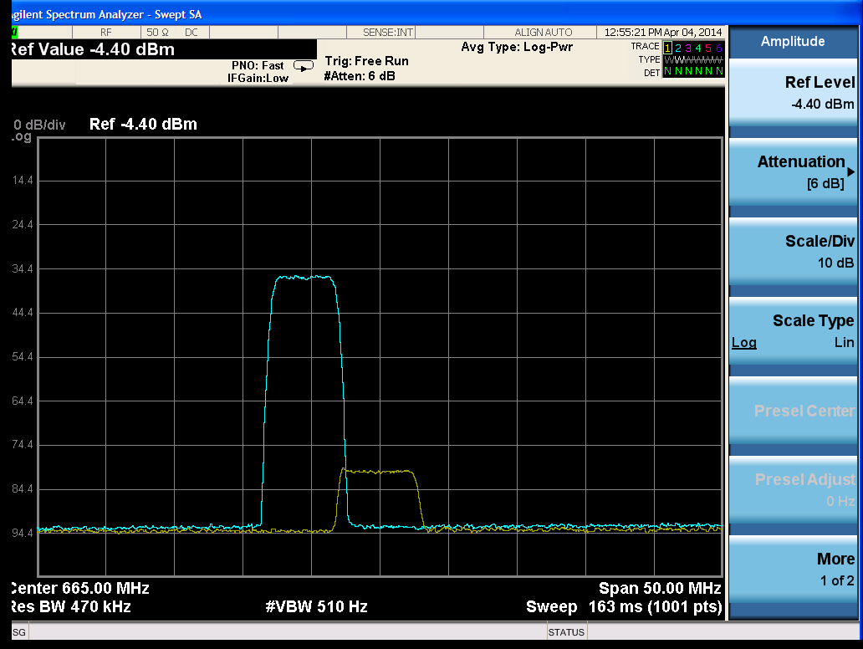 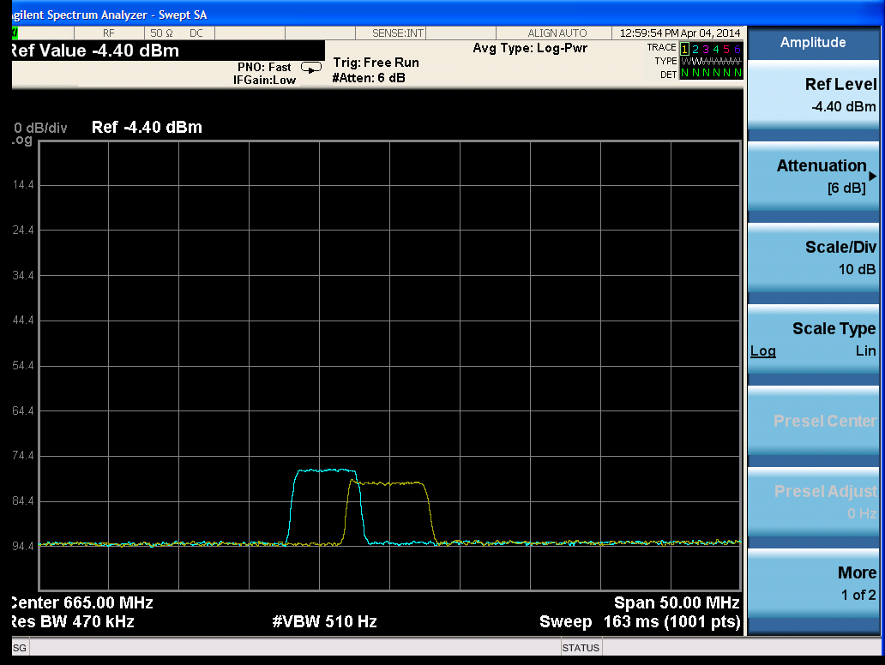

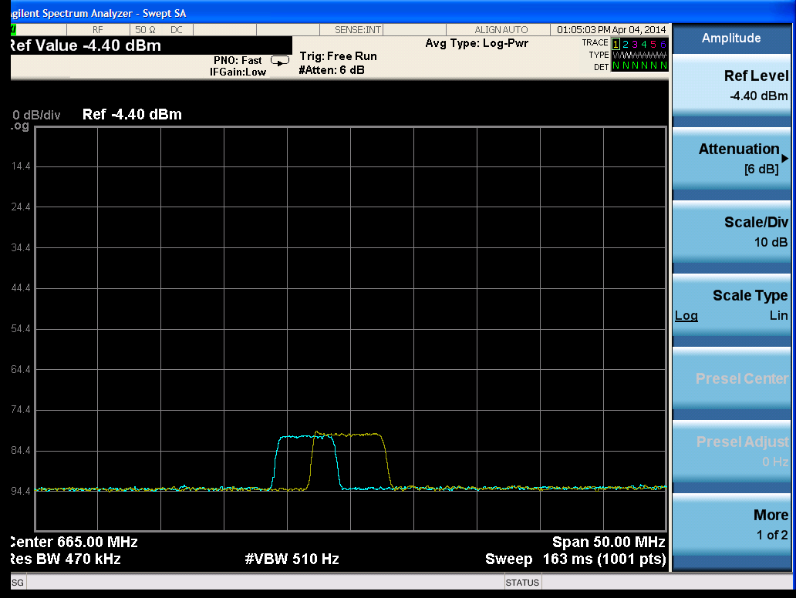 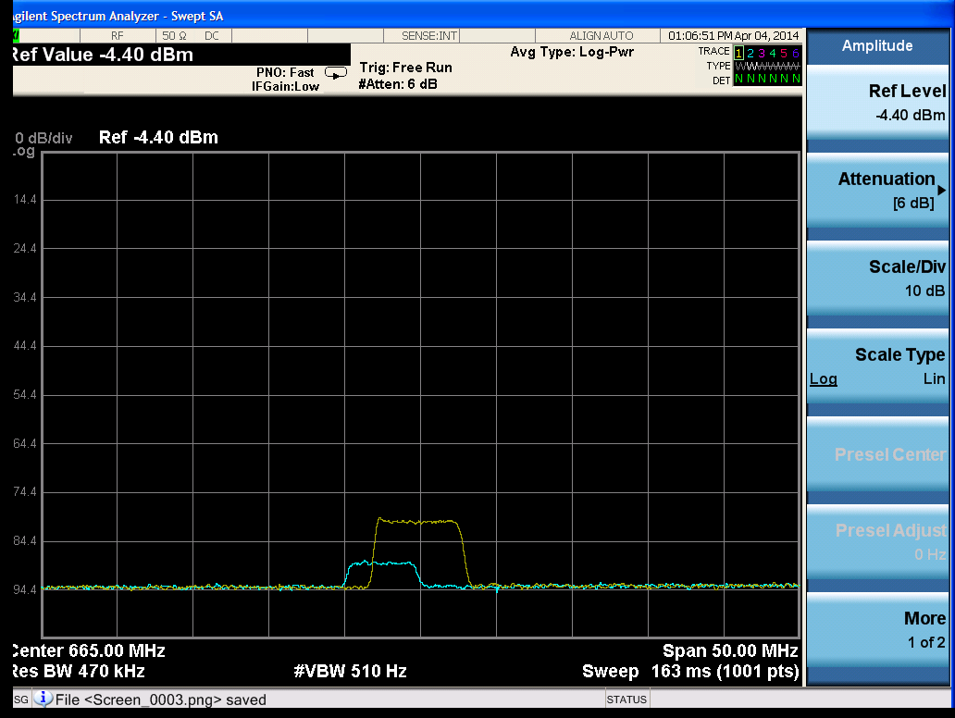

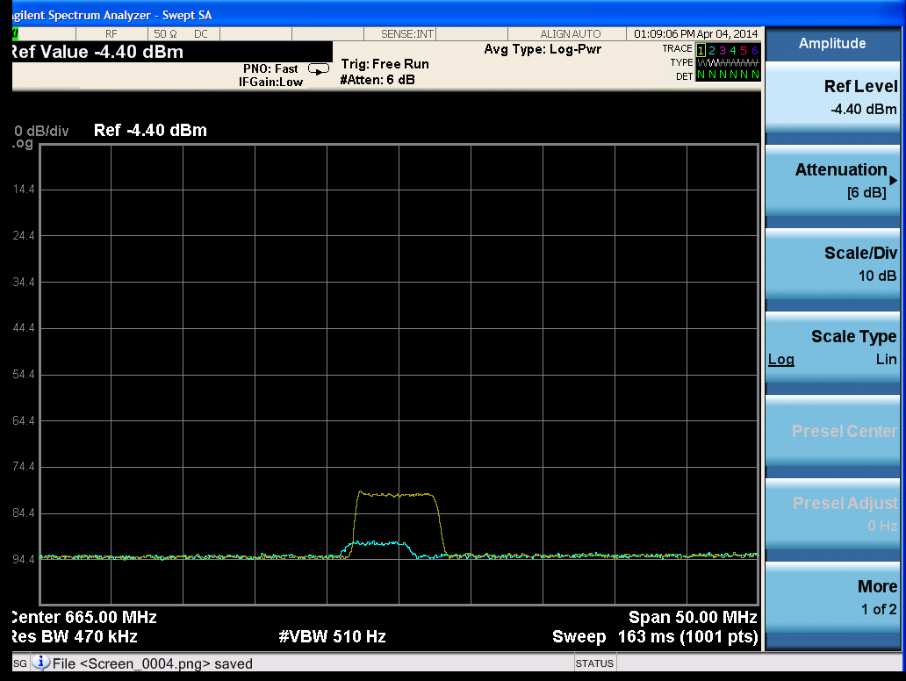 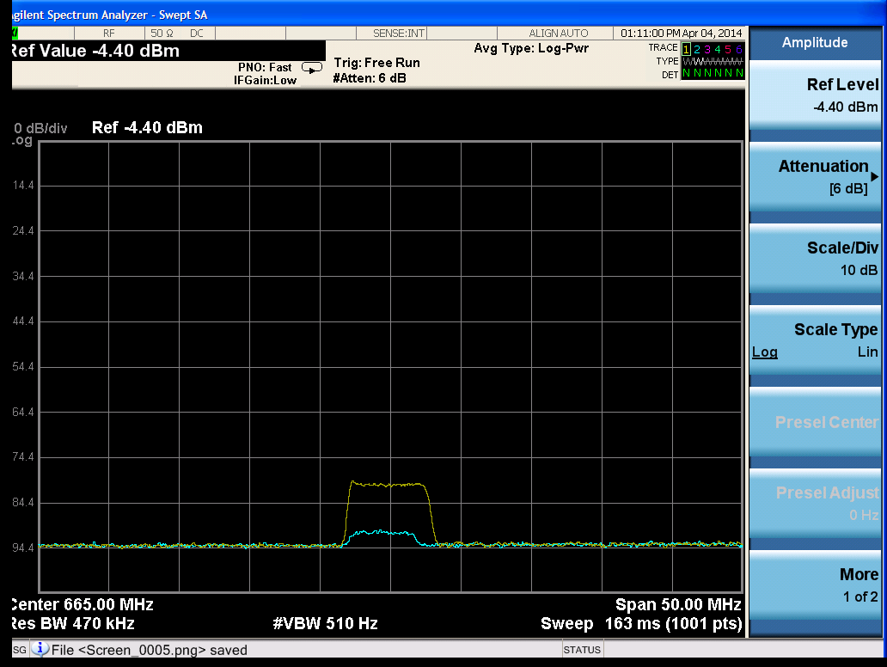

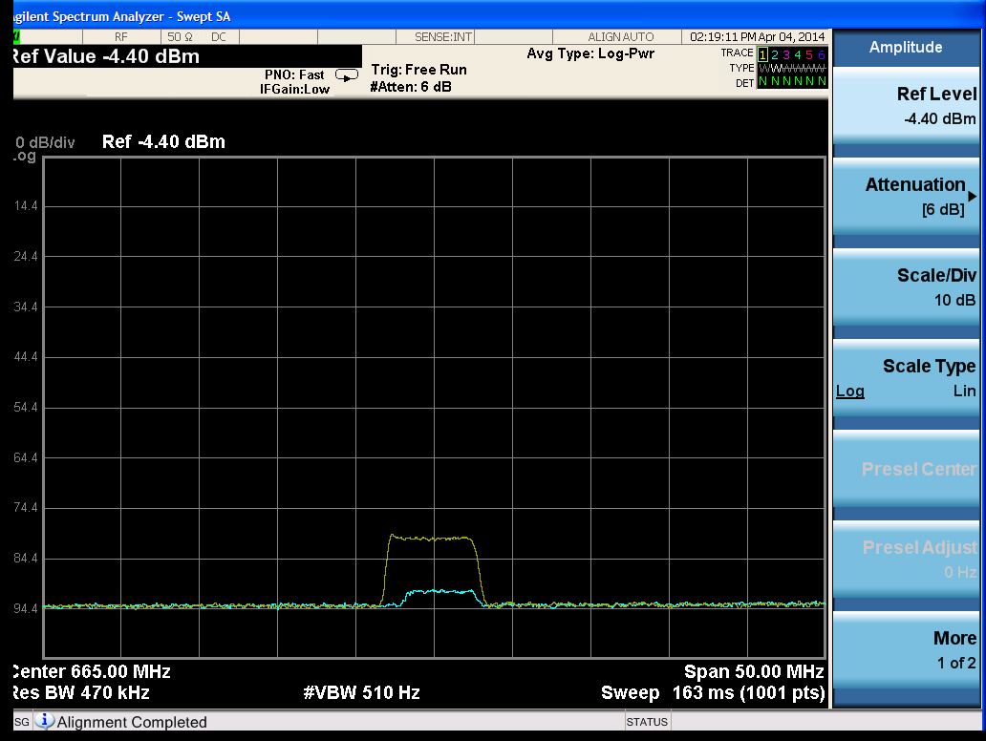 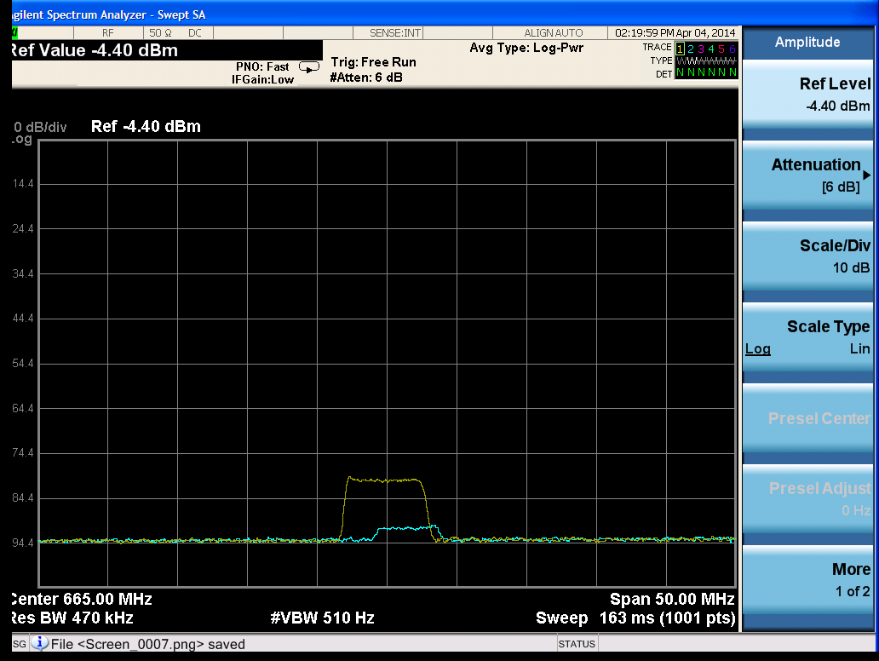

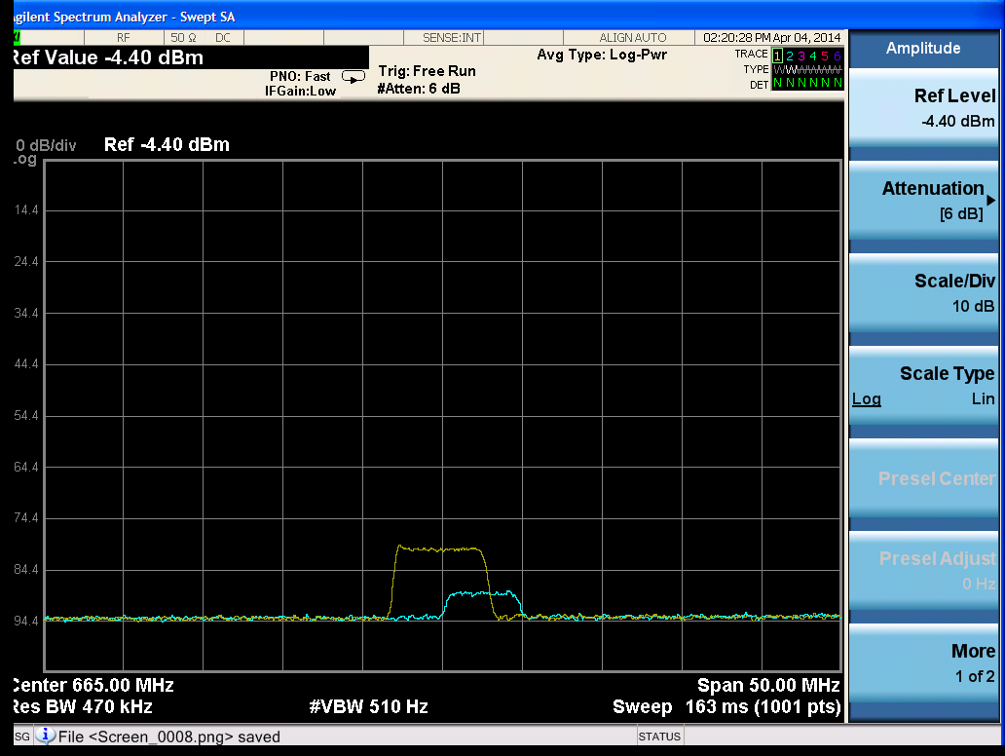 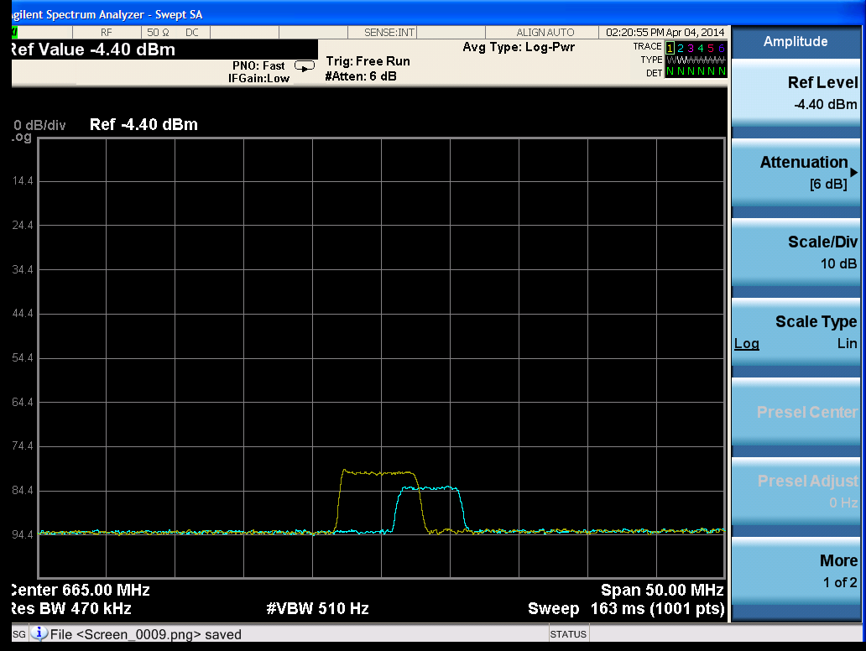

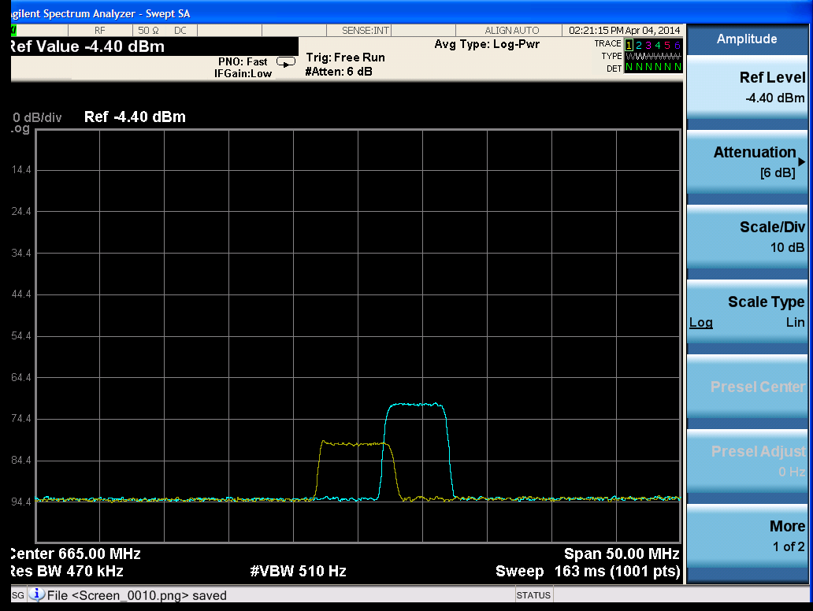 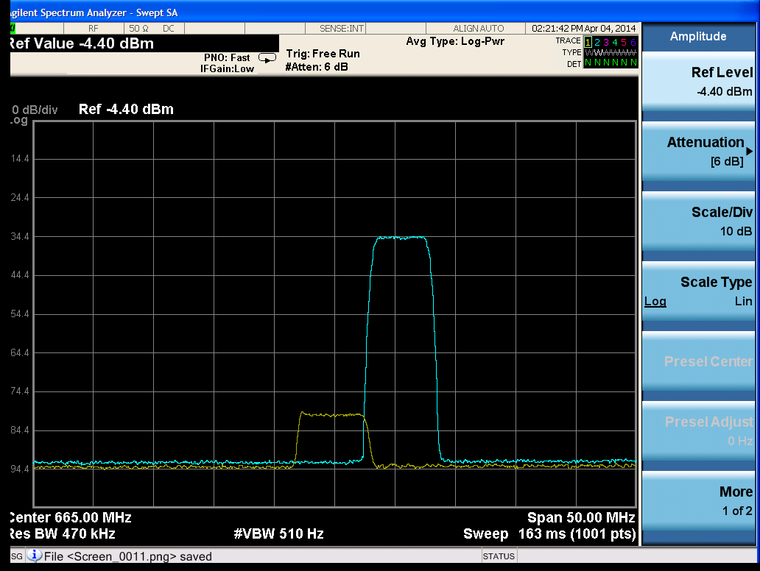

Below are representative images for the 10 MHz tests, also for RX3.

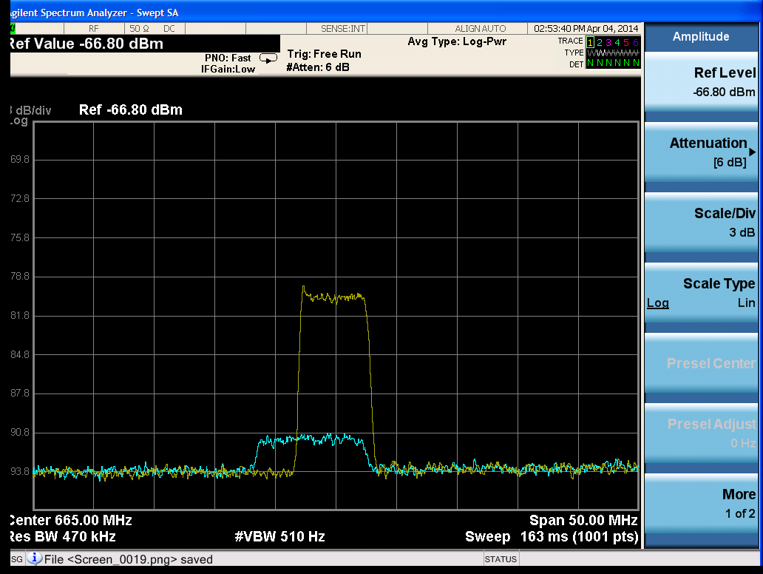 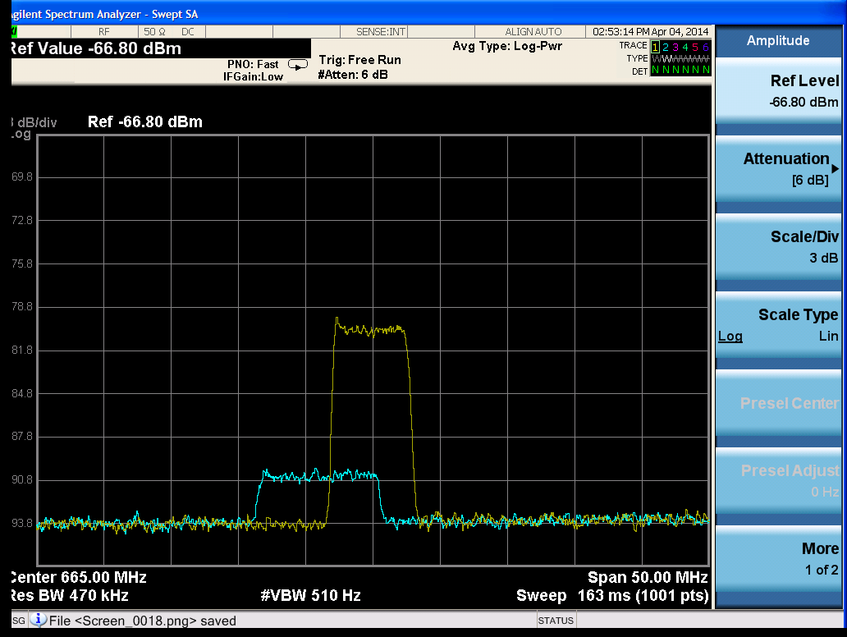

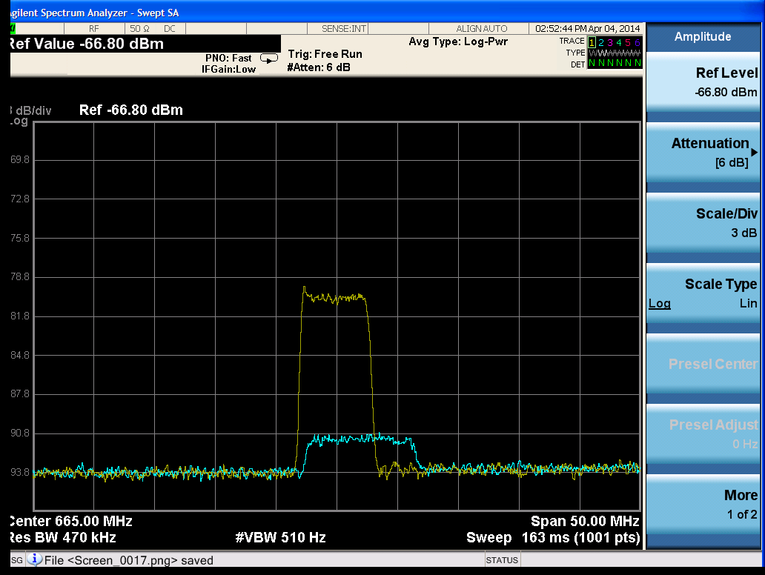 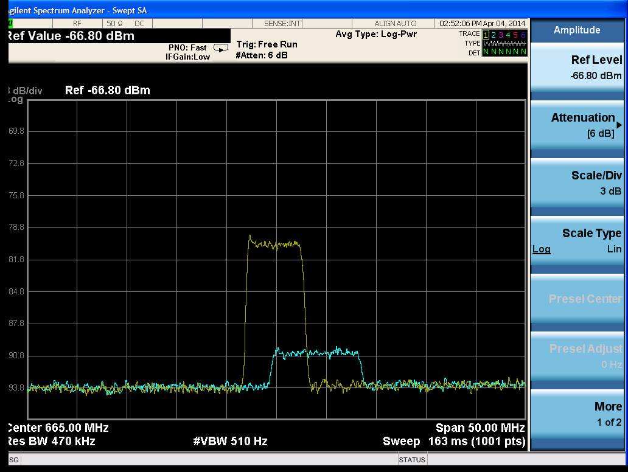

1. *In the Matter of Expanding the Economic and Innovation Opportunities of Spectrum Through Incentive Auctions*, Report and Order, GN Docket 12-268, FCC 14-50 at para. 82 (rel. October 2, 2012) <http://hraunfoss.fcc.gov/edocs_public/attachmatch/FCC-12-118A1.pdf>
2. Long-term evolution, see <http://www.3gpp.org/>. All major and numerous competitive U.S. wireless carriers have filed comments expressing their intent to deploy LTE-based networks in the 600 MHz band.
3. Public Notice DA 14-98, “OET Seeks to Supplement the Incentive Auction Proceeding Record Regarding Potential Interference Between Broadcast Television and Wireless Services,” ET Docket No. 14-14 and GN Docket No. 12-268, January 29, 2014. <http://transition.fcc.gov/Daily_Releases/Daily_Business/2014/db0129/DA-14-98A1.pdf>
4. FCC Rules, Section 73.623(c)(3), 47 CFR §73.623(c)(3).
5. Since June 13, 2009, full-power television stations are required to broadcast their signal exclusively in a digital format. See *Digital Transition and Public Safety Act of 2005,* Pub. L. No.109–171, 109th Congress, 2nd Session (Feb. 8, 2006)
6. FCC/OET Bulletin No. 69, Table 3, February 6, 2004. <http://transition.fcc.gov/Bureaus/Engineering_Technology/Documents/bulletins/oet69/oet69.pdf>
7. *Ibid*. -106.2 dBm + 7 dB + 15.19 dB = -84.0 dBm. NT + NS + C/N.
8. This CNR value is sometimes rounded to 15 dB.
9. Stephen R. Martin, “Tests of ATSC 8-VSB Reception Performance of Consumer Digital Television Receivers Available in 2005,” FCC/OET Report TR-05-1017. The median CNR value across all receivers tested was 15.3 dB.
10. *Ibid*. The median threshold signal level across all receivers tested was -83.9 dBm.
11. The level of the signal generator was measured at the input to the MLP using a calibrated power sensor (Agilent E4418) and adjusted with a calibrated attenuator.
12. Carl Eilers and Gary Sgrignoli, “Digital Television Transmission Parameters – ATSC Compliance Factors,” IEEE Trans. Broadcasting, Vol. 45, No. 4 (Dec. 1999)
13. 47 CFR §73.623(c)(3)(i).
14. *Ibid*.
15. *Ibid*. The quantity (S/N - 15.19) is the amount by which the actual desired signal-to-noise ratio (in dB) exceeds the minimum required for DTV reception (15.19 dB is the minimum S/N planning factor value). The CNR and S/N are taken to be equivalent for this calculation.
16. Application of formula in Section 73.623(c)(3)(i), assuming -84 dBm MSL.
17. Application of formula in 73.623(c)(3)(i), using measured MSL from Table 1 at Channel 33.
18. We note that the nominal 3 dB bandwidths for 5 MHz LTE and 6 MHz DTV are about 4.5 and 5.38 MHz, respectively.
19. The amount of spectral overlap can also vary depending on the number of 5 MHz blocks an LTE signal occupies. For example, 5, 10, 15, and 20 MHz LTE signals would occupy about 4.5, 9, 13.5, and 18 MHz respectively (*i.e*., 90% of the usable bandwidth), removing most of the in-channel power from the edge of the last block in the band by 0.25, 0.5, 0.75, and 1 MHz respectively. Thus, ignoring the smallest bandwidths described in the 3GPP specifications (which are not commonly used), a 5 MHz LTE signal would extend closest to the block edge. In other words, in comparing a single 20 MHz LTE signal to four separate 5 MHz LTE signals, the nearest 5 MHz LTE signal would be 0.25 MHz away from the block edge but the 20 MHz LTE signal would be 1 MHz away from the block edge. Only 5 and 10 MHz LTE signals were used in these tests.
20. We note that the conventional weak and moderate signal levels commonly used in DTV receiver testing are -68 and -53 dBm. See “ATSC Recommended Practice: Receiver Performance Guidelines,” Document A/74:2010, 7 April 2010. <http://www.atsc.org/cms/standards/a_74-2010.pdf> The actual signal levels are offset by 1.7 dB due to a configuration error during equipment set-up. We do not expect any significant difference in receiver performance due to this small deviation from the conventional values.
21. E-UTRA Test Model 3.1, “LTE Base Station Conformance Testing,” ETSI TS 136 141 v10.1.0 (2011-01). <http://www.etsi.org/deliver/etsi_ts/136100_136199/136141/10.01.00_60/ts_136141v100100p.pdf>
22. Hysteresis was observed in only a few cases at moderate signal levels only, with a difference of 0.2 dB or less.
23. Based on planning factor values.