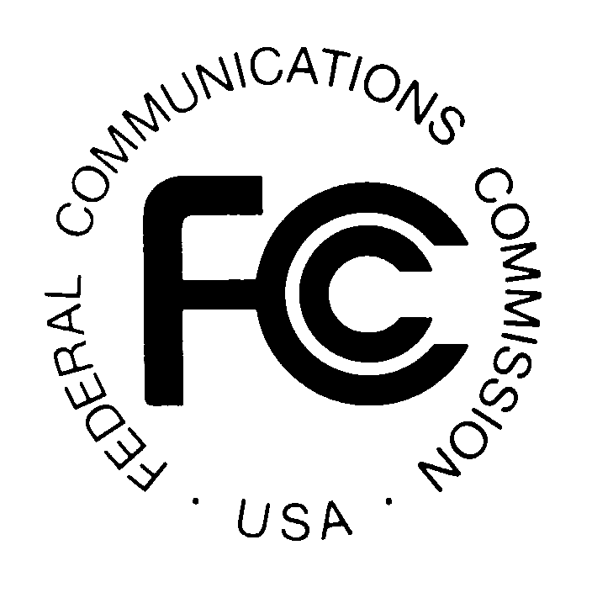
News media information 202 / 418-0500
TTY 202 / 418-2555
Internet: http://www.fcc.gov
PUBLIC NOTICE

Federal Communications Commission
445 12th St., S.W.
Washington, D.C. 20554

DA 14-779

June 5, 2014

PUBLIC SAFETY AND HOMELAND SECURITY BUREAU ANNOUNCES

REGION 15 (IOWA) PUBLIC SAFETY REGIONAL PLANNING COMMITTEES TO HOLD 700 MHZ AND 800 MHZ NPSPAC MEETINGS

PR Docket No. 92-288

The Region 15 (Iowa) Public Safety Regional Planning Committees (RPCs) will hold two consecutive planning meetings on Wednesday, June 18, 2014. Beginning at 1:00 p.m., the 700 MHz Public Safety RPC will convene at the Department of Public Safety Building, 215 East 7th Street
Des Moines, Iowa.
.
The agenda for the 700 MHz meeting includes:
- Greetings and introductions
- Review and approval of the September 12, 2012 Meeting Minutes
- Chairperson’s Report
- Database Manager Report
- Old Business - No old business pending
- New Business - Election of officers
- Opportunity for public comment
- Adjournment

Immediately following the 700 MHz Public Safety RPC meeting, the 800 MHz Public Safety RPC will convene at the same location.

The agenda for the 800 MHz meeting includes:
- Greetings and introductions
- Review and approval of the September 12, 2012 meeting minutes
- Chairperson’s Report
- Old Business - No old business pending
- New Business - Election of officers
- Opportunity for public comment
- Adjournment

The Region 15 700 MHz RPC meeting is open to the public. It is essential that public safety
agencies in all areas of government, including state, municipality, county, and Native American Tribal, and non-governmental organizations eligible under Section 90.523 of the Commission’s rules, 47 C.F.R. § 90.523, be represented in order to ensure that each agency’s future spectrum needs are considered in the allocation process. Administrators who are not oriented in the communications field should delegate someone with this knowledge to attend, participate, and represent their agency’s needs.

All interested parties wishing to participate in the planning for the use of public safety spectrum in the 700 MHz band within Region 15 should plan to attend. For further information, please contact:

Leslie Fish, Chairperson
700 MHz Public Safety RPC
Iowa State Patrol Communications
59 2nd Avenue
Des Moines, IA. 51313
(515) 281-8804
Leslie.fish@dps.ia.gov

-FCC -

