PUBLIC NOTICE
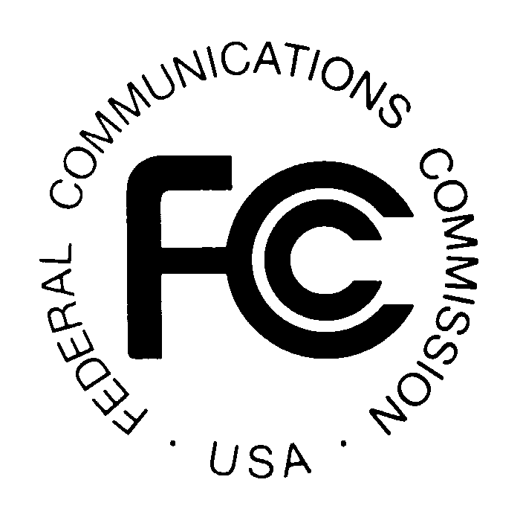

News media information (202) 418-0500
TTY (202) 418-2555
Internet: http://www.fcc.gov
Federal Communications Commission
445 12th St., S.W.
Washington, D.C. 20554

DA 14-1193

August 14, 2014

PUBLIC SAFETY AND HOMELAND SECURITY BUREAU ANNOUNCES

REGION 10 (GEORGIA) PUBLIC SAFETY REGIONAL PLANNING COMMITTEES TO HOLD 700 MHZ AND 800 MHZ NPSPAC REGIONAL PUBLIC SAFETY PLANNING MEETINGS

PR Docket No. 92-189

The Region 10 (Georgia) Public Safety Regional Planning Committees (RPCs) will hold two consecutive planning meetings on Thursday, October 16, 2014. Beginning at 10:00 a.m., the 700 MHz Public Safety RPC will convene at the Georgia Public Safety Training Center, 1000 Indian Springs Drive, Training Bay-B, Forsyth, Georgia. A continental breakfast and lunch will be provided. Breakfast will be served from 9:00 – 10:00 a.m.

The agenda for the 700 MHz meeting includes:
- Introduction of RPC officers
- Review and approval of the meeting minutes
- FCC application process
- Old business
- New business
- Standing committee reports
- Regional radio groups
- FCC regulatory update
- Schedule 2015 RPC meeting

Immediately following the 700 MHz Public Safety RPC meeting, the 800 MHz Public Safety RPC will convene at the same location.

The agenda for the 800 MHz meeting includes:
- Introduction of RPC officers
- Review and approval of the meeting minutes
- FCC application process
- Old business
- New business
- Standing committee reports
- Regional radio groups
- FCC regulatory update
- Schedule 2015 RPC meeting

Both Region 10 Public Safety RPCs’ meetings are open to the public. All eligible public safety providers in Region 10 may utilize these frequencies. It is essential that eligible public safety agencies in all areas of government, including state, municipality, county, and Native American Tribal be represented in order to ensure that each agency’s future spectrum needs are considered in the allocation process. Administrators who are not oriented in the communications field should delegate someone with this knowledge to attend, participate, and represent their agency’s needs.

All interested parties wishing to participate in planning for the use of public safety spectrum in the 700 MHz and 800 MHz bands within Region 10 should plan to attend. For further information, please contact Ralph Bevan at (404) 656-2042, or Jim Mollohan.

Jim Mollohan, PMP
Chairman, Region 10, 700 MHz and 800 MHz Public Safety RPCs
Georgia Technology Authority, Spectrum Management Office
47 Trinity Avenue S.W., Suite 330-22
Atlanta, Georgia 30334-9007
(404) 656-5619 Office
(678) 296-3940 Mobile
Jim.Mollohan@gta.ga.gov

- FCC -

The Region 10 700 MHz and 800 MHz Regional Planning Committees’ area includes all 159 counties in the State of Georgia.

