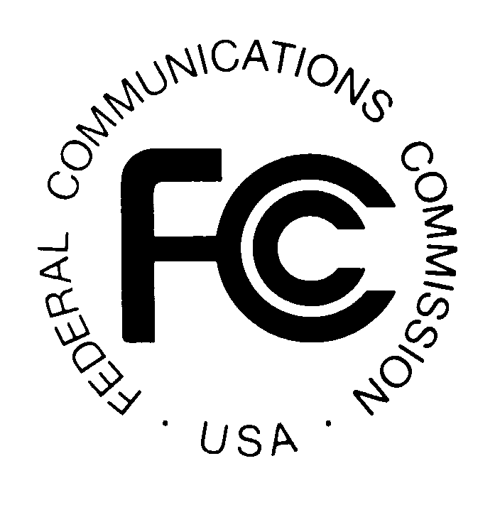
News media information 202 / 418-0500
TTY 202 / 418-2555
Internet: http://www.fcc.gov
PUBLIC NOTICE

Federal Communications Commission
445 12th St., S.W.
Washington, D.C. 20554

DA 13-714

April 15, 2013

PUBLIC SAFETY AND HOMELAND SECURITY BUREAU ANNOUNCES

REGION 42 (VIRGINIA) PUBLIC SAFETY REGIONAL PLANNING COMMITTEES TO HOLD 700 MHZ AND 800 MHZ NPSPAC MEETINGS

PR Docket No. 91-300

The Region 42 (Virginia) Public Safety Regional Planning Committees (RPCs) will hold two planning meetings on Tuesday, May 15, 2013. Beginning at 1:30 p.m., the 700 MHz RPC will convene at the Sheraton Virginia Beach Oceanfront Hotel, 3501 Atlantic Avenue, Virginia Beach, Virginia.

The agenda for the 700 MHz meeting includes:
- Call to Order
- Introductions
- Old business
- New business
- King William County talk-around request
- Other Business
- Nominations for committee officers
  - Election for Chairperson, Vice-chairperson, Treasurer, and Secretary
- Adjourn

Beginning at 3:00 p.m., the 800 MHz meeting will convene at the same location.

The agenda for the 800 MHz NPSPAC meeting includes:
    - Call to Order
    - Introductions
    - Old business
    - 800 MHz Plan updates
    - Arlington County request
    - Region 20 – St. Mary’s County STA concurrence
    - Other business
    - Nominations for committee members and officers
  - Election for Chairperson, Vice-chairperson, and Secretary
    - Adjourn

Both Region 42 Public Safety RPC meetings are open to the public. All eligible public safety providers in Region 42 may utilize these frequencies. To ensure that RPC meetings consider each agency’s future spectrum needs in the allocation process, it is essential that eligible public safety agencies in all areas of government, including state, municipality, county, and Native American Tribal be represented. Administrators who are not oriented in the communications field should delegate someone with this knowledge to attend, participate, and represent their agency’s needs.

All interested parties wishing to participate in planning for the use of public safety spectrum in the 700 and 800 MHz bands within Region 42 should plan to attend. For further information, please contact:

Linda Boring, Vice Chairperson
Region 42 700 MHz and 800 MHz Public Safety RPCs
City of Newport News
513 Oyster Road
Newport News, Virginia 23602
757-269-2430
lboring@nngov.com

- FCC -

