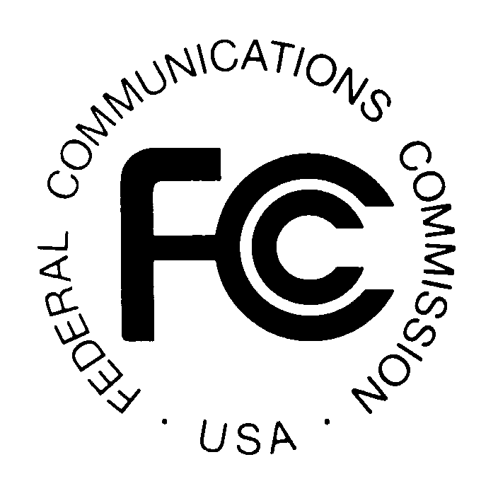
News media information 202 / 418-0500
TTY 202 / 418-2555
Internet: http://www.fcc.gov
PUBLIC NOTICE

Federal Communications Commission
445 12th St., S.W.
Washington, D.C. 20554

DA 13-667

April 8, 2013

PUBLIC SAFETY AND HOMELAND SECURITY BUREAU ANNOUNCES

REGION 13 (ILLINOIS) PUBLIC SAFETY REGIONAL PLANNING COMMITTEE

2013 SCHEDULE FOR 700 MHZ AND 800 MHZ PUBLIC SAFETY PLANNING MEETINGS

PR Docket No. 91-228

The Region 13 (Illinois) 700 MHz and 800 MHz Public Safety Regional Planning Committee will hold its next meetings as follows:

- Wednesday, May 15, 2013, 10:00 a.m., at Effingham City Hall, 206 E. Jefferson Avenue, Effingham, Illinois

- Wednesday, August 14, 2013, 10:00 a.m., at ILEAS Building, 1701 East Main Street, Urbana, Illinois

- Wednesday, November 20, 2013, 10:00 a.m., Bi-State Development Agency, Illinois Metro Bus Operations Facility, Upstairs Conference Room, 801 North 47th Street, East St. Louis, Illinois

The purpose of the meetings will be to discuss the needs of the 700 MHz and 800 MHz spectrum users, including public safety, public health, emergency management, and public utility services.

The Region 13 700 MHz and 800 MHz Public Safety Regional Planning Committee meetings are open to the public. All eligible public safety providers in Region 13 may utilize these frequencies. It is essential that eligible public safety agencies in all areas of government, including state, municipality, county, and Native American Tribal be represented in order to ensure that each agency’s future spectrum needs are considered in the allocation process. Administrators who are not oriented in the communications field should delegate someone with this knowledge to attend, participate, and represent their agency’s needs.

All interested parties wishing to participate in planning for the use of public safety spectrum in the 700 MHz and 800 MHz bands within Region 13 should plan to attend. For further information, please contact:

William J. Carter, Chairman
Region 13 700 MHz and 800 MHz Public Safety RPCs
Radio Communications Coordinator, Illinois Department of Public Health
Office of Preparedness and Response, Division of Disaster Planning and Readiness
122 South Michigan
Chicago, IL 60603
(312) 814-5208
Billy.Carter@illinois.gov
-FCC-

