DA 13-18
January 8, 2013

MEDIA BUREAU OFFERS EXAMPLES TO CLARIFY AUCTION 83 FM TRANSLATOR APPLICATION SELECTIONS AND CAP SHOWINGS REQUIREMENTS

On December 21, 2012, the Media Bureau (Bureau) released a Public Notice announcing the January 10 – January 25, 2013 filing window for application selections and cap showings required of certain Auction 83 FM translator applicants. The Translator Showings Public Notice provides detailed information on the national and per-market cap implementation procedures recently adopted LPFM Fifth Order on Reconsideration. The Bureau has received numerous questions concerning the upcoming filing requirements. To assist existing FM translator applicants, the Bureau has prepared the following examples to clarify and illustrate the required submissions. The examples provided in the Attachment are intended to provide general guidance reflecting the staff’s initial interpretation of the application selections and cap showings procedures. They are not intended to establish binding precedent. The staff will make specific rulings in response to actual selections and submissions on a case-by-case basis.

For further information, contact James Bradshaw or Robert Gates, Audio Division, Media Bureau, (202) 418-2700.
ATTACHMENT

The following definitions apply to the examples below:

Application – Any pending short form proposal from the 2003 Auction 83 application window or related Form 349 application.
Appendix A – Creation of a Low Power Radio Service, Fourth Report and Order and Third Order on Reconsideration, 27 FCC Rcd 3364, 3398-3402 (2012).
Appendix A Market – Any Arbitron market listed in Appendix A.
Inside a Market – A transmitter site located within the boundaries of any Appendix A market.
Outside all Appendix A Markets – A transmitter site located outside the boundaries of ALL Appendix A Markets.
In Grid – A transmitter site located within the 20x20 or 30x30 minute grid that was used to determine the status of each Appendix A and Appendix B market as “spectrum limited” or “spectrum available.” All markets indicated as “spectrum limited” on Appendix A used 30x30 minute grids. All other markets are listed in Appendix B, far right column, as “30 min.” or “20 min.”
Out of Grid – A transmitter site which is not In Grid.
In Buffer – A transmitter site within 39 km of the grid used to assess the status of a market as “spectrum limited” or “spectrum available” in Appendix A or Appendix B.
Protected Contour – 60 dBµ contour calculated in accordance with 47 C.F.R. § 74.1204(b).
No Overlap Showing – A showing that the Protected Contour of an Application does not overlap the Protected Contour of any other Application of that applicant or the Protected Contour of an FM translator authorization held by that applicant as of December 4, 2012. Showing applies to certain Outside all Appendix A Markets Applications and certain Inside a Market Applications.
National Cap Transmitter Site Showing – A showing that at least one LPFM channel would remain at the transmitter site if the Application is granted or that no LPFM channel would remain at the transmitter site if the Application is dismissed. Showing applies only to Applications Outside all Appendix A Markets and only if applicant prosecutes more than 50 Applications.
Appendix A Grid Preclusion Showing – A showing that the Application would not preclude any future LPFM licensing opportunities at any In Grid location for that Appendix A Market. Showing is required for all Applications in a market if Applicant prosecutes more than one Application in that Appendix A Market.
Appendix A Transmitter Site Showing - A showing that at least one LPFM channel would remain at the transmitter site if the Application is granted or that no LPFM channel would remain at the transmitter site if the Application is dismissed. Showing applies only to Applications Inside a Market and only if applicant prosecutes more than one Application in such market.

National cap-related examples:

Example 1 (Applicant with 71 Applications – all Outside all Appendix A Markets):

The applicant may only prosecute 70 Applications nationwide. The applicant must select 70 Applications to prosecute and/or one Application to dismiss. Failure to do so will result in the dismissal of the last-filed Application. The applicant also must submit a No Overlap Showing and a National Cap Transmitter Site Showing for each of the 70 Applications. Failure to do so will result in the dismissal of all but the first 50-filed Applications.

Example 2 (Applicant with 55 Applications in Appendix A Markets):

The applicant may only prosecute 50 Applications within Appendix A Markets. The applicant must select 50 Applications to prosecute and/or five Applications to dismiss. Failure to do so will result in the dismissal of the five last-filed Applications.

Example 3 (Applicant with 50 Applications – all Outside all Appendix A Markets):

The applicant need not submit any showing at this time for any of these 50 Applications.

Example 4 (Applicant with 51 Applications - all Outside all Appendix A Markets):

The applicant must submit a No Overlap Showing and a National Cap Transmitter Site Showing for each of the 51 Applications. Failure to do so will result in the dismissal of the last-filed Application.

Example 5 (Applicant with 70 Applications – all Outside all Appendix A Markets):

The applicant must submit the showings listed in Example 4, above, for each Application. Failure to do so will result in the dismissal of the last 20-filed Applications.

Example 6 (Applicant with 40 Applications in Appendix A Markets and 11 Applications Outside all Appendix A Markets):

The applicant must submit a No Overlap Showing and a National Cap Transmitter Site Showing for each of the 11 Outside all Appendix A Market Applications. Failure to do so will result in the dismissal of the last-filed Outside all Appendix A Market Application. No showings are required at this time for any of the 40 Applications in Appendix A Markets, provided that each Application is in a different market.

Appendix A Markets cap-related examples:

Example 7 (Applicant with four Applications in an Appendix A Market):

Only three Applications are allowed per market. Applicant must pick three to prosecute and/or one to dismiss. Applicant must submit an Appendix A Grid Protection Showing, an Appendix A Transmitter Site showing and a No Overlap Showing for each Application that it chooses to prosecute. Failure to make a selection or to submit the necessary showings will result in the dismissal of all but the first-filed Application from that market.

Example 8 (Applicant with one Application in an Appendix A Market):

The applicant need not submit any showing at this time for this Application.

Example 9 (Applicant with one Application each in three different Appendix A Markets):

The applicant need not submit any showing at this time for any of these three Applications.

Example 10 (Applicant with three Applications in an Appendix A Market):

The applicant must submit a No Overlap Showing, an Appendix A Grid Preclusion Showing and an Appendix A Transmitter Site Showing for each Application. See Example 12, below, for details. Failure to submit the necessary showings will result in the dismissal of all but the first-filed Application.

Example 11 (Applicant with two Applications in an Appendix A Market):

The applicant must submit a No Overlap Showing, an Appendix A Grid Preclusion Showing and an Appendix A Transmitter Site Showing for each Application. See Example 12, below, for details. Failure to submit the necessary showings will result in the dismissal of all but the first-filed Application.

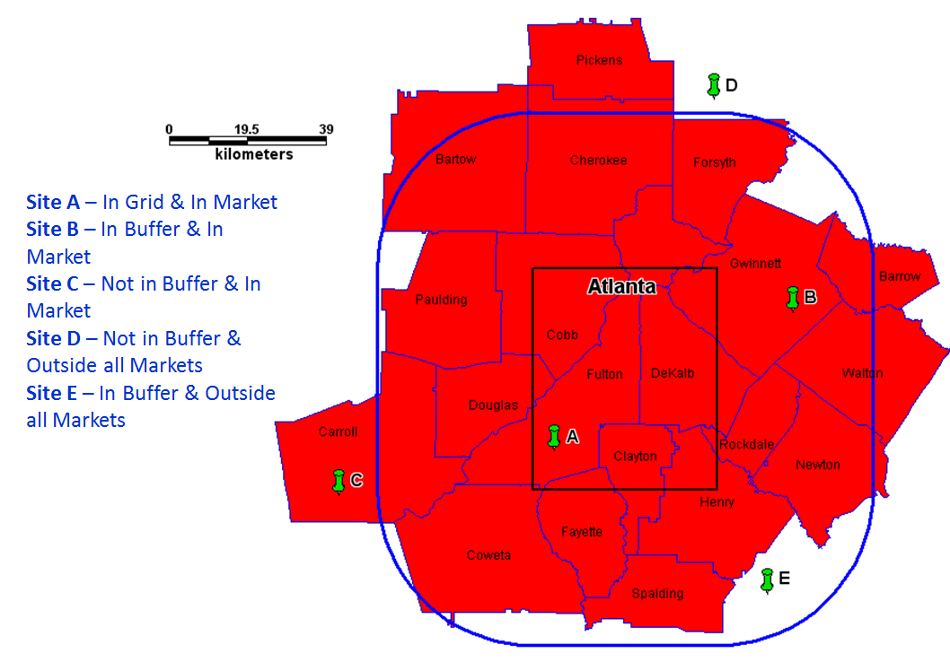

Example 12 (the Atlanta Arbitron Metro map (the counties mapped above) with overlays of the Grid and 39 km buffer. For all of the following examples, applicant is prosecuting the 5 Applications (A, B, C, D and E) depicted above. Sites A, B and C are Inside the Atlanta Market. Thus, this applicant’s failure to submit all necessary showings with respect to Applications A, B and C will result in the dismissal of all but the first-filed of these three Applications. See Example 10, above. Sites D and E are Outside the Atlanta Market. Thus, this applicant may choose to prosecute all five Applications, provided that the Applications D and E do not conflict with the National Cap Conditions and Local Cap Conditions. In this example, Sites D and E are Outside all Appendix A Markets. Applicant also is prosecuting 51 Applications nationwide:

Applicant must submit a No Overlap Showing for Applications A, B and C. This showing is also required for Applications D and E because those Applications are Outside all Appendix A Markets and the applicant is pursuing 51 Applications. (A No Overlap Showing is only required for Applications Outside all Appendix A Markets if the applicant is pursuing 51 or more Applications nationwide.)

- In addition:
Example 12a Application A (In Grid and In Market):

This Application is counted toward the Atlanta Market Cap. Applicant must submit an Appendix A Grid Preclusion Showing and an Appendix A Transmitter Site Showing.

Example 12b Application B (In Buffer and In Market):

This Application is counted toward the Atlanta Market Cap. Applicant must submit an Appendix A Grid Preclusion Showing and an Appendix A Transmitter Site Showing.

Example 12c Application C (Not In Buffer and In Market):

This application is counted toward the Atlanta Market Cap for this applicant. Applicant must submit an Appendix A Grid Preclusion Showing. The following would be a sufficient showing: “Transmitter site is 39 kilometers or more from any In Grid location and therefore cannot preclude any LPFM licensing opportunity in the grid in this Appendix A Market.” Applicant must also submit an Appendix A Transmitter Site Showing.

Example 12d Application D (Not In Buffer and Outside all Appendix A Markets):

This application is NOT counted toward the Atlanta Market Cap. Applicant is NOT required to submit an Appendix A Grid Preclusion Showing. However, this applicant is required to submit a National Cap Transmitter Site Showing because the applicant is pursuing 51 Applications nationwide.

Example 12e Application E (In Buffer and Outside all Appendix A Markets):

This application is NOT counted toward the Atlanta Market Cap. The applicant is NOT required to submit an Appendix A Grid Preclusion Showing because the Application is not located Inside a Market. However, this applicant must submit a National Cap Transmitter Site Showing because the applicant is prosecuting 51 Applications nationwide.

Media Bureau Offers Announces January 10 – January 25, 2013 Filing Window for Auction 83 FM Translator Application Selections and Cap Showings, Public Notice (MB rel. Dec. 21, 2012) (DA 12-2073) (“Translator Showings Public Notice”).
See Creation of a Low Power Radio Service, Fifth Order on Reconsideration and Sixth Report and Order, FCC 12-144 (rel. Dec. 4, 2012) (“Fifth Order on Reconsideration”).
See Translator Showings Public Notice at 2-3.
See id. at 1.

